Query Instructions

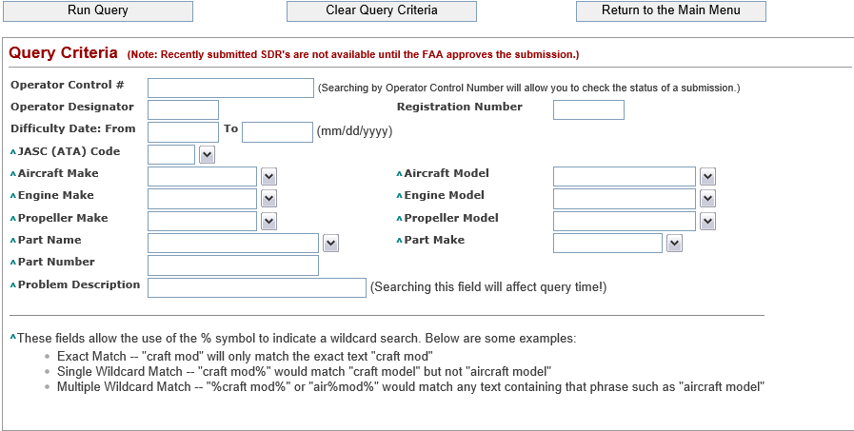

Buttons

a) Run Query – Searches the SDR data based upon the criteria that you supplied. Results are limited to 1500 records.

b) Clear Query Criteria – Clears all criteria from the query form.

c) Return to the Main Menu – Returns you to the main menu of the SDR application.

Lookup Table

When you see the  icon, this indicates that there is a lookup table available to assist you in filling out the associated field. If you click  icon, within a few seconds a window will show up with a list of values that you may choose. The search box at the top will allow you to filter the list based upon the text that you enter into it (ex. If you type ‘112’ only JASC codes with 112 anywhere in them would be listed). Once you have chosen a value click the Select button to populate the value into the related field. Clicking the Cancel button will close the lookup without modifying the value in the associated field.

Query Criteria



To find the status of a submission you may search by Operator Control #. Only processed records will be displayed to the public, but by using the operator control number of your submission you will be able to check that we have received your submission successfully.

You may query by any combination of the fields under the query criteria section. Unless denoted the search will only match exactly the data entered into the field. You may use the lookups to populate some of the fields by clicking the  icon.

^ These fields allow the use of the % symbol to indicate a wildcard search. Below are some examples:

* Exact Match – "craft mod" will only match the exact text "craft mod"
* Single Wildcard Match – "craft mod%" would match "craft model" but not "aircraft model"
* Multiple Wildcard Match – "%craft mod%" would match any text containing that phrase such as "aircraft model"