Table of Contents
1. Introduction 1
2. Batch Submission for New Records 2
2.1 Submitting a New Records Batch Upload 2
2.2 Checking Records That Failed Validation 5
2.3 View Batch Upload History 6
3. Batch Submission for Supplemental Records 8
3.1 Submitting a Supplemental Batch Upload 8
3.2 Checking Records That Failed Validation 11
3.3 View Batch Upload History 12

Introduction
Service Difficulty Reports (SDRs) may be submitted in batches. This feature is intended for operators who routinely transmit large volumes of reports. Only SDRs can be submitted through the batch process. Malfunction or Defect Reports must be entered through the application’s web interface.
A valid batch submission consists of a pipe‑delimited text file containing 77 values per record. Each record must appear on its own line and follow this format:
Value1|Value2|Value3|Value4|Value5|…………|Value77
Figure 1 – File with sample data
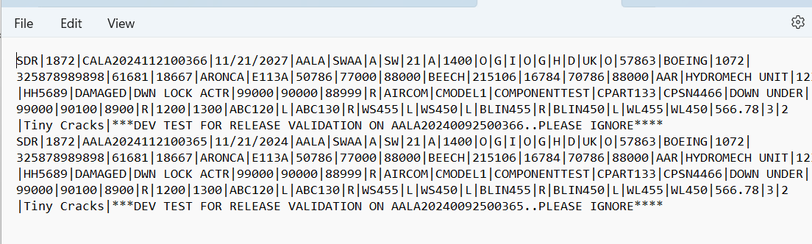
All 77 value positions must be present in every record. If a particular value does not apply, the position must remain empty but still included in the sequence. In this case, the file will show two consecutive pipes (||), indicating a blank value.
Example(s)
If there is no Value3, the record string would be:
Value1|Value2||Value4|Value5|Value6|Value7|Value8|Value9|Value10|………|Value77
If there is no Value3 AND no Value6, the record string would be:
Value1|Value2||Value4|Value5||Value7|Value8|Value9|Value10|………|Value77
If there is no Value3 AND no Value6 AND no Value9, the record string would be:
Value1|Value2||Value4|Value5||Value7|Value8||Value10|………|Value77
After submission, the system automatically validates each record in the batch to confirm proper formatting and verify that all records meet reporting requirements.
There are two distinct batch submission processes:
- Batch Submission for New Records (new records not previously submitted)
- Batch Submission for Supplemental Records (updates to previously submitted records)

Batch Submission for New Records
The User has the option to upload multiple new SDR Reports in a single transmission by using the New Record Batch Upload functionality in SDRS. New records are SDRs that have not been previously submitted, i.e. they do not exist as records.

Submitting a New Records Batch Upload
- Login to SDRS and navigate to the Home Page
- Click on the SDR Batch upload link
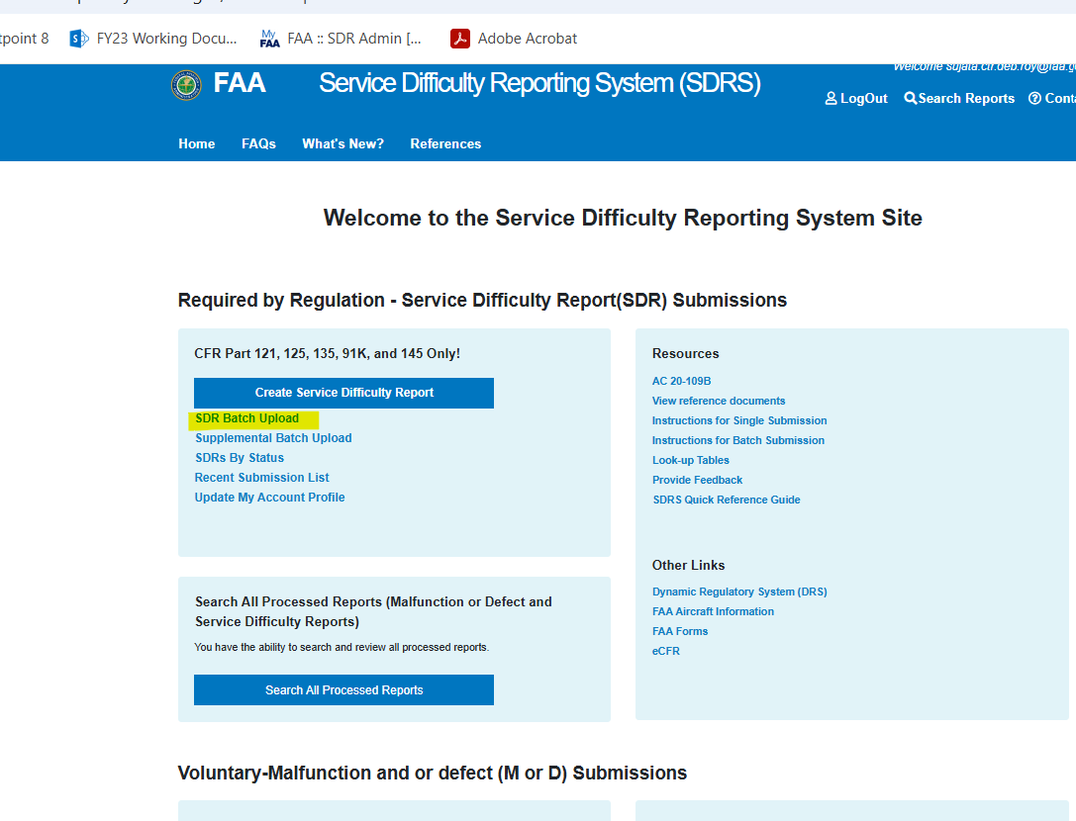
- The SDRS Batch Upload screen is displayed
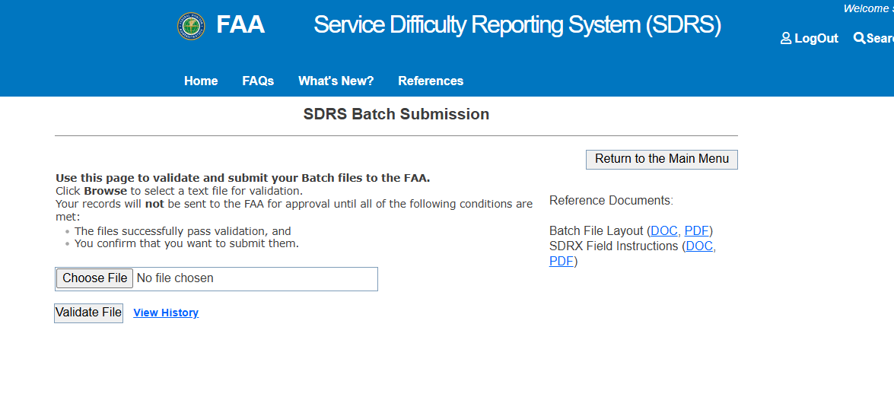
- Click ‘Choose File’ button and pick a batch file from the local C/drive or wherever the batch file is saved
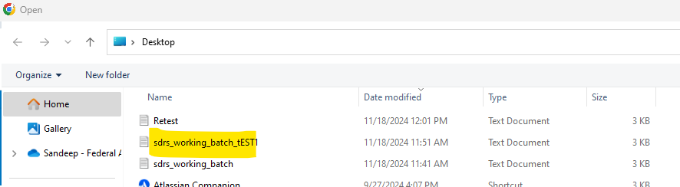
- After choosing the file to upload, select "Validate File"
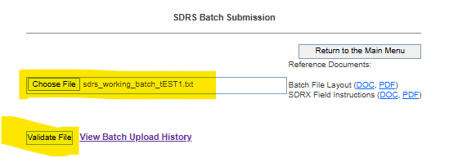
- Validation results are displayed, listing all validation errors if any, at the top of the page
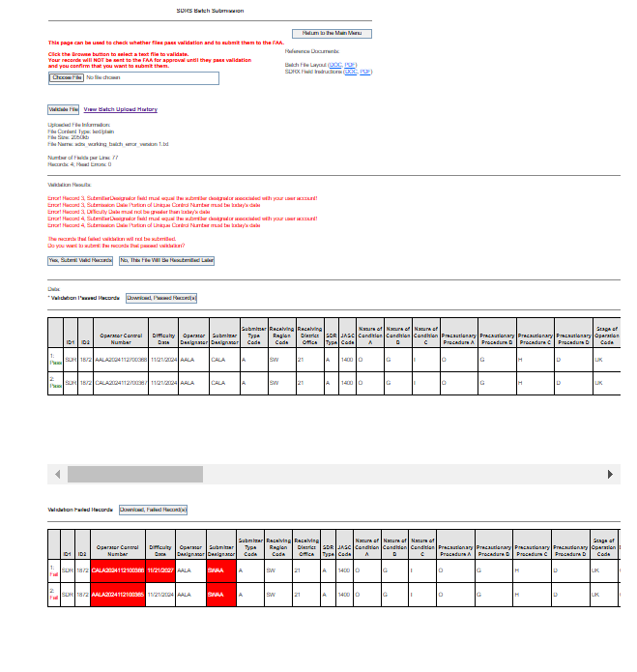
- Additionally,
  - Passed records are displayed in the top grid and
  - Failed records, in the bottom grid
- The Submitter user has the option to submit all the passed records for FAA to review.
- Click on “Yes, Submit Valid Records” for submission to FAA for review
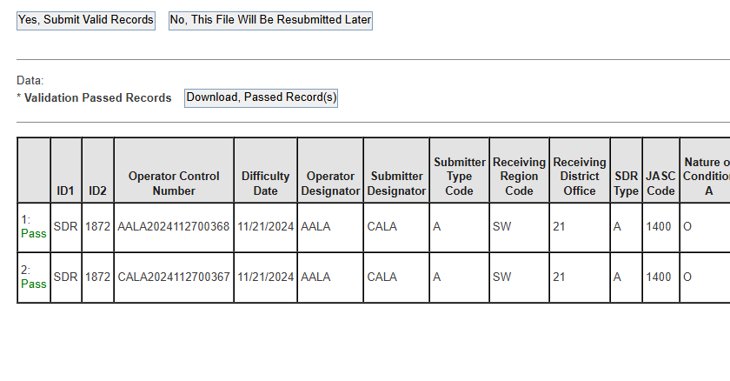
- Upon successful submission of the validated records -- a confirmation message in green with the records that were submitted successfully is displayed on the screen
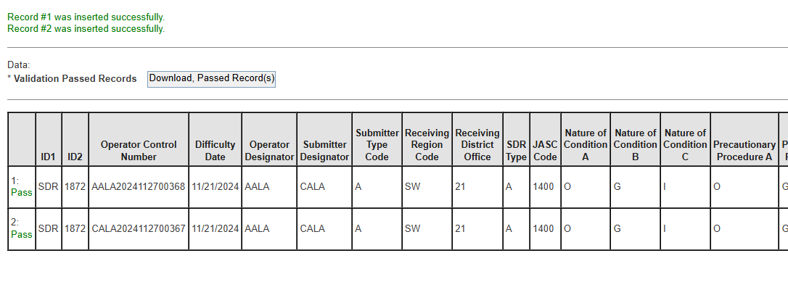
- To Validate the records were submitted successfully, navigate to the home page by selecting "Return to Main Menu" and then selecting SDRS by Status>> SDRS Status Submitted >> records that were submitted are displayed in the queue.
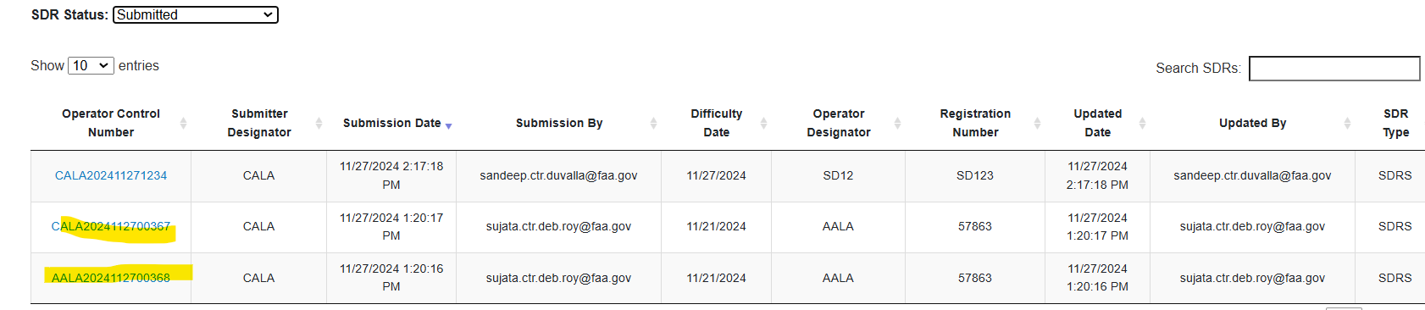

Checking Records That Failed Validation
The Submitter user can choose not to move ahead with the submission and instead correct the errors displayed on the failed records. In the event the Submitter decides to go that route, they need to navigate to the failed records grid.
- All items that failed validation are displayed in red for a quick review
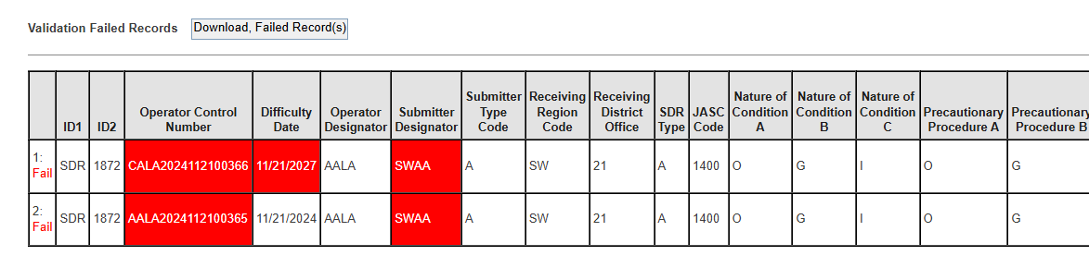
- Users can click on the Download Failed Records Button to download a txt copy of the failed records. See image as an example below.
They can update the records and resubmit the corrected data using the batch upload process

View Batch Upload History
Submitter Users can check the History of Batch Uploads they submitted. To check Batch Upload history, follow the steps below:
- To view Batch Upload history, click ‘View History’ link.

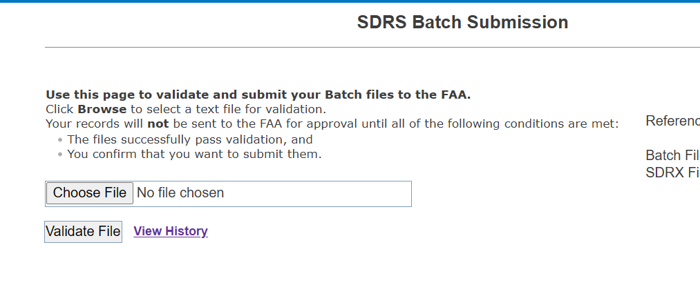
- Batch upload history page is displayed.
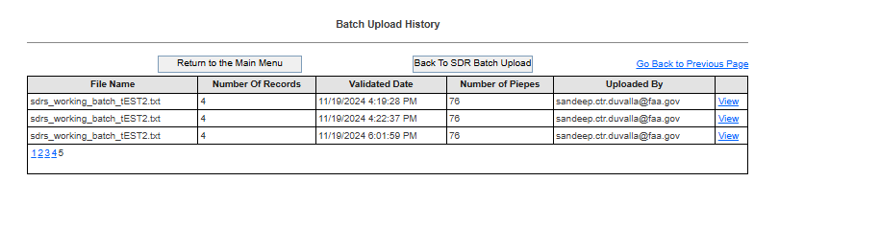
- Click on the ‘View’ link.
- The history page with all validations (records passed validation and records failed validation) is displayed to the Submitter User

Batch Submission for Supplemental Records
The User has the option to upload multiple SDR Supplemental Reports in a single transmission by using the Supplemental Batch Upload functionality in SDRS. Supplementals are corrections or data additions to existing SDRS records.

Submitting a Supplemental Batch Upload
- Login to SDRS and navigate to the Home Page
- Click on the Supplemental Batch Upload link
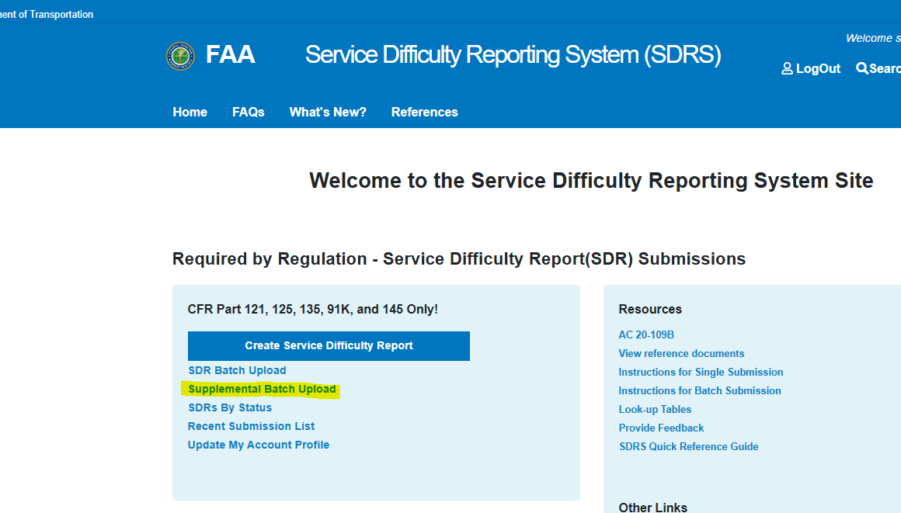
- The SDRS Supplemental Batch Upload screen is displayed
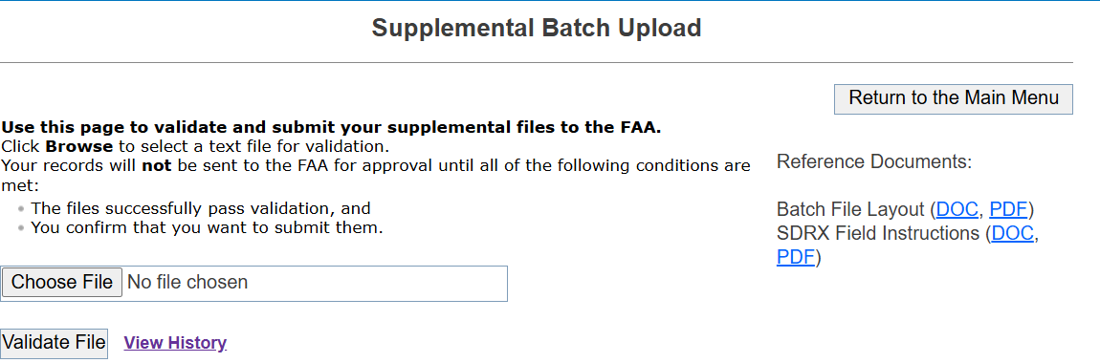
- Click ‘Choose File’ button and pick a batch file from the local C/drive or wherever the batch file is saved
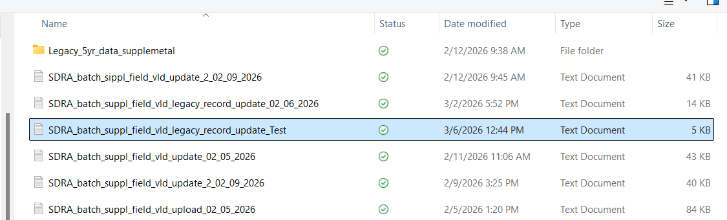
- Note: User must ensure that the Unique Control numbers# in the upload file match SDRS records for which they want to submit Supplementals
- After choosing the file to upload, click "Validate File" button.
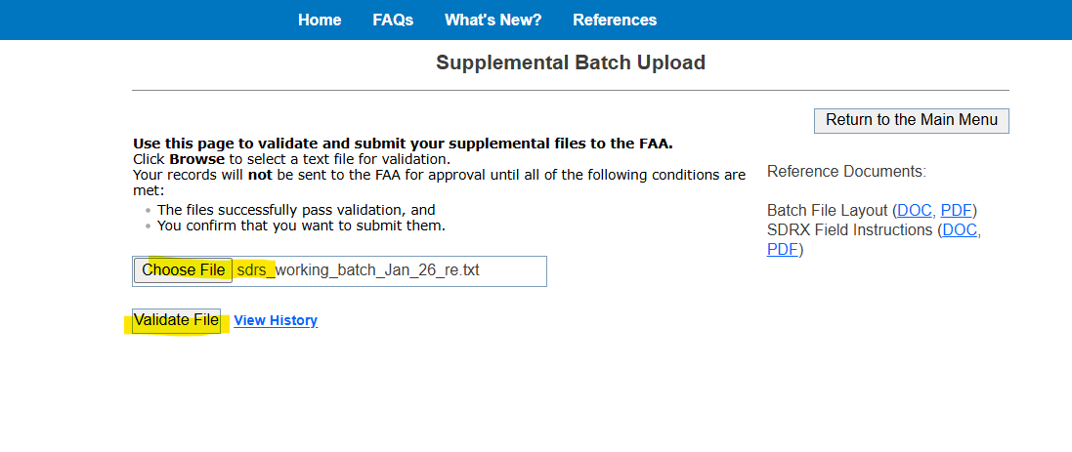
- Validation results are displayed, listing all validation errors if any, at the top of the page
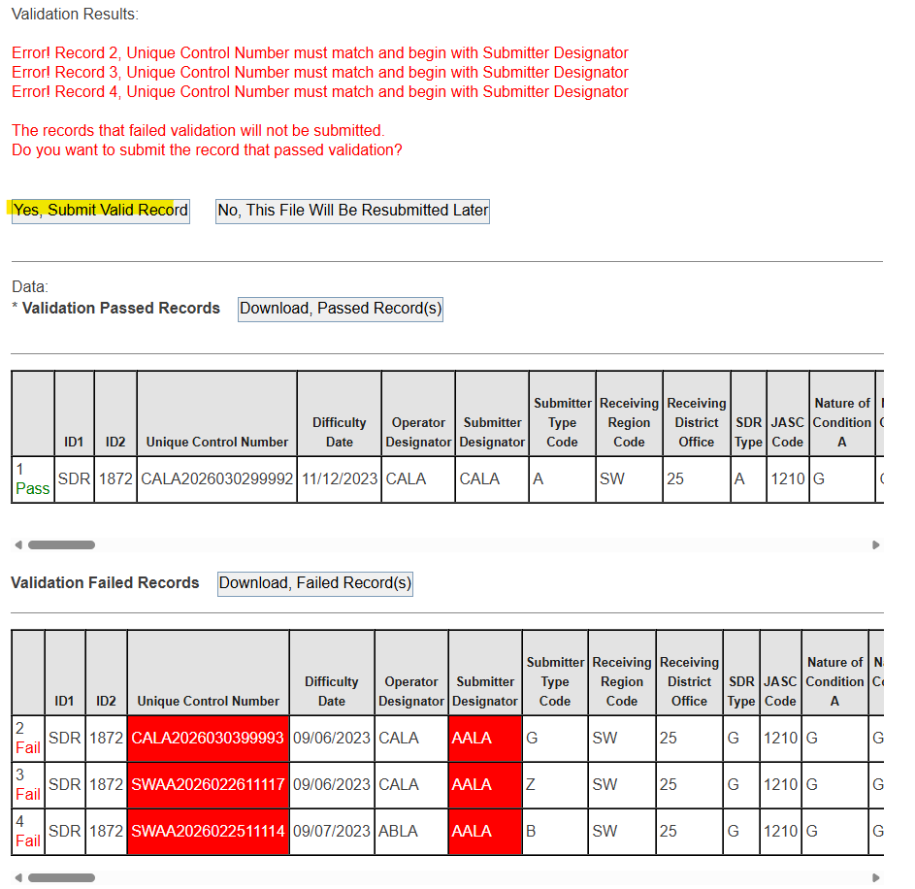
- Additionally,
  - Passed records are displayed in the top grid and
  - Failed records, in the bottom grid
- The Submitter user has the option to submit all the passed records for FAA to review.
- Click on “Yes, Submit Valid Records” for submission to FAA for review
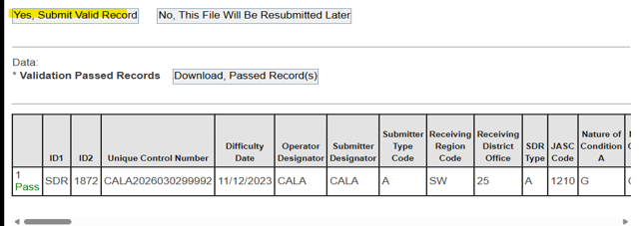
- Upon successful submission of the validated records -- a confirmation message in green with the records that were submitted successfully is displayed on the screen
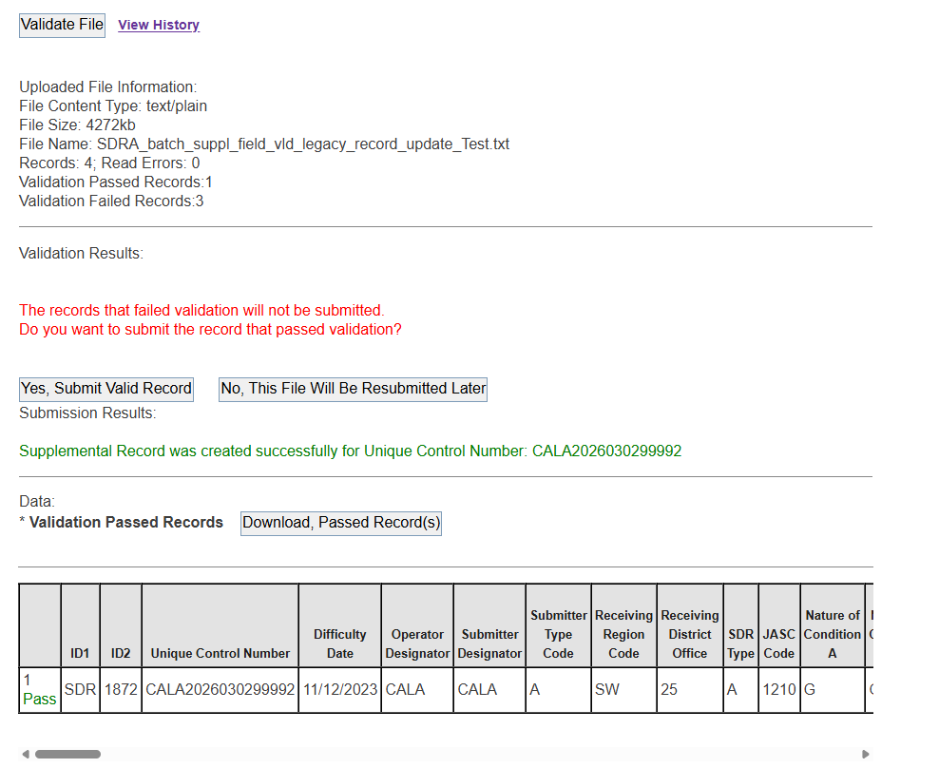
- To Validate the records were submitted successfully, navigate to the home page by selecting "Return to Main Menu" and then selecting SDRS by Status>> SDRS Status Submitted >> records that were submitted are displayed in the queue.
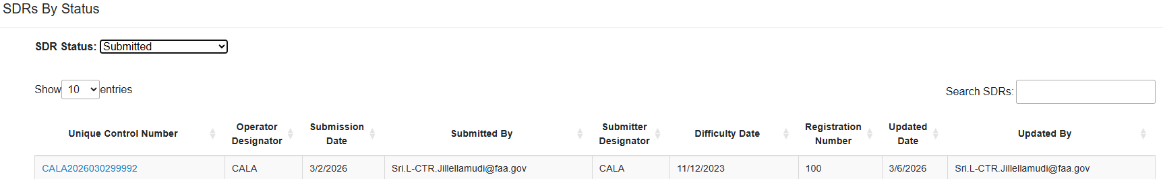

Checking Records That Failed Validation
The Submitter user can choose not to move ahead with the submission and instead correct the errors displayed on the failed records. In the event the Submitter decides to go that route, they need to navigate to the failed records grid.
All items that failed validation are displayed in red for a quick review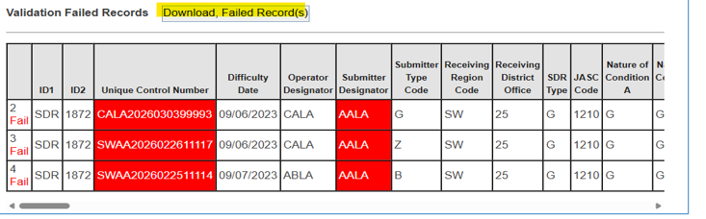
- Submitter Users can click on the Download Failed Records to Button to download a txt copy of the failed records. See image as an example below.
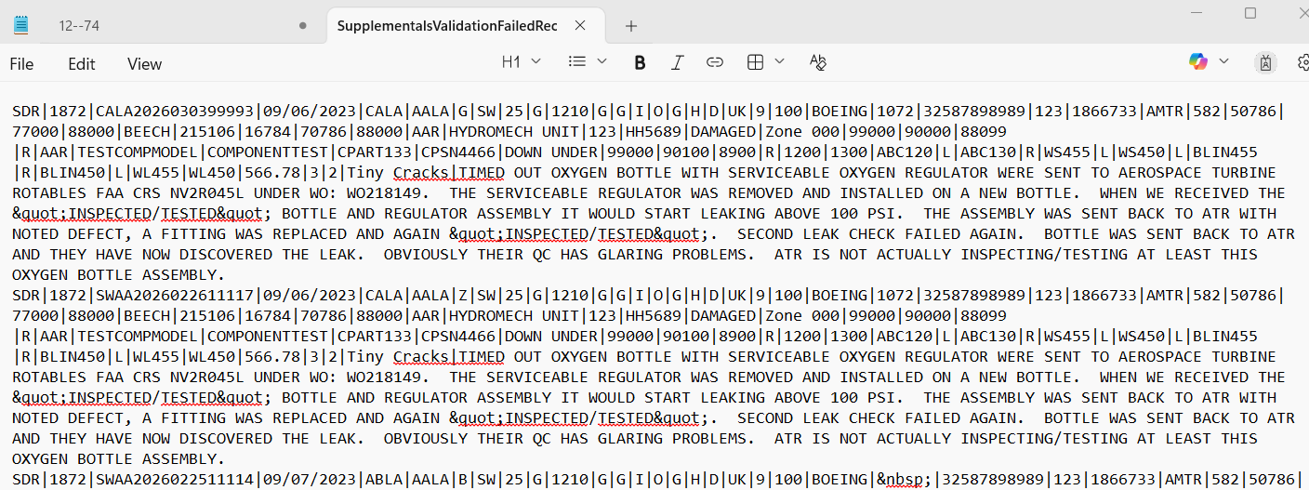
- They can update the records and resubmit the corrected data using the batch upload process

View Batch Upload History
Submitter Users can check the History of Supplemental Batch Uploads they submitted. To check Supplemental Batch Upload history, follow the steps below:
- To view Batch Upload history, click ‘View History’ link.
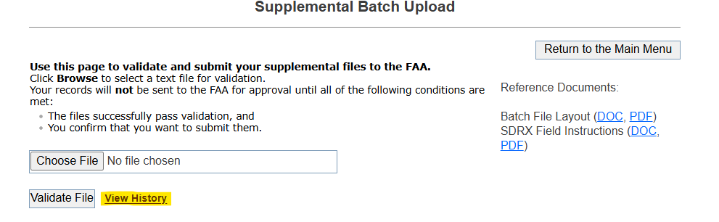
- Upload history page is displayed

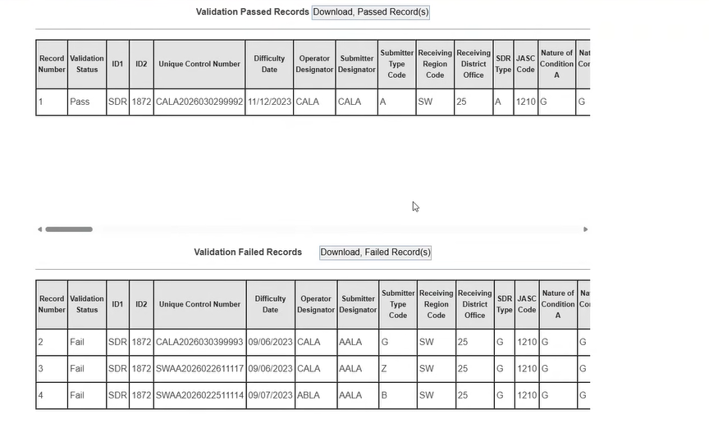
- The history page displays all records with all validations (records passed validation and records failed validation)

