
FAA
Aviation Safety
Quality, Integration, & Executive Service
Information Technology Division

Service Difficulty Reporting System /SDRS

User Manual
Version 1.5
3/17/2026
Prepared by: Karsun Solutions

Table of Contents
1. Introduction 1
1.1 Overview 1
2. SDRS System Roles Description 2
2.1 SDR Admin User 2
2.2 QC Tool User 2
2.3 Submitter User 3
2.4 Oversight Role User 3
3. Registering For SDRS Access 4
3.1 ADMIN User / QC Tool User 4
3.2 Oversight User 5
3.3 Submitter User 6
4. Accessing the Application and Landing Page 7
4.1 ADMIN User view 7
4.2 QC Tool User view 7
4.3 Submitter User View 8
4.4 Oversight User View 8
5. SDRS Features and Submitter User Functions 10
5.1 Submitter Dashboard 10
5.1.1 SDR Status 11
5.2 Submitting a SDR Report 19
5.2.1 Submitter Information 21
5.2.2 Codes 21
5.2.3 Major Equipment Identity 23
5.2.4 Problem Description 24
5.2.5 Specific Part or Structure Difficulty 24
5.2.6 Component/Assembly That Includes Defective Part 25
5.3 Submitting M Or D Report 28
5.3.1 Submitter Information 29
5.3.2 Codes 30
5.3.3 Major Equipment Identity 32
5.3.4 Problem Description 32
5.3.5 Specific Part or Structure Causing Difficulty 33
5.3.6 Component/Assembly That Includes Defective Part 34
5.3.7 Submitted By 35
5.4 Batch Upload SDR Report 36
5.4.1 Submitting a Batch Upload 36
5.4.2 Checking Records That Failed Validation 40
5.4.3 View Batch Upload History 41
5.5 Batch Upload Supplemental Records 42
5.5.1 Submitting a Supplemental Batch Upload 42
5.5.2 Checking Records That Failed Validation 45
5.5.3 View Batch Upload History 46
6. SDRS Features and Oversight User Functions 48
6.1 Submitting M Or D Report 48
6.1.1 Submitter Information 50
6.1.2 Codes 51
6.1.3 Major Equipment Identity 52
6.1.4 Problem Description 53
6.1.5 Specific Part or Structure Causing Difficulty 54
6.1.6 Component/Assembly That Includes Defective Part 55
6.1.7 Submitted By 56
6.2 Submitter Dashboard 57
6.2.1 SDR Status 58
7. SDR Admin User Registration Application Features - Quality Control Tool, Maintenance Tool Functions And User Management 66
7.1 User Management 67
7.1.1 Submitters 68
7.1.2 OKTA Registered Users 69
7.1.3 Unapproved Accounts 70
7.1.4 Administrators 74
7.1.5 QC Technical 74
7.1.6 QC Non-Technical 75
7.1.7 Oversight 75
7.1.8 FAA Inspectors 75
7.1.9 Deleted users 76
7.2 QC Tool 77
7.2.1 Awaiting QC 77
7.2.2 QC Work in Progress 79
7.2.3 Returned For Correction 80
7.2.4 Supplementals Received 81
7.2.5 Processed 82
7.3 Maintenance Tool 82
7.3.1 Edit SDR/ M or D 83
7.3.2 Edit Part Condition 84
7.3.3 Edit Part Name 86
7.3.4 Delete an SDR or M or D Report 88
7.3.5 Submitters Designator 89
7.4 Other Tools 91
7.4.1 Submission by User Per Month across the Designators 92
7.4.2 Reports 93
7.4.3 Submission Counts 98
8. Override Functionality 100
8.1 As a QC USER 100
8.2 As a Submitter 103

Introduction
This User Manual provides the information necessary for SDRS ADMIN Users, QC Users and Submitter Users to effectively use the SDRS System.
The SDR Application provides for Data Entry of SDR’s and Quality Checking existing SDR’s.
The Federal Aviation Administration (FAA) SDRS database contains records of mechanical malfunctions, defects, and failures on civil aviation aircraft. The aviation community submits these reports (via online portal, email, mail and fax) to the FAA whenever a system, component, or part of an aircraft, power plant, propeller, or appliance fails to function in a normal or usual manner. The objective of this program is to achieve the prompt correction of conditions that may adversely affect the continued airworthiness of aeronautical products. To accomplish this, Service Difficulty Reports (SDRs) are collected, stored, and made readily available to the appropriate segments of the FAA, aviation community, and public for review and analysis.

Overview
The purpose of this User Manual is to provide a single document that contains relevant system description information for interacting with the SDRS System.
This section addresses the following:
• What Is an SDRS? What constitutes a Service Difficulty Report? And how does it support an ecosystem for users of these reports.
• Users of the SDRS Application: Defines the different types of individuals who are part of this process, as well as their duties and responsibilities.

SDRS System Roles Description
The following roles will be available within the SDRS (Service Difficulty Reporting System) application for submitting, viewing, and processing submitted Service Difficulty Reports (SDR) and Malfunctional or Defect Reports (M or D’s)
- SDRS Internal User Roles
  - ADMINISTRATOR
  - QC TECHNICAL
  - QC NON-TECHNICAL
- SDRS External Users Roles:
  - SUBMITTER
  - OVERSIGHT

SDR Admin User
An SDRS ADMIN User role has access to everything in the module – User Management, Maintenance Tool, QC Tool and Other tools. An ADMIN User can complete the full QC process without having to switch roles to perform an end-to-end QC review and submission.
- Manage Internal/External users (Add/Update/Delete)
- Update/Delete SDR records from Production
- Update lookup tables
  - Part Name
  - Part Condition
- Run the following reports:
  - Run Submission Counts Report
  - SDRS Submission by User Per Month across the Designators
  - Run reports by Status

Note: The ADMIN User can do full QC, however that functionality will be addressed under QC Technical Role
Note: User Administration is restricted to the ADMIN User

QC Tool User
A QC Tool User has access to just the QC Tool Tab. There are two roles defined for the QC Tool User:

2.2.1 QC Technical
- Has access to look at the entire record.
- Process the SDR or M or D Submission and can Save them to production
- Run reports by status

2.2.2 QC Non-Technical
- Has access to look at the entire record.
- Process SDR reports and Save them for further technical evaluation
- Look at Submitter Information, JASC Codes, Major Equipment Identity, Component/Assembly That Includes Defective Part, and the Problem Description Sections.

Note: Non-Technical role only reviews records and saves them for Technical QC Role to review and submit to the Production SDRS tables.

Both Users will see the same landing page. However, someone in the QC Non-Technical role will not be able to finish the workflow of submitting the SDRS to the Production Table.
The Non-Technical QC review needs to be done first.

Submitter User
The Federal Aviation Administration receives Service Difficulty Reports (SDRs) from Submitters. The Submitters will have following user functions.

- Create a new SDR.
- Create a new M Or D report
- Query a specific Processed SDR and M or D by criteria.
- SDR Batch Upload
- Supplemental Batch upload
- Dashboard View
- Ability to view SDR’s by status.
- Ability to search by criteria.
- Ability to initiate supplemental.
- Ability to see Recent Submission List

Oversight Role User
Supervisory role, can see all different SDRs that were submitted for a designator
- Add a new M Or D report.
- Dashboard View
- Ability to view SDRs by status.
- Ability to search by criteria.
- Ability to see Recent Submission List
  - Note: Since the Oversight role can only Submit M or D reports, their submission list will consist of M Or D Submissions.
  - Additionally, they should be logged into the SDRS application during the submission process to see the record on the Recent Submission List
- Search All Processed reports on external page.

Registering For SDRS Access
To access SDRS application users will need to register for the application. The Registration page has a few different elements depending on the role that is assigned to the user.

ADMIN User / QC Tool User
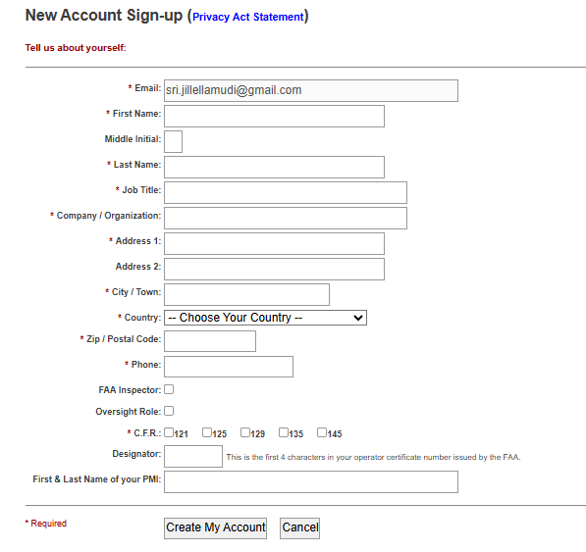

Oversight User
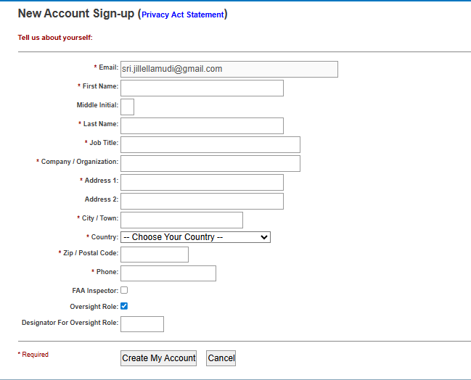

Submitter User
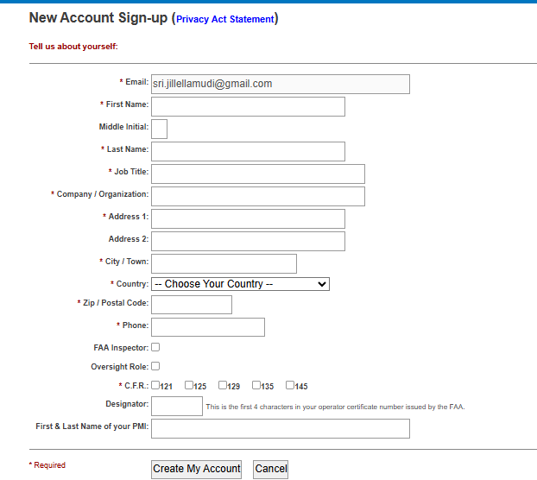

Accessing the Application and Landing Page
- To access the ADMIN Site, Users will click on the SDRS Internal Site link: https://sdradm.faa.gov

- To access the External Site, User will click on the SDRS External Site link:
https://sdrs.faa.gov/

Depending on the User’s role they will see different pages upon login.

ADMIN User view
The ADMIN user will see the following screen upon login:
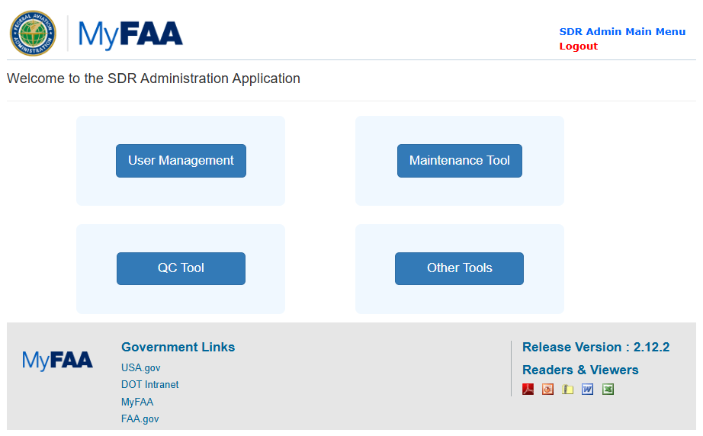

QC Tool User view
The QC Technical or Non-Technical user will see the following screen upon login:
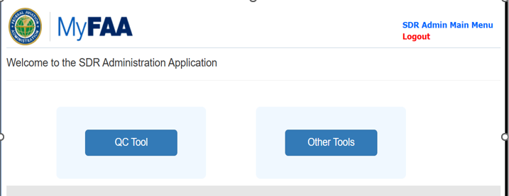

Submitter User View
Submitter users upon login will see the following screen:

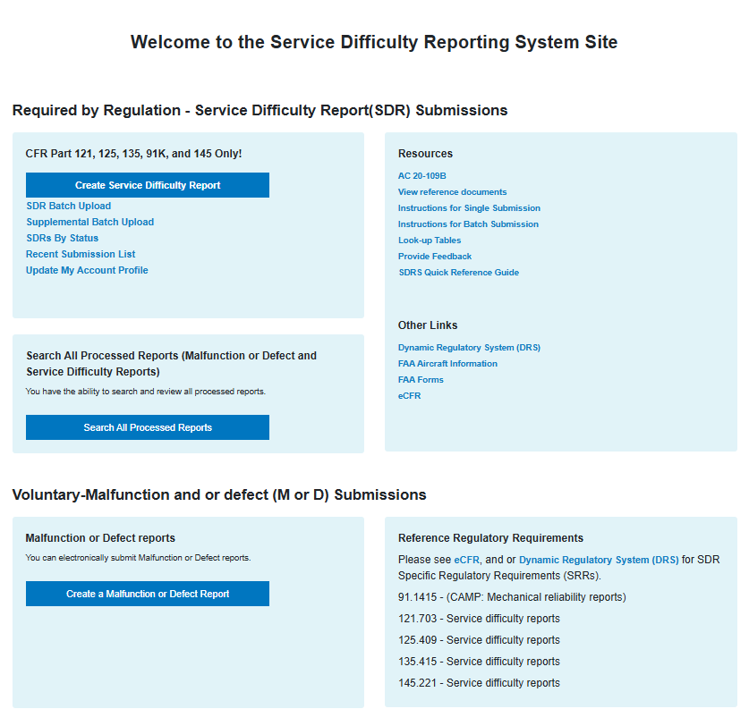

Oversight User View

The Oversight user will see the following screen upon login:

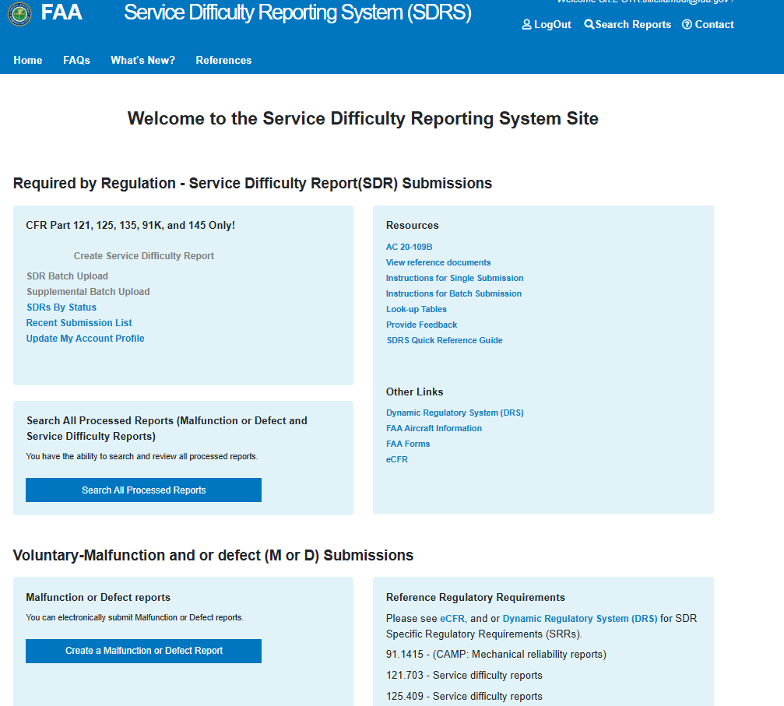

SDRS Features and Submitter User Functions
The Federal Aviation Administration receives two type types of report
- Service Difficulty Reports (SDR)
- Malfunction or Defect Reports (M or D)

The following is a list of Submitter user functions.

- Dashboard View
- Ability to view SDR’s by status and take actions.
- Query a specific SDR by criteria.
- Ability to search processed SDRS records by criteria.
- Ability to view recent submission list
- Add a new SDR – Service Difficulty Report
- Add a new M Or D Report
- Batch Upload SDR.
- Supplemental Batch Upload
- Initiate supplemental.

Submitter Dashboard
As a Submitter, select SDR’S By Status to see the status of the submitted records.
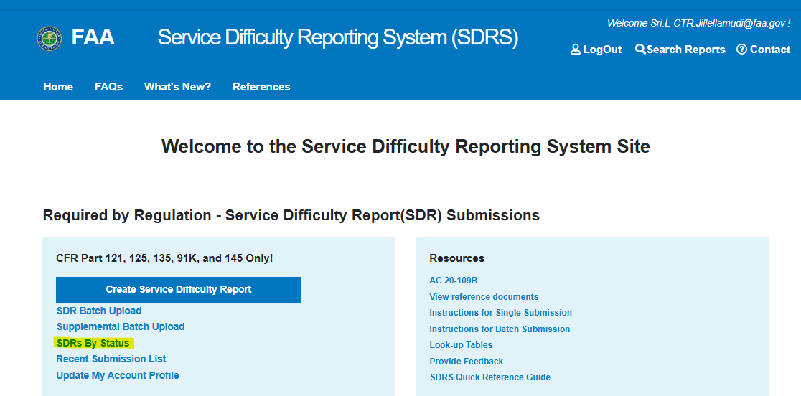

Upon licking the “SDRs By Status” the SDR Status Dashboard is displayed.
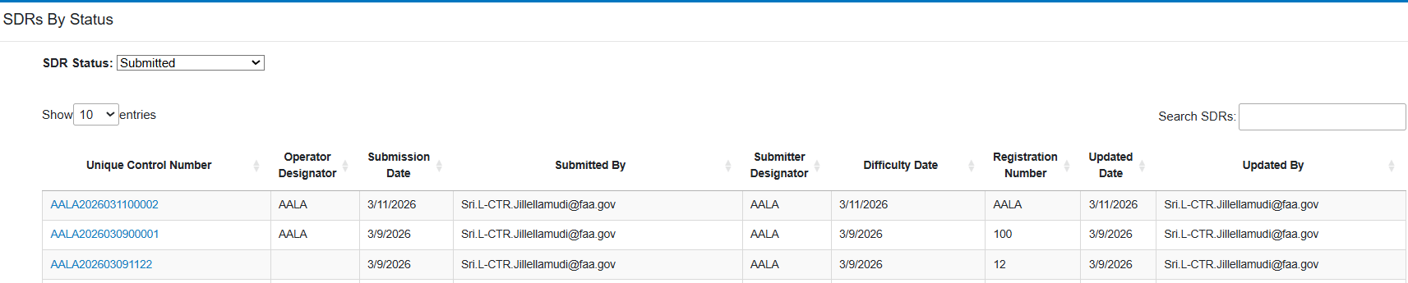

SDR Status

Submitted
- Click SDR Status dropdown, select Submitted option.
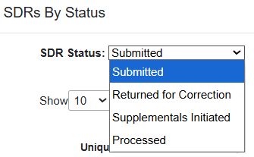
- Submitted SDR’s list is displayed

- Enter any search criteria on ‘Search SDRS’ field
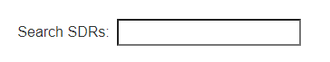

- Select Unique Control Number to navigate to review SDR form. This page opens in read only mode
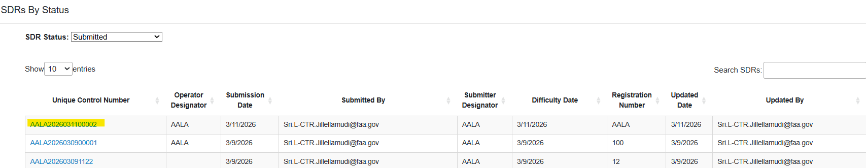
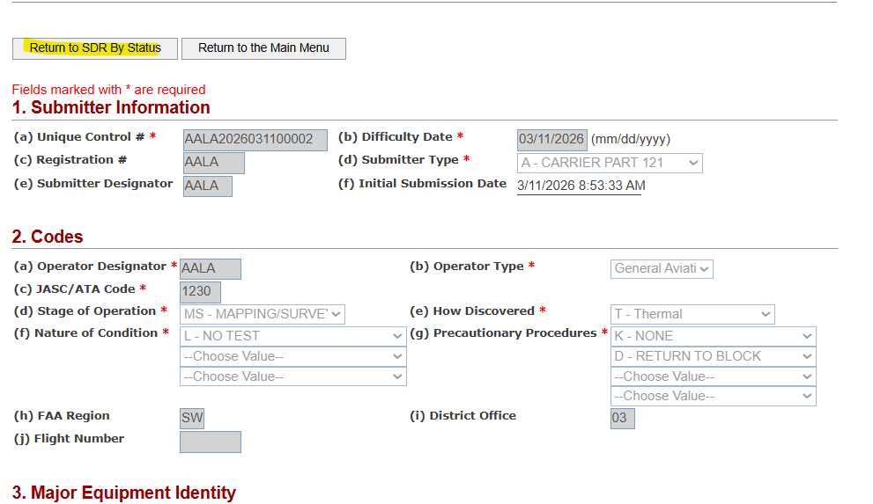
- Select ‘Return to SDR By Status’ to navigate back to main page.
Note: User has the option to return to main page

Returned for Correction
- Click SDR Status dropdown, select Return for Correction option.
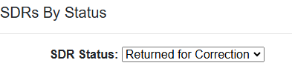
- SDR’s that have been returned for correction are displayed

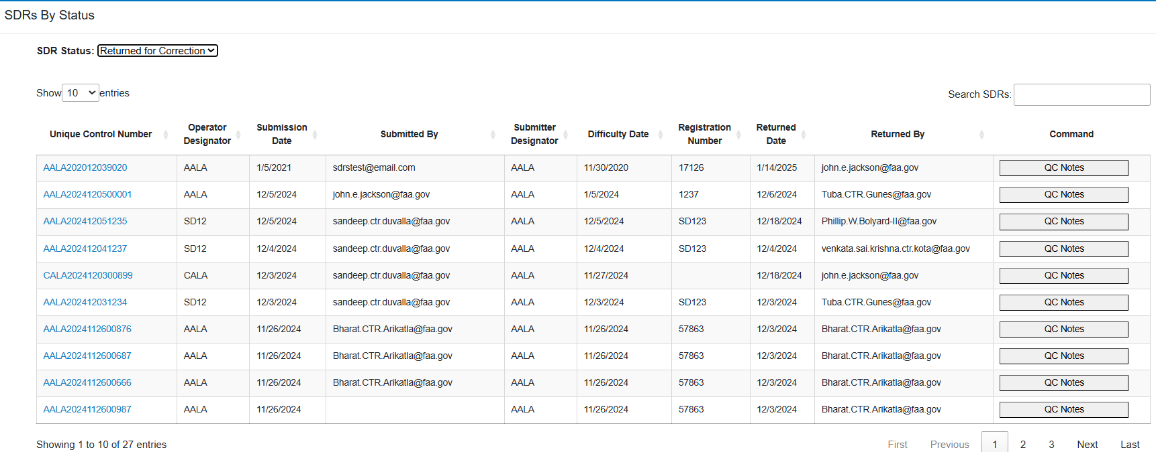
- Enter any search criteria on ‘Search SDRS’ field
- Select Unique Control Number to navigate to review the SDR form. This page opens in read only mode

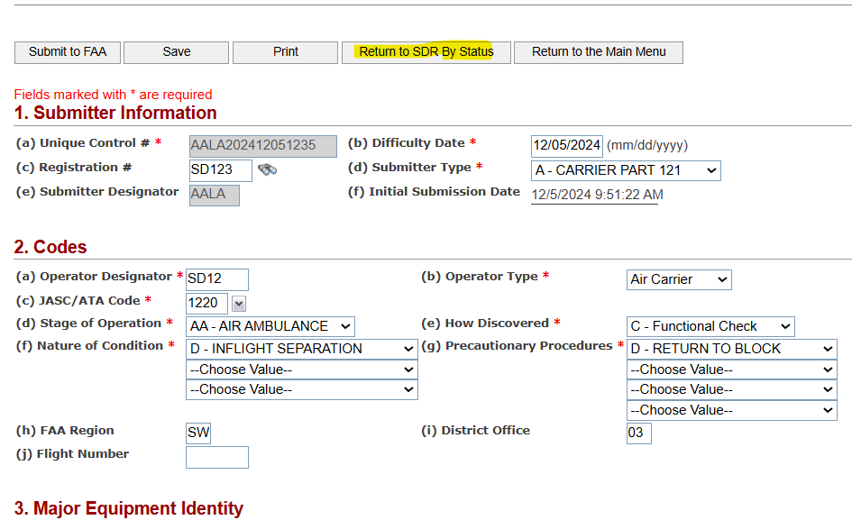

Supplementals Initiated
- Click SDR Status dropdown, select Supplemental Initiated option.
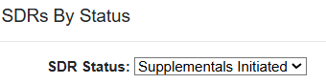
- All SDR’s for which Supplementals have been initiated are displayed

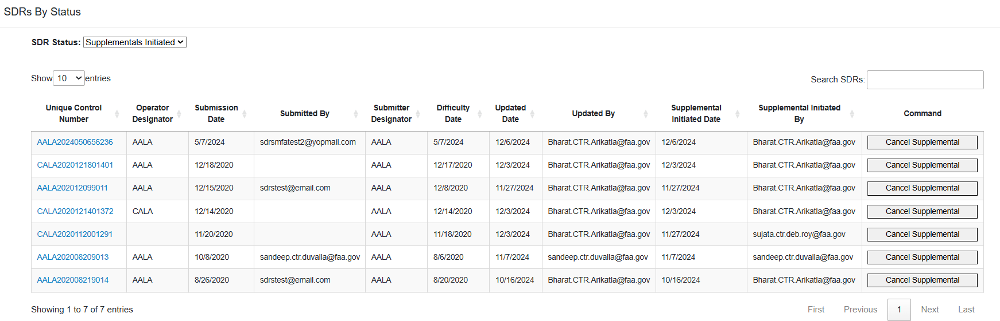
- Select Unique Control Number to navigate to review SDR form. This page opens in read only mode
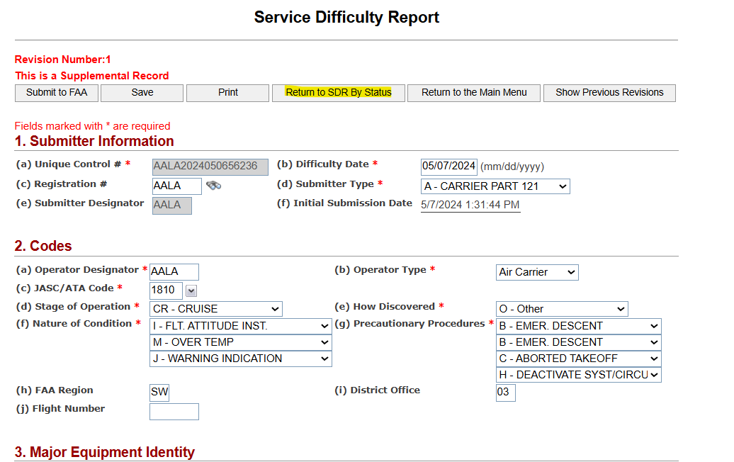

- Select ‘Return to SDR By Status’ to navigate back to main page.
- Note: User has the option to return to main page

Processed
- Select ‘Processed’ from the SDR Status dropdown field.

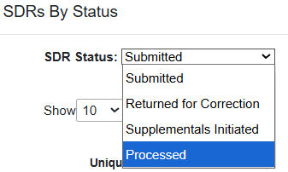
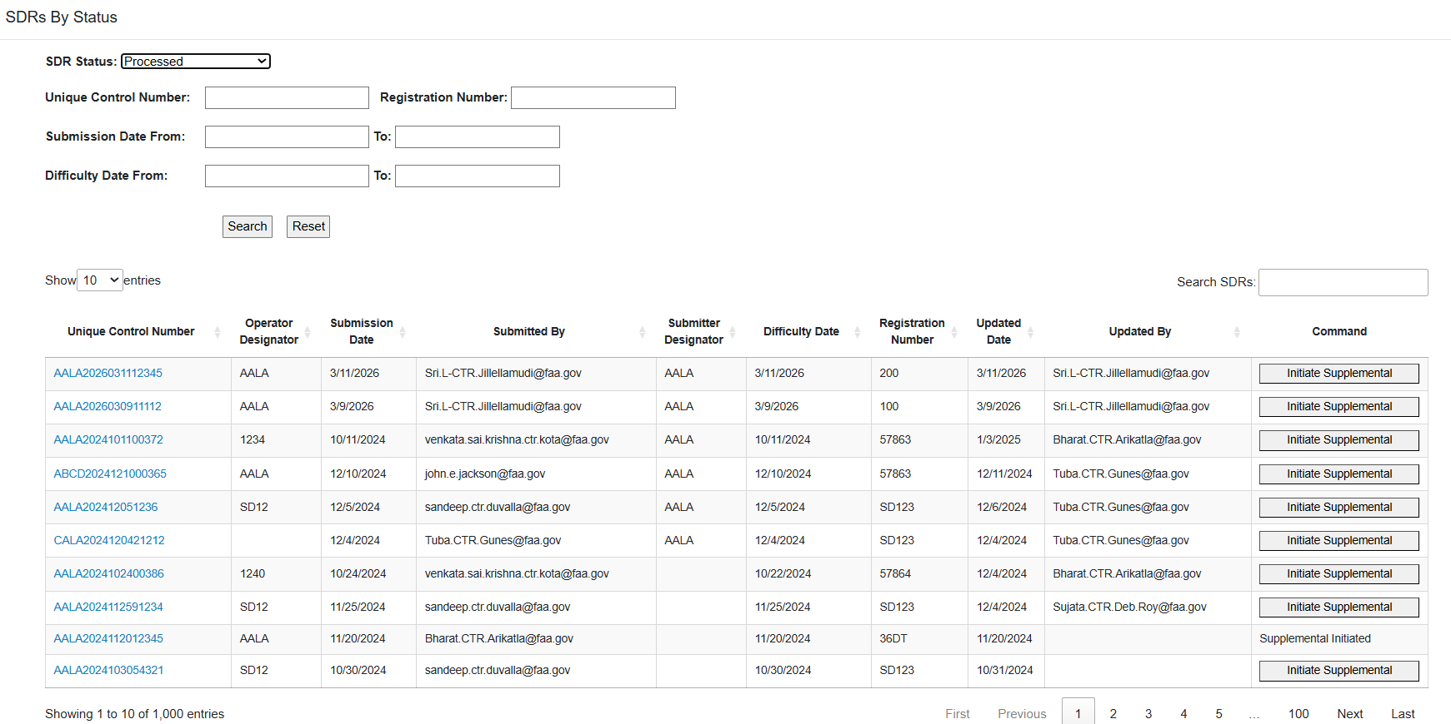
- To do a selected search -- enter additional search criteria on the available fields.
To initiate a Supplemental, select ‘Initiate Supplemental’ under Command column
- Select ‘Ok’ on the warning message, User will have an option to select cancel to cancel Supplemental initiation.
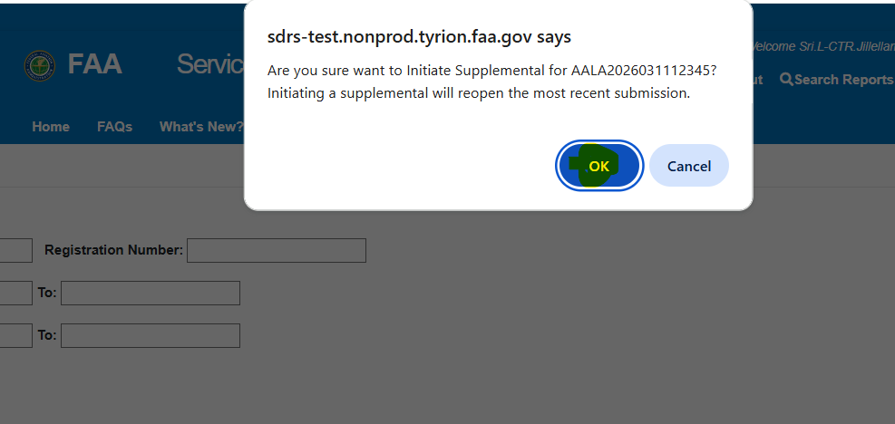
- Supplemental Record Form is displayed; User will have an option to:
- Edit the form by updating any open fields.
- Save the changes.
- Print the form.
- Return to SDR By Status Page
- Return to the Main Menu
- Show previous revisions.
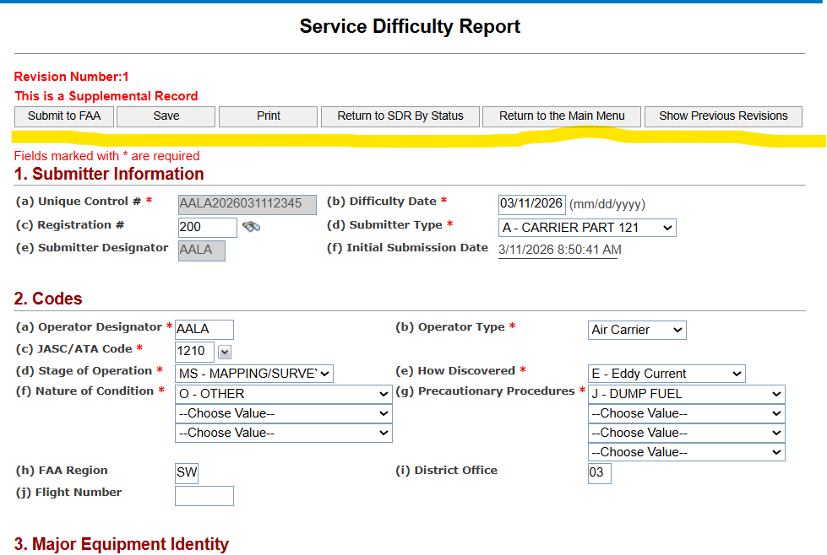
- Select ‘Show Previous Revisions” to see all the previous revisions made to the report. Click ‘Unique Control Number’ hyperlink to see the details.
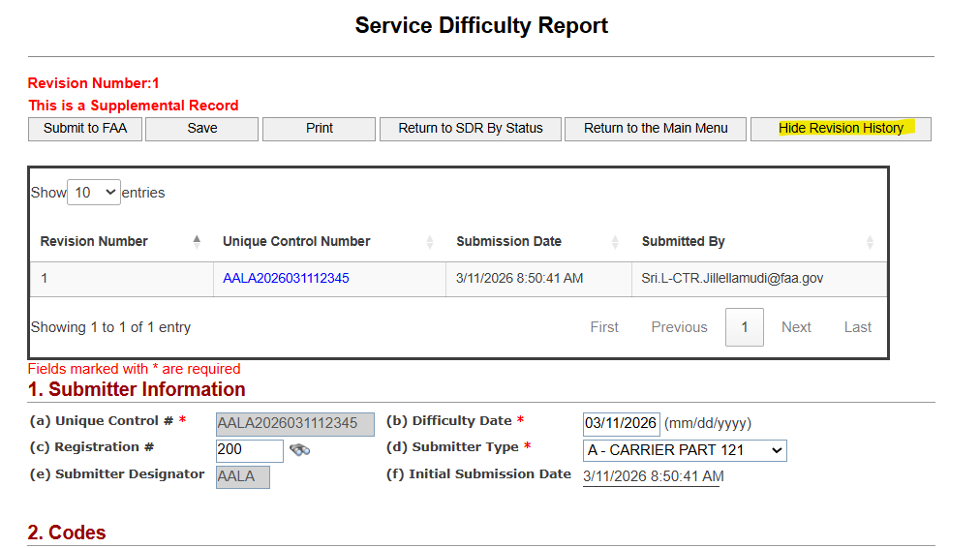
Select ‘Submit to FAA’ to submit supplemental report

Submitting a SDR Report
As a Submitter, click on the Create Service Difficulty Report tab/button. 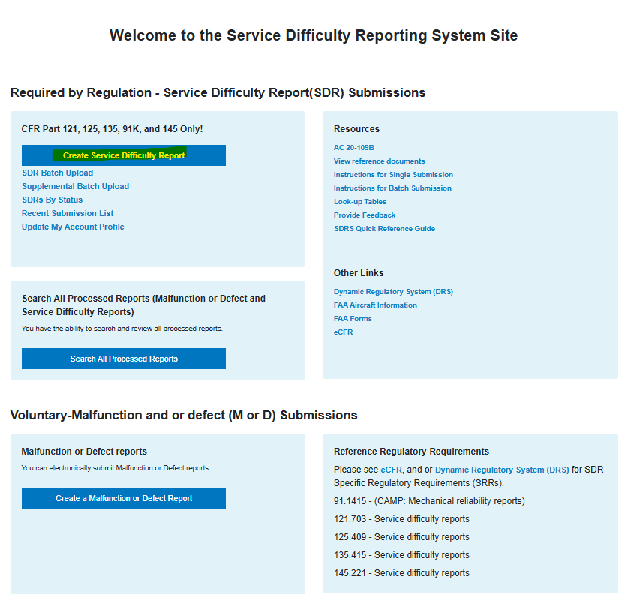

Create Service Difficulty Report Form is displayed.
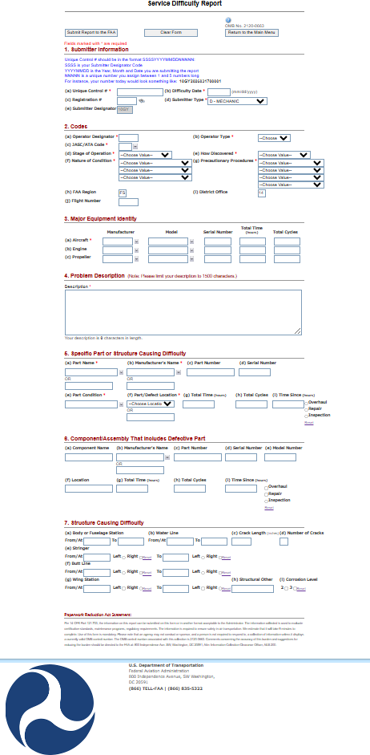

Submitter Information
This section allows data entry of SDR’s. To complete this section, all required information must be filled in.
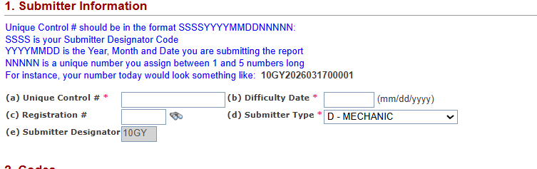

Submittal Information Fields
Field | Description | Required
Unique Control # | Unique control number | Required
Difficulty Date | Date on which the service difficulty occurred. Should be in the “mm/dd/yyyy” format | Required
Registration # | Registration number associated with the aircraft on which the difficulty occurred | Optional
Submitter Type | Code indicating the type of person/organization that is submitting this report. Select from Look-Up Table. | Required
Submitter Designator | Designator assigned to user by the FAA; Cannot be changed. | Driven by the Submitter Type

Codes
This section allows submitter to fill in codes related information. To complete this section, all required information must be filled in.
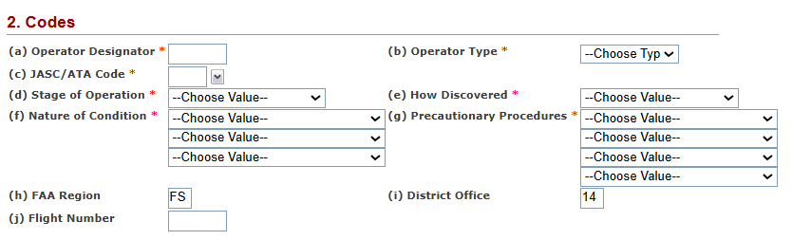

Codes Fields
Field | Description | Required
Operator Designator | The designator code assigned to the operator that you are submitting for | Required
Operator Type | Indicate whether your operator is an Air Carrier or is General Aviation | Required
JASC/ATA Code | A four-digit JASC code to indicate the type of difficulty that occurred | Required
Stage of Operation | Choose a code from the Look-up table to indicate at what stage the difficulty occurred. | Required
How Discovered | Choose a code from the Look-up table to indicate how the difficulty was discovered. | Required
Nature of Condition | Choose up to three codes from the drop downs to describe the nature of the difficulty’s condition | Required: First One Only
Precautionary Procedures | Choose up to three codes from the Look-Up Table to describe any procedures followed once the difficulty was discovered. | Required: First One Only
FAA Region | Enter your FAA region | Optional
District Office | Enter your certificate holding office | Optional
Flight Number | You may provide the flight number on which the difficulty occurred | Optional

Major Equipment Identity
This section allows submitter to supply information for each major equipment’s (Aircraft, Engine, and Propeller. To complete this section, all required information must be filled in.
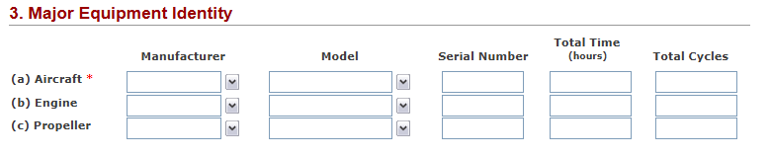

Major Equipment Identity Fields
Field | Description | Required
Manufacturer | The manufacturer of the equipment | Required if JASC Code is 7000-9000; unless it is a Repair station
Model | The model of the equipment | Required if JASC Code is 7000-9000; unless it is a Repair station
Serial Number | The serial number associated with the equipment | Required
Total Time | The total time of the equipment in hours | Optional
Total Cycles | The total cycles of the equipment | Optional
Propeller Make | The make of the propeller | Optional; required if the JASC Code is 6100 - 6199
Propeller Model | The model of the propeller | Optional; required if the JASC Code is 6100 - 6199

Problem Description
This section allows submitter to Provide a description of the problem that is occurring. To complete this section, all required information must be filled in.

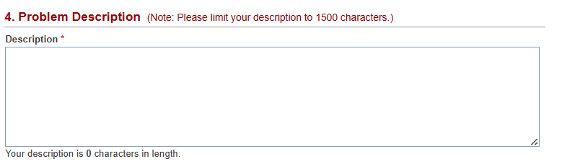

Problem Description Fields
Field | Description | Required
Description | Provide a description of the problem that is occurring | Required

Specific Part or Structure Difficulty
This section allows submitter to supply information for each part or structure that is causing difficulty. To complete this section, all required information must be filled in.
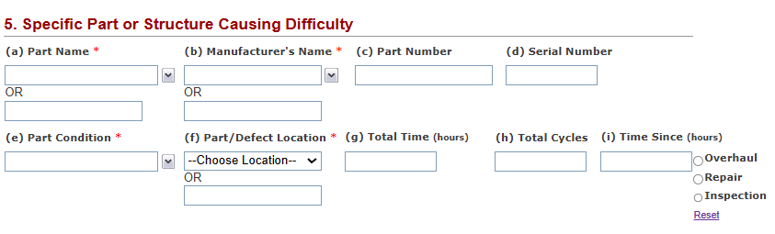

Specific Part or Structure Causing Difficulty Fields

Field | Description | Required
Part Name | This is the name of the part as defined by the manufacturer | Required
Manufacturer’s Name | This is the name of manufacturer who made the part. | Required
Part Number | The part number as defined by the manufacturer | Optional
Serial Number | The serial number of the part as defined by the manufacturer | Optional
Part Condition | The condition that the part is in | Required
Part/Defect Location | The placement of the part | Required
Total Time | The total time of the part in hours | Optional
Total Cycles | The total cycles of the part | Optional
Time Since | The time since the last Overhaul, Repair, or Inspection in hours; also indicate if this period is since a Overhaul, Repair, or Inspection | Optional

Component/Assembly That Includes Defective Part
This section allows submitter to supply information for each component/assembly that includes defective part. To complete this section, all required information must be filled in.
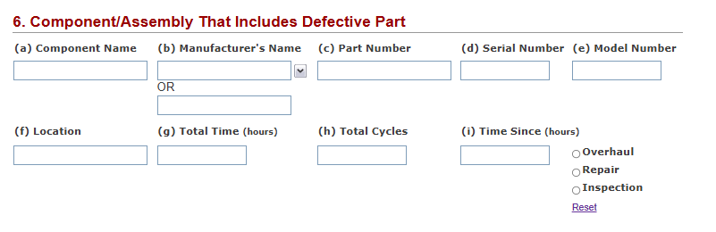

Component/Assembly That Includes Defective Part Fields
Field | Description | Required
Component Name | This is the name of the component as defined by the manufacturer. | Optional, Yes; conditionally— “is required if the ComponentPartNumber is entered
Manufacturer’s Name | This is the name of manufacturer who made the component. | Optional, Yes; conditionally— “is required if the ComponentPartNumber is entered
Part Number | The part number of the component as defined by the manufacturer. | Optional
Serial Number | The serial number of the component as defined by the manufacturer | Optional
Model Number | The model number of the component. | Optional
Location | The location of the component that had the difficulty. | Optional
Total Time | The total time of the component in hours. | Optional
Total Cycles | The total cycles of the component | Optional
Time Since | The time since the last Overhaul, Repair, or Inspection in hours; also indicate if this period is since an Overhaul, Repair, or Inspection. | Optional
- - Use to clear the selection of an Overhaul, Repair, or Inspection.

Submitting M Or D Report
Select ‘Create a Malfunction or Defect Report.
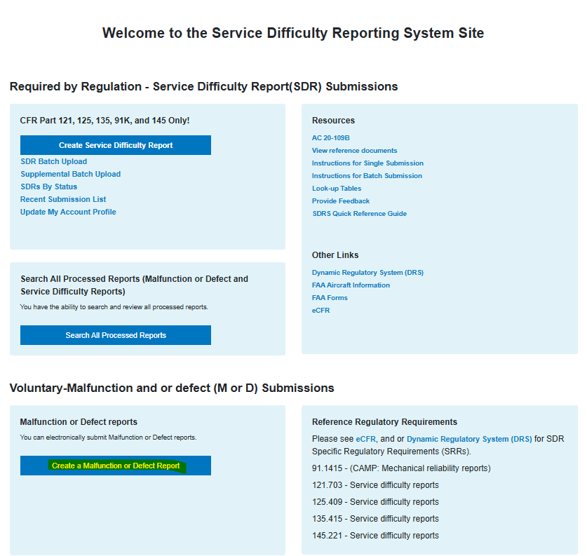
Malfunction or Defect Report is displayed.
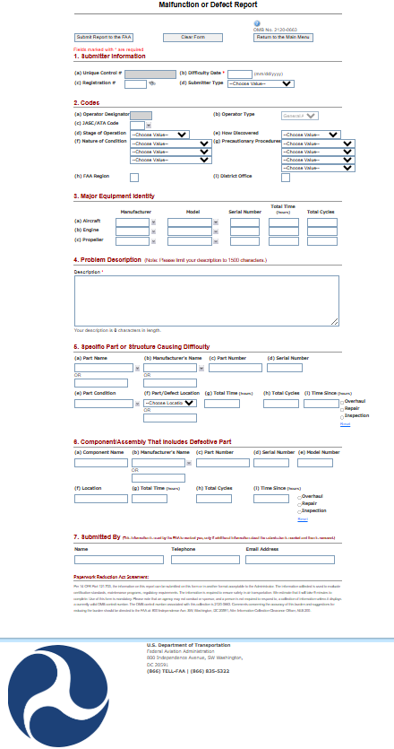

Submitter Information

This section allows submitter to fill in submitter information. To complete this section, all required information must be filled in.
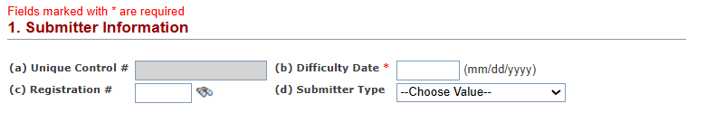

Submittal Information Fields
Field | Description | Required
Unique Control # | Auto- generated for M Or D when user clicks the ‘Submit Report to FAA’ button. | Required
Difficulty Date | Date on which the service difficulty occurred. Should be in the “mm/dd/yyyy” format | Required
Registration # | Registration number associated with the aircraft on which the difficulty occurred | Optional
Submitter Type | Code indicating the type of person/organization that is submitting this report. Select from Look-Up Table. | Optional

Codes
This section allows submitter to fill in codes related information. To complete this section, all required information must be filled in.
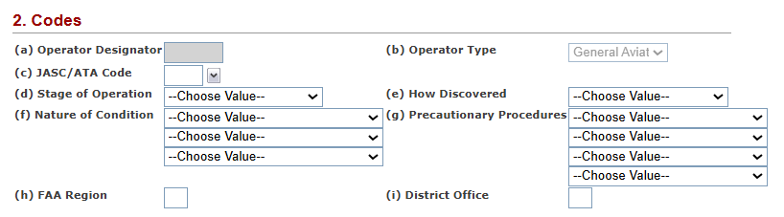

Codes Fields
Field | Description | Required
Operator Designator | The designator code assigned to the operator that you are submitting for | Optional
Operator Type | Indicate whether your operator is an Air Carrier or is General Aviation | Optional
JASC/ATA Code | A four-digit JASC code to indicate the type of difficulty that occurred | Optional
Stage of Operation | Choose a code from the Look-up table to indicate at what stage the difficulty occurred. | Optional
How Discovered | Choose a code from the Look-up table to indicate how the difficulty was discovered. | Optional
Nature of Condition | Choose up to three codes from the drop downs to describe the nature of the difficulty’s condition | Optional
Precautionary Procedures | Choose up to three codes from the Look-Up Table to describe any procedures followed once the difficulty was discovered. | Optional
FAA Region | Enter your FAA region | Optional
District Office | Enter your certificate holding office | Optional
Flight Number | You may provide the flight number on which the difficulty occurred | Optional

Major Equipment Identity
This section allows submitter to supply information for each major equipment’s (Aircraft, Engine, and Propeller. To complete this section, all required information must be filled in.
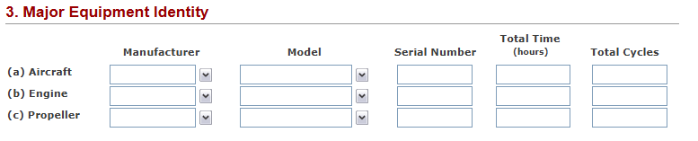

Major Equipment Identity Fields
Field | Description | Required
Manufacturer | The manufacturer of the equipment | Optional
Model | The model of the equipment | Optional
Serial Number | The serial number associated with the equipment | Optional
Total Time | The total time of the equipment in hours | Optional
Total Cycles | The total cycles of the equipment | Optional

Problem Description
This section allows submitter to Provide a description of the problem that is occurring. To complete this section, all required information must be filled in.

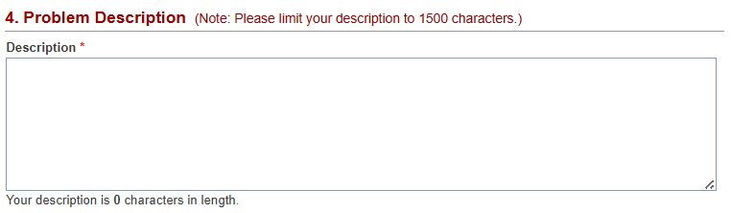

Problem Description Fields
Field | Description | Required
Description | Provide a description of the problem that is occurring | Required

Specific Part or Structure Causing Difficulty
This section allows submitter to supply information for each part or structure that is causing difficulty. To complete this section, all required information must be filled in.
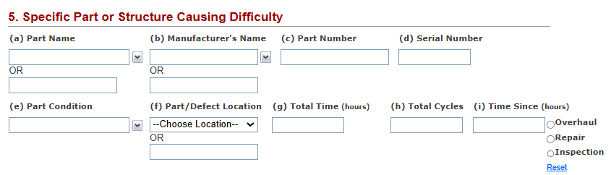

Specific Part or Structure Causing Difficulty Fields
Field | Description | Required
Part Name | This is the name of the part as defined by the manufacturer | Optional
Manufacturer’s Name | This is the name of manufacturer who made the part. | Optional
Part Number | The part number as defined by the manufacturer | Optional
Serial Number | The serial number of the part as defined by the manufacturer | Optional
Part Condition | The condition that the part is in | Optional
Part/Defect Location | The placement of the part | Optional
Total Time | The total time of the part in hours | Optional
Total Cycles | –The total cycles of the part | Optional
Time Since | The time since the last Overhaul, Repair, or Inspection in hours; also indicate if this period is since a Overhaul, Repair, or Inspection | Optional

Component/Assembly That Includes Defective Part
This section allows submitter to supply information for each component/assembly that includes defective part. To complete this section, all required information must be filled in.
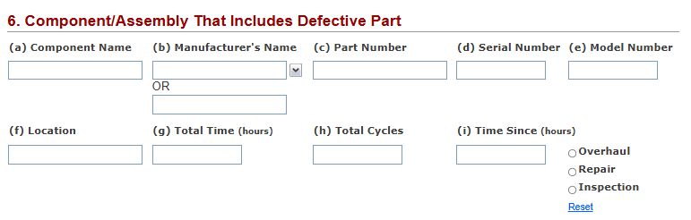

Component/Assembly That Includes Defective Part Fields

Field | Description | Required
Component Name | This is the name of the component as defined by the manufacturer. | Optional
Manufacturer’s Name | This is the name of manufacturer who made the component. | Optional
Part Number | The part number of the component as defined by the manufacturer. | Optional
Serial Number | The serial number of the component as defined by the manufacturer | Optional
Model Number | The model number of the component. | Optional
Location | The location of the component that had the difficulty. | Optional
Total Time | The total time of the component in hours. | Optional
Total Cycles | The total cycles of the component | Optional
Time Since | The time since the last Overhaul, Repair, or Inspection in hours; also indicate if this period is since an Overhaul, Repair, or Inspection. | Optional
- - Use to clear the selection of an Overhaul, Repair, or Inspection.

Submitted By
This section allows submitters to input their information.
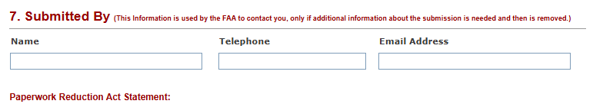

Submitted By Fields
Field | Description | Required
Submitted Name | This is the name of the submitter | Optional
Submitted Telephone | This is the Telephone Number of the submitter | Optional
Submitted Email | This is the Email of the submitter | Optional
- - Use to clear the selection of an Overhaul, Repair, or Inspection.

Batch Upload SDR Report
The Submitter User has the option to upload multiple SDR Reports in a single shot by using the Batch Upload Functionality in SDRS.

Submitting a Batch Upload
To submit Batch Upload, follow the steps below:
- Login to SDRS and navigate to the Home Page
- Once logged in, the SDR Batch Upload link will be visible
Click on the highlighted SDR Batch upload link
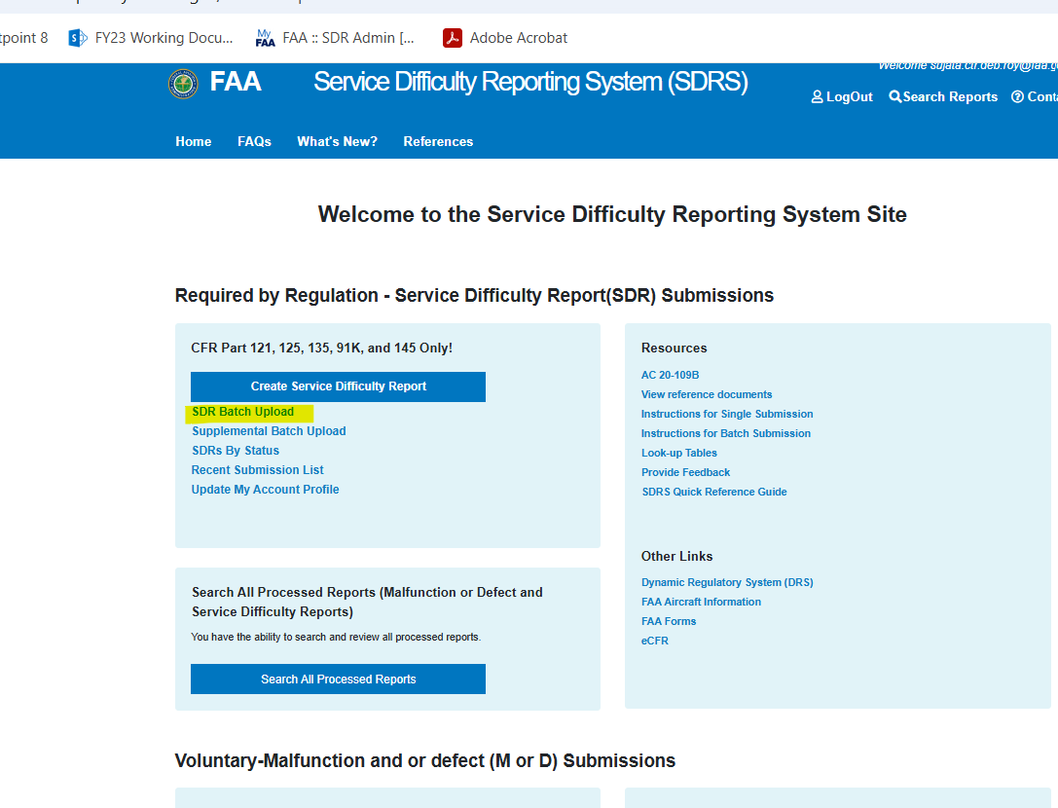
- The SDRS Batch Upload screen is displayed
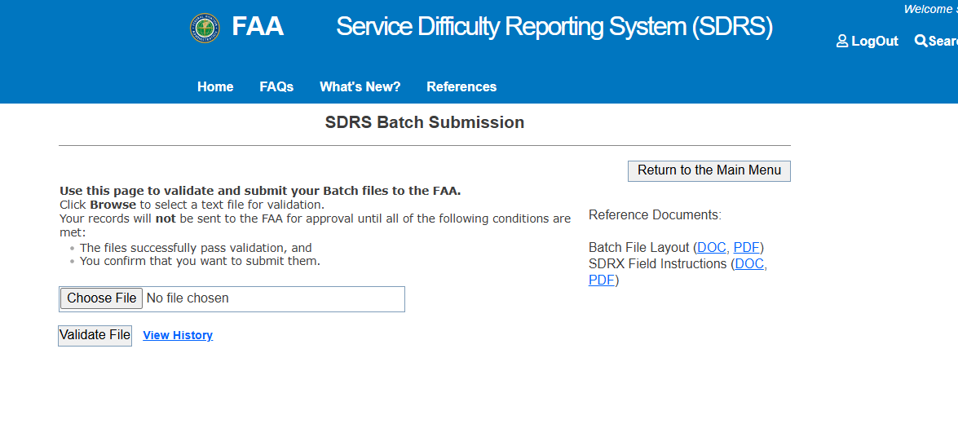
- Click ‘Choose File’ button and pick a batch file from the local C/drive or wherever the batch file is saved
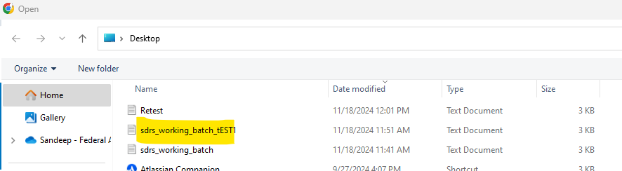
- After choosing the file to upload, select "Validate File"
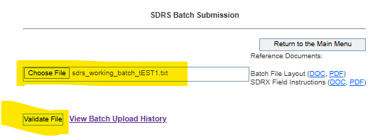
- Validation results are displayed, listing all validation errors if any, at the top of the page
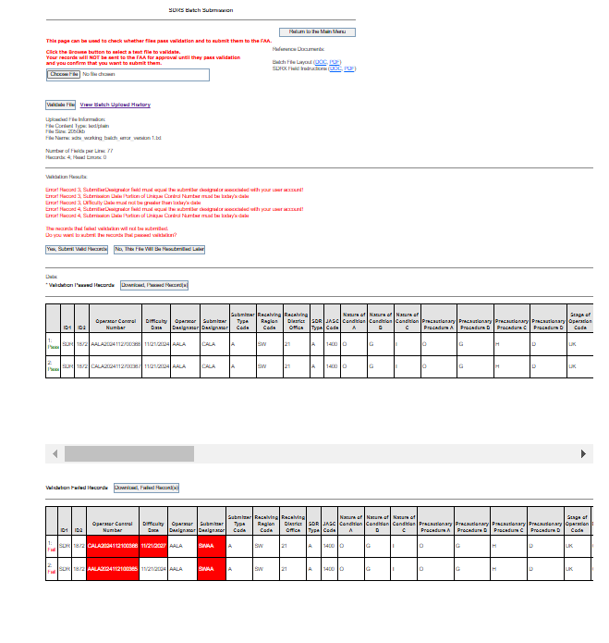
- Additionally,
  - Passed records are displayed in the top grid and
  - Failed records, in the bottom grid
- The Submitter user has the option to submit all the passed records for FAA to review.
- Click on “Yes, Submit Valid Records” for submission to FAA for review
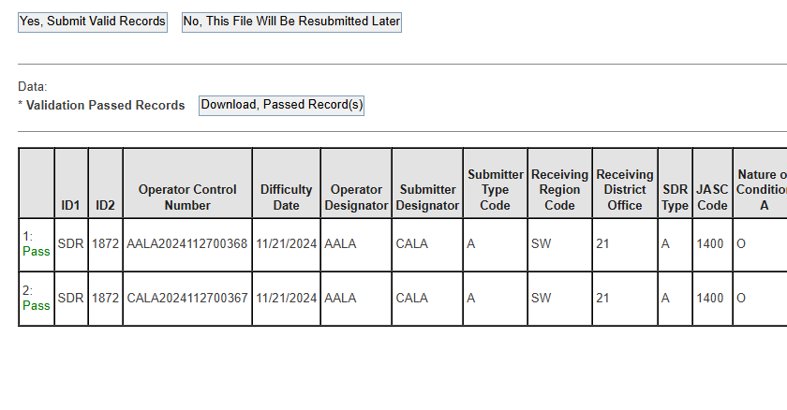
- Upon successful submission of the validated records -- a confirmation message in green with the records that were submitted successfully is displayed on the screen
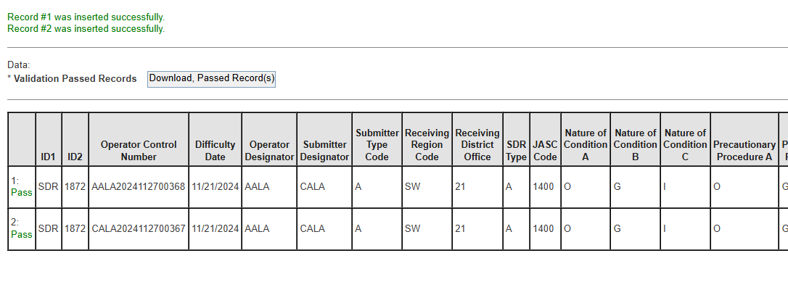
- To Validate the records were submitted successfully, navigate to the home page by selecting "Return to Main Menu" and then selecting SDRS by Status>> SDRS Status Submitted >> records that were submitted are displayed in the queue.
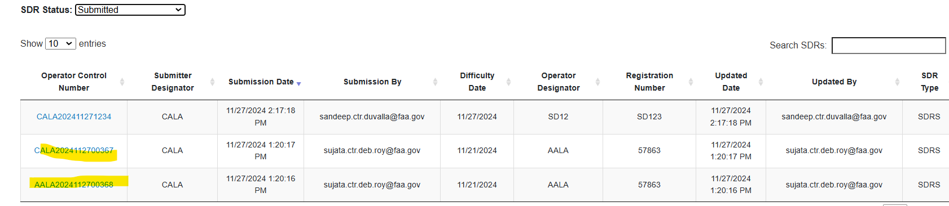

Checking Records That Failed Validation
The Submitter user can choose not to move ahead with the submission and instead correct the errors displayed on the failed records. In the event the Submitter decides to go that route, they need to navigate to the failed records grid.
- All items that failed validation are displayed in red for a quick review
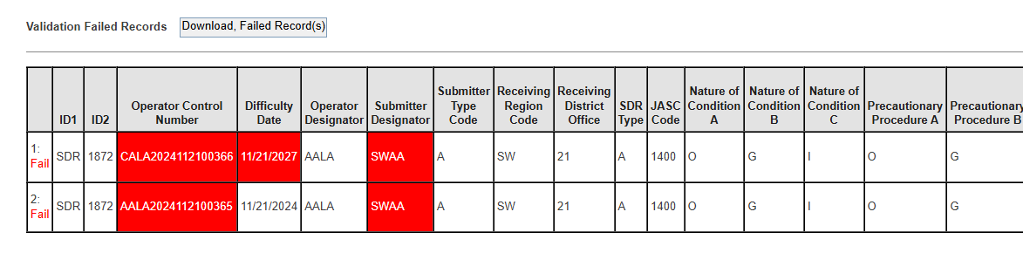
- Submitter Users can click on the Download Failed Records to Button to download a txt copy of the failed records. See image as an example below.
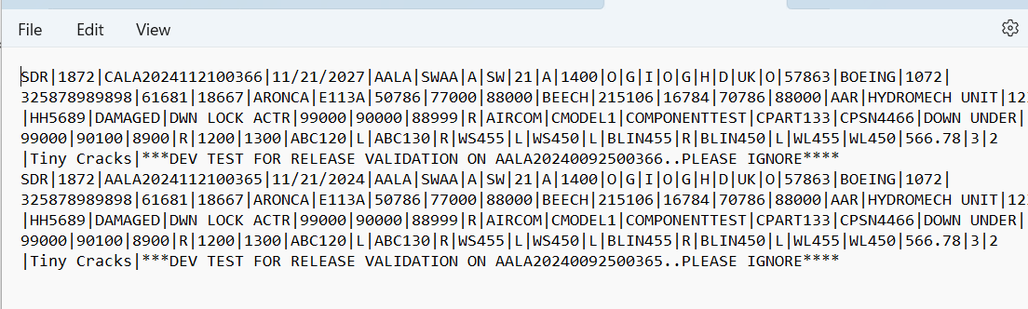
They can update the records and resubmit the corrected data using the batch upload process

View Batch Upload History
Submitter Users can check the History of Batch Uploads they submitted. To check Batch Upload history, follow the steps below:
- To view Batch Upload history, click ‘View Batch Upload History’ link.
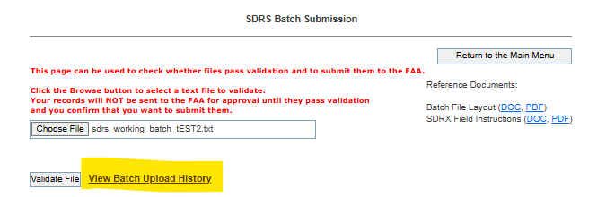
- Batch upload history page is displayed.
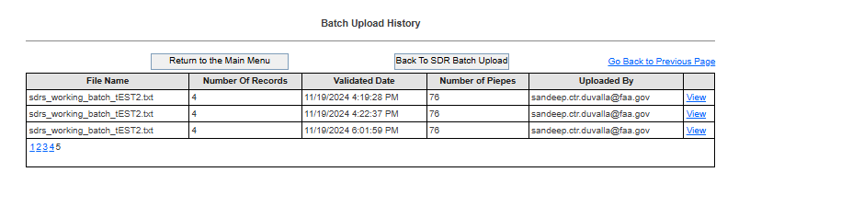
- Click on the ‘View’ link.
- The history page with all validations (records passed validation and records failed validation) is displayed to the Submitter User

Batch Upload Supplemental Records
The Submitter User has the option to upload multiple SDR Supplemental Reports in a single shot by using the Supplemental Batch Upload functionality in SDRS. Supplementals are corrections or addition to existing SDRS records.

Submitting a Supplemental Batch Upload
To submit Supplemental Batch Upload, follow the steps below:
- Login to SDRS and navigate to the Home Page
- Once logged in, the SDR Supplemental Batch Upload link will be visible
Click on the highlighted Supplemental Batch Upload link
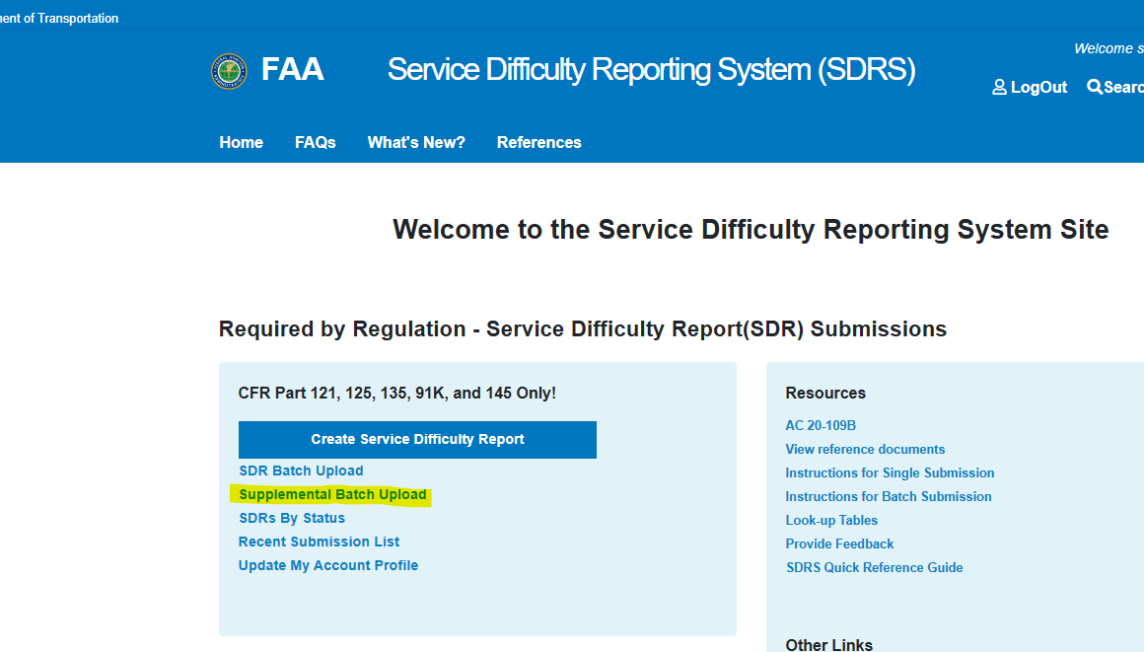
- The SDRS Supplemental Batch Upload screen is displayed
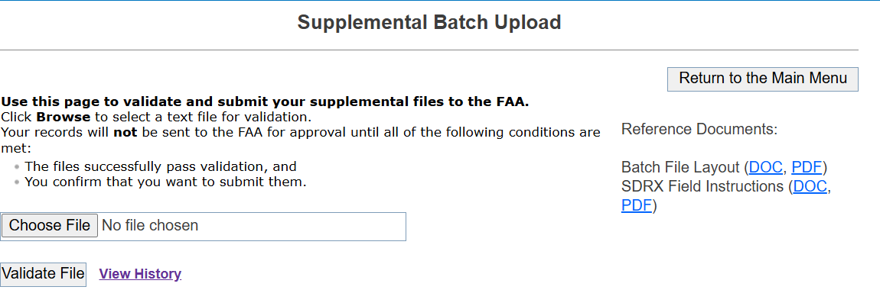
- Click ‘Choose File’ button and pick a batch file from the local C/drive or wherever the batch file is saved
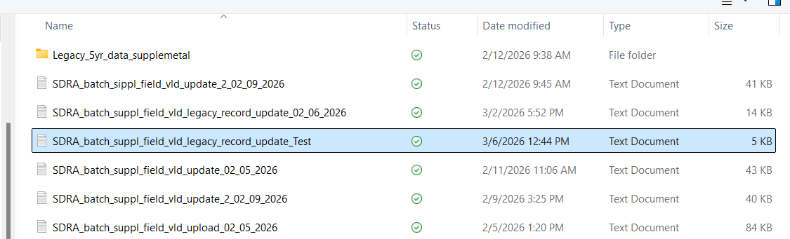
- Note: User must ensure that the Unique Control numbers# in the upload file match SDRS records for which they want to submit Supplementals
- After choosing the file to upload, click "Validate File" button.
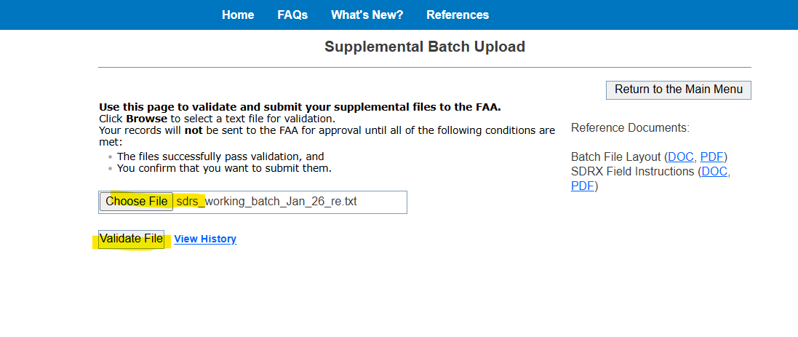
- Validation results are displayed, listing all validation errors if any, at the top of the page
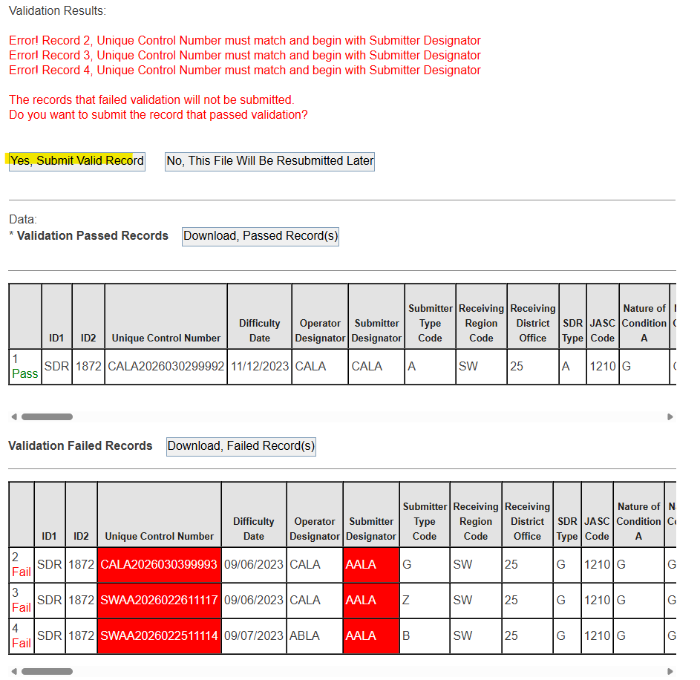
- Additionally,
  - Passed records are displayed in the top grid and
  - Failed records, in the bottom grid
- The Submitter user has the option to submit all the passed records for FAA to review.
- Click on “Yes, Submit Valid Records” for submission to FAA for review
- 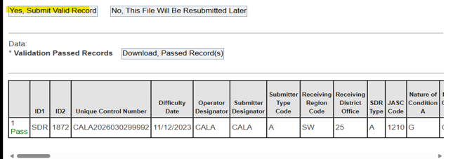
- Upon successful submission of the validated records -- a confirmation message in green with the records that were submitted successfully is displayed on the screen
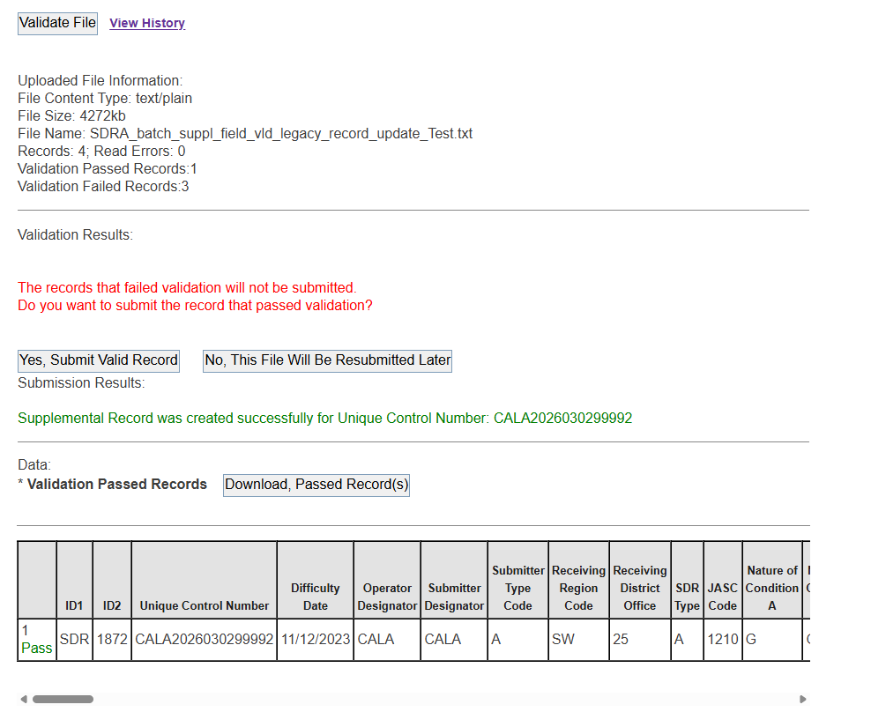
- To Validate the records were submitted successfully, navigate to the home page by selecting "Return to Main Menu" and then selecting SDRS by Status>> SDRS Status Submitted >> records that were submitted are displayed in the queue.
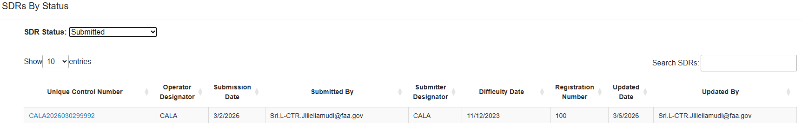

Checking Records That Failed Validation
The Submitter user can choose not to move ahead with the submission and instead correct the errors displayed on the failed records. In the event the Submitter decides to go that route, they need to navigate to the failed records grid.
- All items that failed validation are displayed in red for a quick review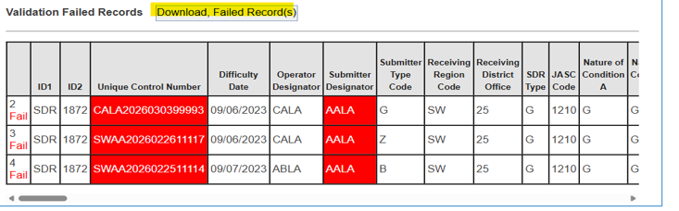
- Submitter Users can click on the Download Failed Records to Button to download a txt copy of the failed records. See image as an example below.
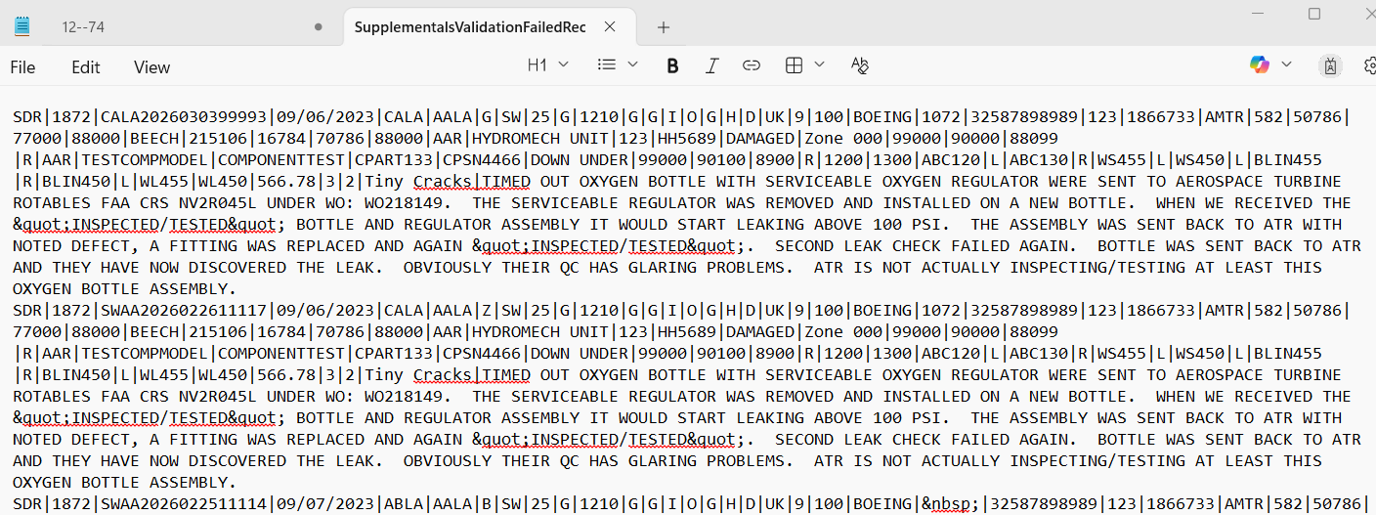
- They can update the records and resubmit the corrected data using the batch upload process

View Batch Upload History
Submitter Users can check the History of Supplemental Batch Uploads they submitted. To check Supplemental Batch Upload history, follow the steps below:
- To view Batch Upload history, click ‘View History’ link.
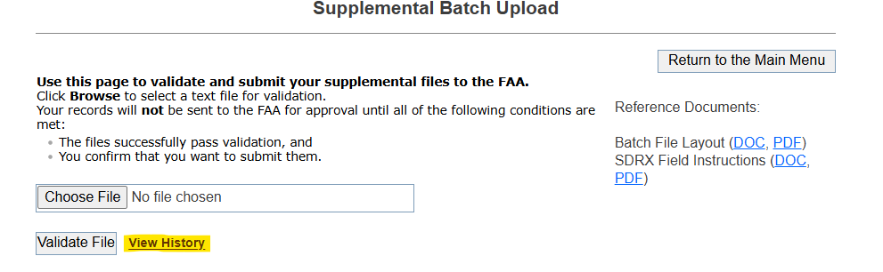
- Upload history page is displayed

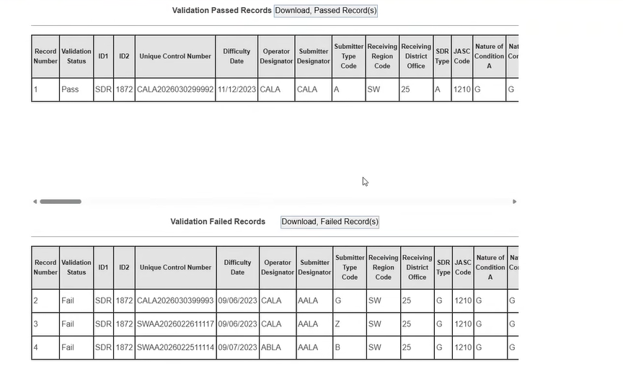
- The history page displays all records with all validations (records passed validation and records failed validation)

SDRS Features and Oversight User Functions
Oversight user role is a Supervisory role. In this role users can see all different SDRs that were submitted for a particular designator
- Add a new M Or D report.
- Dashboard View
- Ability to view SDRs by status.
- Ability to search by criteria.
- Ability to see Recent Submission List (only in the context of M or D submission made by the user)
- Search All Processed reports on external page.

Submitting M Or D Report
Select ‘Create a Malfunction or Defect Report.
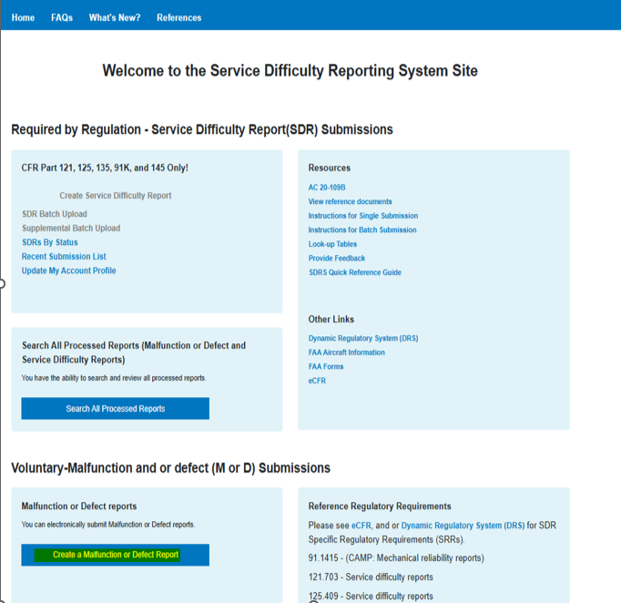

Malfunction or Defect Report is displayed.
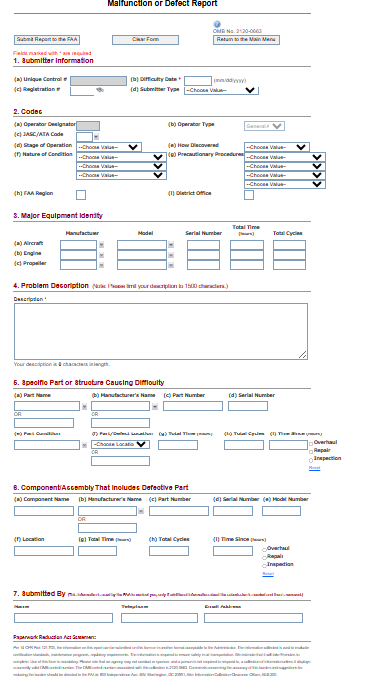

Submitter Information

This section allows submitter to fill in submitter information. To complete this section, all required information must be filled in.
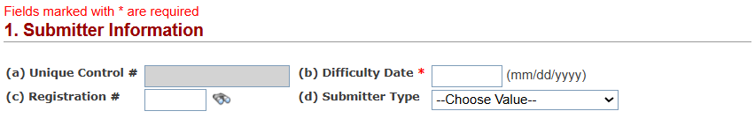

Submittal Information Fields
Field | Description | Required
Unique Control # | Auto- generated for M Or D when user clicks the ‘Submit Report to FAA’ button. | Required
Difficulty Date | Date on which the service difficulty occurred. Should be in the “mm/dd/yyyy” format | Required
Registration # | Registration number associated with the aircraft on which the difficulty occurred | Optional
Submitter Type | Code indicating the type of person/organization that is submitting this report. Select from Look-Up Table. | Optional

Codes
This section allows submitter to fill in codes related information. To complete this section, all required information must be filled in.
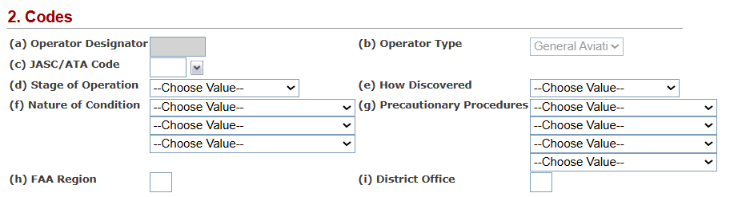

Codes Fields
Field | Description | Required
Operator Designator | The designator code assigned to the operator that you are submitting for | Optional
Operator Type | Indicate whether your operator is an Air Carrier or is General Aviation | Optional
JASC/ATA Code | A four-digit JASC code to indicate the type of difficulty that occurred | Optional
Stage of Operation | Choose a code from the Look-up table to indicate at what stage the difficulty occurred. | Optional
How Discovered | Choose a code from the Look-up table to indicate how the difficulty was discovered. | Optional
Nature of Condition | Choose up to three codes from the drop downs to describe the nature of the difficulty’s condition | Optional
Precautionary Procedures | Choose up to three codes from the Look-Up Table to describe any procedures followed once the difficulty was discovered. | Optional
FAA Region | Enter your FAA region | Optional
District Office | Enter your certificate holding office | Optional
Flight Number | You may provide the flight number on which the difficulty occurred | Optional

Major Equipment Identity
This section allows submitter to supply information for each major equipment’s (Aircraft, Engine, and Propeller. To complete this section, all required information must be filled in.
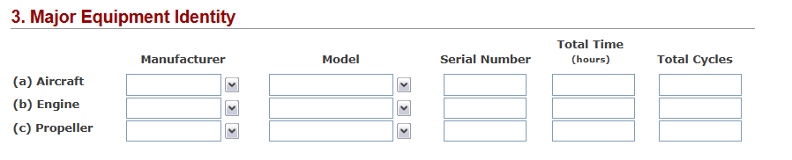

Major Equipment Identity Fields
Field | Description | Required
Manufacturer | The manufacturer of the equipment | Optional
Model | The model of the equipment | Optional
Serial Number | The serial number associated with the equipment | Optional
Total Time | The total time of the equipment in hours | Optional
Total Cycles | The total cycles of the equipment | Optional

Problem Description
This section allows submitter to Provide a description of the problem that is occurring. To complete this section, all required information must be filled in.

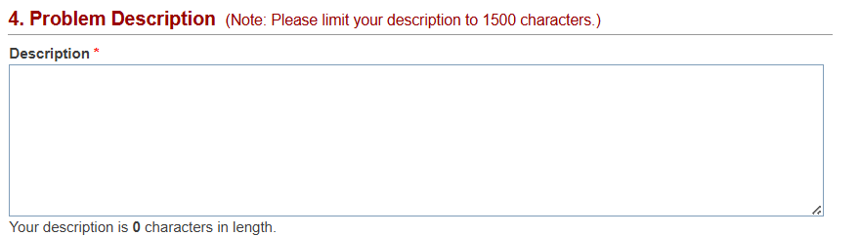

Problem Description Fields
Field | Description | Required
Description | Provide a description of the problem that is occurring | Required

Specific Part or Structure Causing Difficulty
This section allows submitter to supply information for each part or structure that is causing difficulty. To complete this section, all required information must be filled in.
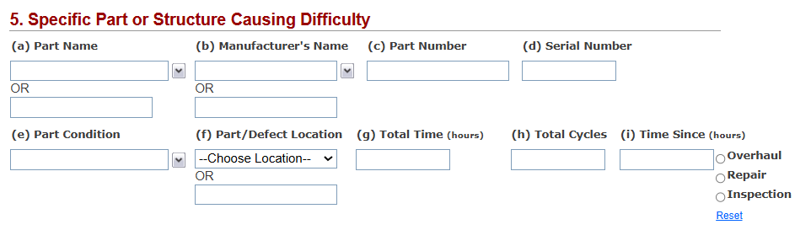

Specific Part or Structure Causing Difficulty Fields
Field | Description | Required
Part Name | This is the name of the part as defined by the manufacturer | Optional
Manufacturer’s Name | This is the name of manufacturer who made the part. | Optional
Part Number | The part number as defined by the manufacturer | Optional
Serial Number | The serial number of the part as defined by the manufacturer | Optional
Part Condition | The condition that the part is in | Optional
Part/Defect Location | The placement of the part | Optional
Total Time | The total time of the part in hours | Optional
Total Cycles | –The total cycles of the part | Optional
Time Since | The time since the last Overhaul, Repair, or Inspection in hours; also indicate if this period is since a Overhaul, Repair, or Inspection | Optional

Component/Assembly That Includes Defective Part
This section allows submitter to supply information for each component/assembly that includes defective part. To complete this section, all required information must be filled in.
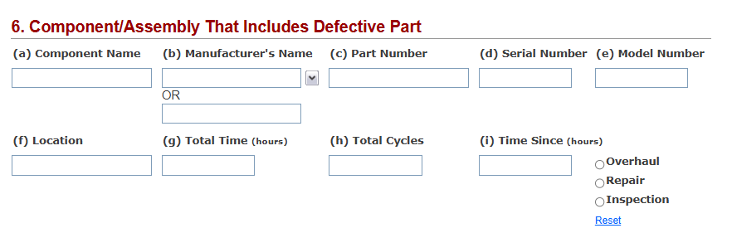

Component/Assembly That Includes Defective Part Fields
Field | Description | Required
Component Name | This is the name of the component as defined by the manufacturer. | Optional
Manufacturer’s Name | This is the name of manufacturer who made the component. | Optional
Part Number | The part number of the component as defined by the manufacturer. | Optional
Serial Number | The serial number of the component as defined by the manufacturer | Optional
Model Number | The model number of the component. | Optional
Location | The location of the component that had the difficulty. | Optional
Total Time | The total time of the component in hours. | Optional
Total Cycles | The total cycles of the component | Optional
Time Since | The time since the last Overhaul, Repair, or Inspection in hours; also indicate if this period is since an Overhaul, Repair, or Inspection. | Optional
- - Use to clear the selection of an Overhaul, Repair, or Inspection.

Submitted By
This section allows submitter to their information.
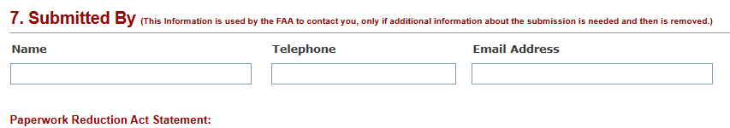

Submitted By Fields
Field | Description | Required
Submitted Name | This is the name of the submitter | Optional
Submitted Telephone | This is the Telephone Number of the submitter | Optional
Submitted Email | This is the Email of the submitter | Optional
- - Use to clear the selection of an Overhaul, Repair, or Inspection.

Submitter Dashboard
As a Oversight user, select SDR’S By Status
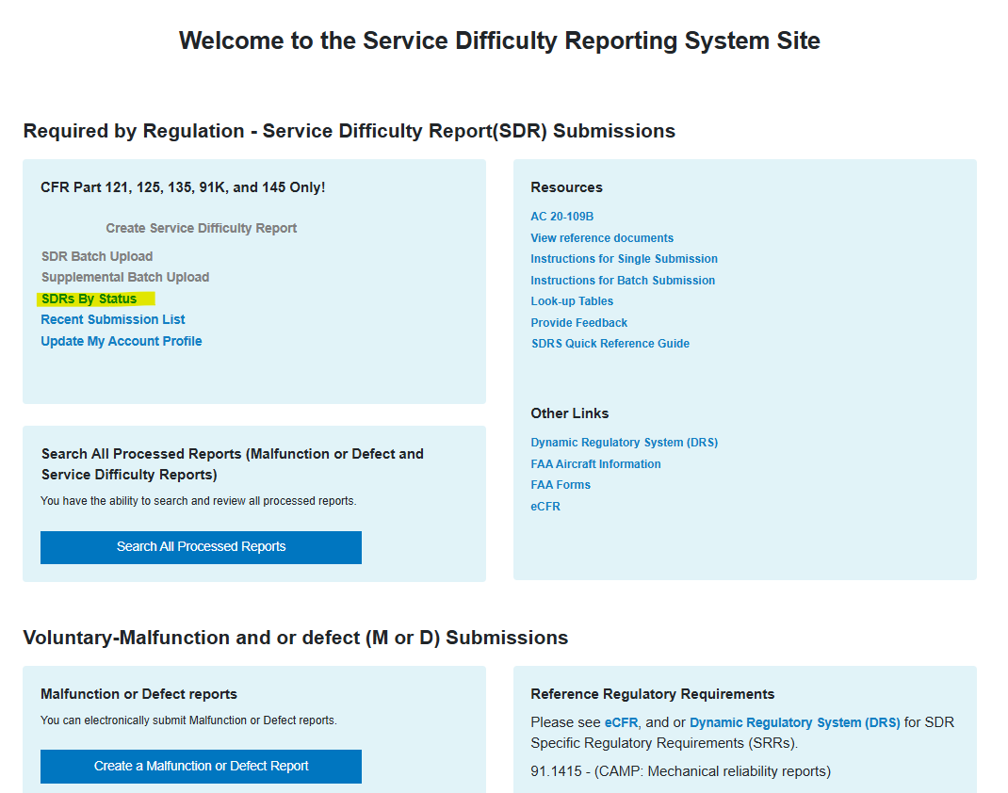
SDR Status Dashboard is displayed.
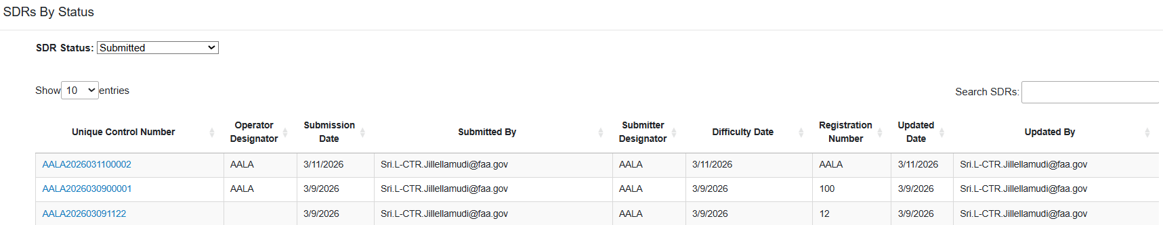

SDR Status

Submitted
- Click SDR Status dropdown, select Submitted option.
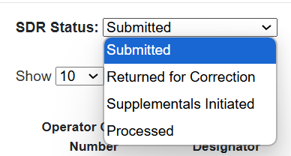
- Submitted SDR’s list is displayed
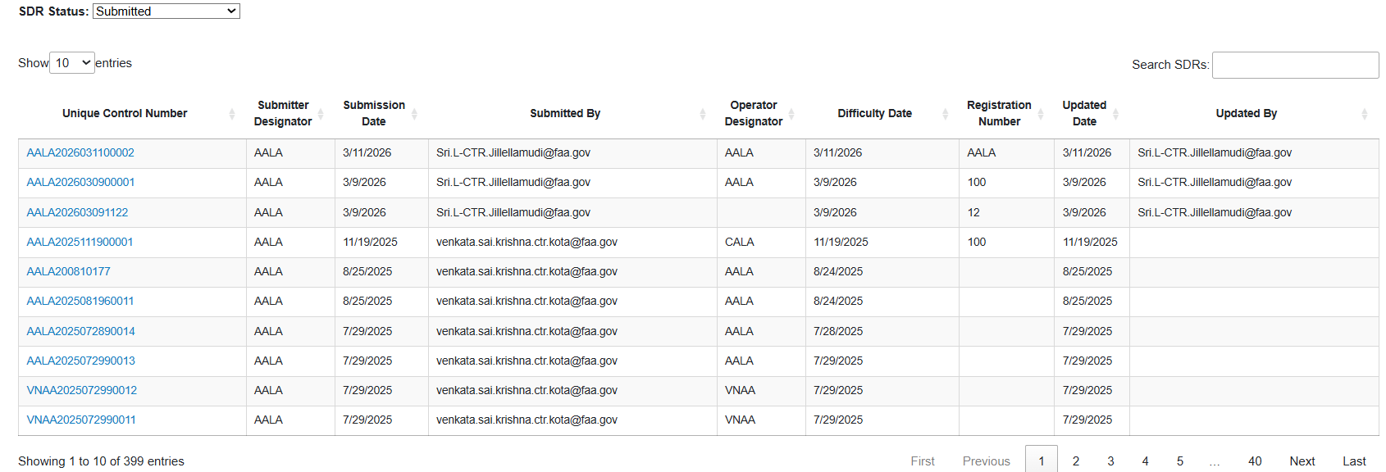
- Enter any search criteria on ‘Search SDRS’ field

- Select Unique Control Number to navigate to review SDR form. This page opens in read only mode
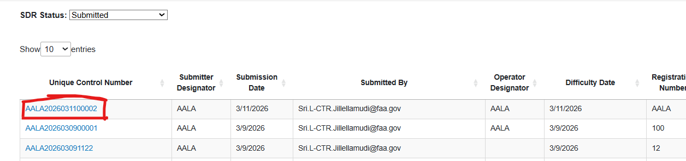
- Select ‘Return to SDR By Status’ to navigate back to main page.
- Note: User has the option to return to main page.
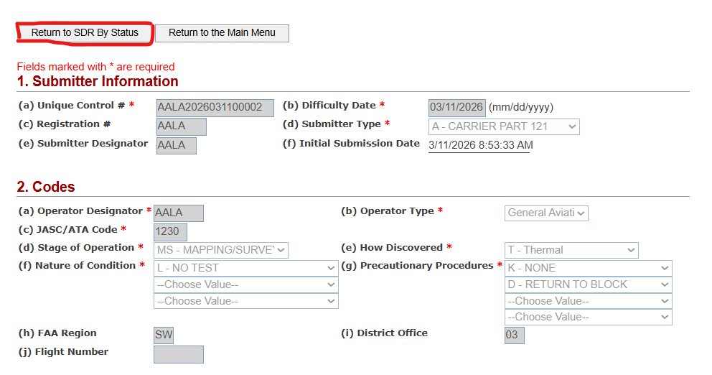

Returned for Correction
- Click SDR Status dropdown, select Return for Correction option.
- SDR’s that have been returned for correction are displayed
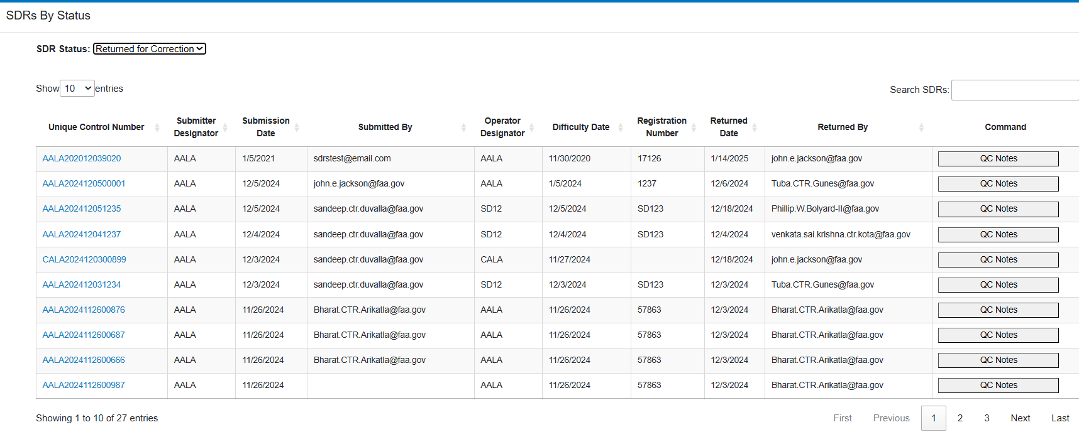
- Enter any search criteria on ‘Search SDRS’ field
- Select ‘QC Notes’ under Command column to review command notes.
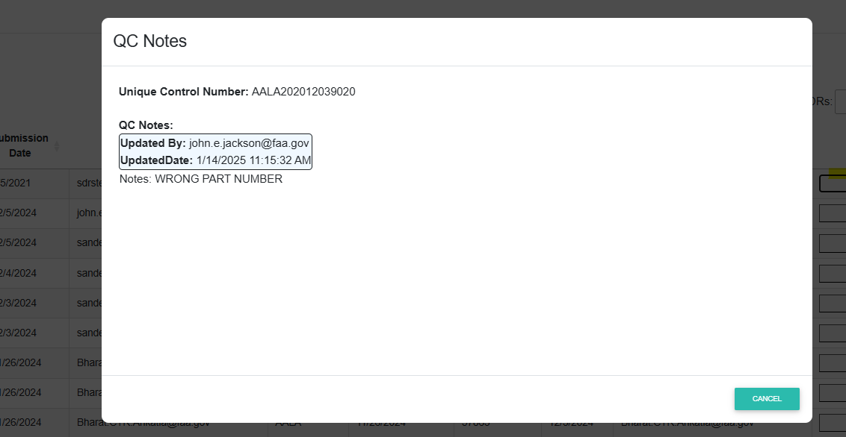
- Click ‘Cancel’ button to close QC Notes popup
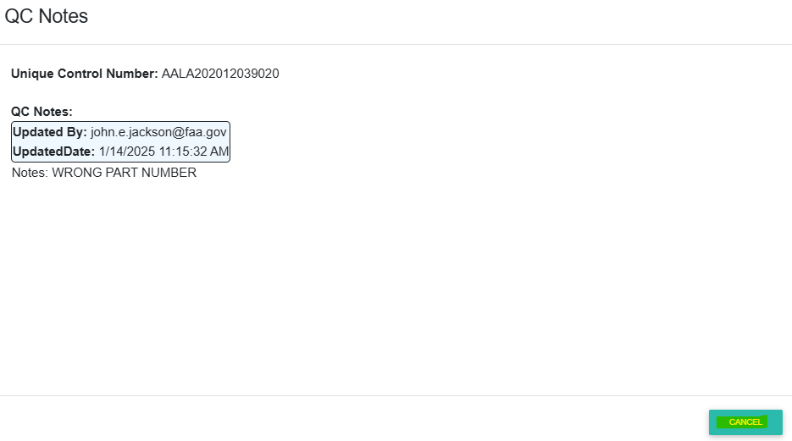
- Select Unique Control Number to navigate to review SDR form. This page opens in read only mode
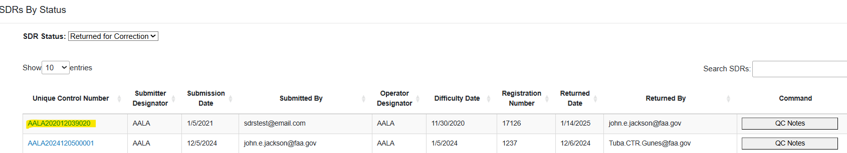

- Select ‘Return to SDR By Status’ to navigate back to main page.
- Note: User has the option to return to main page

Supplements Initiated
- Select ‘Supplements Initiated’ from the SDR Status dropdown field.
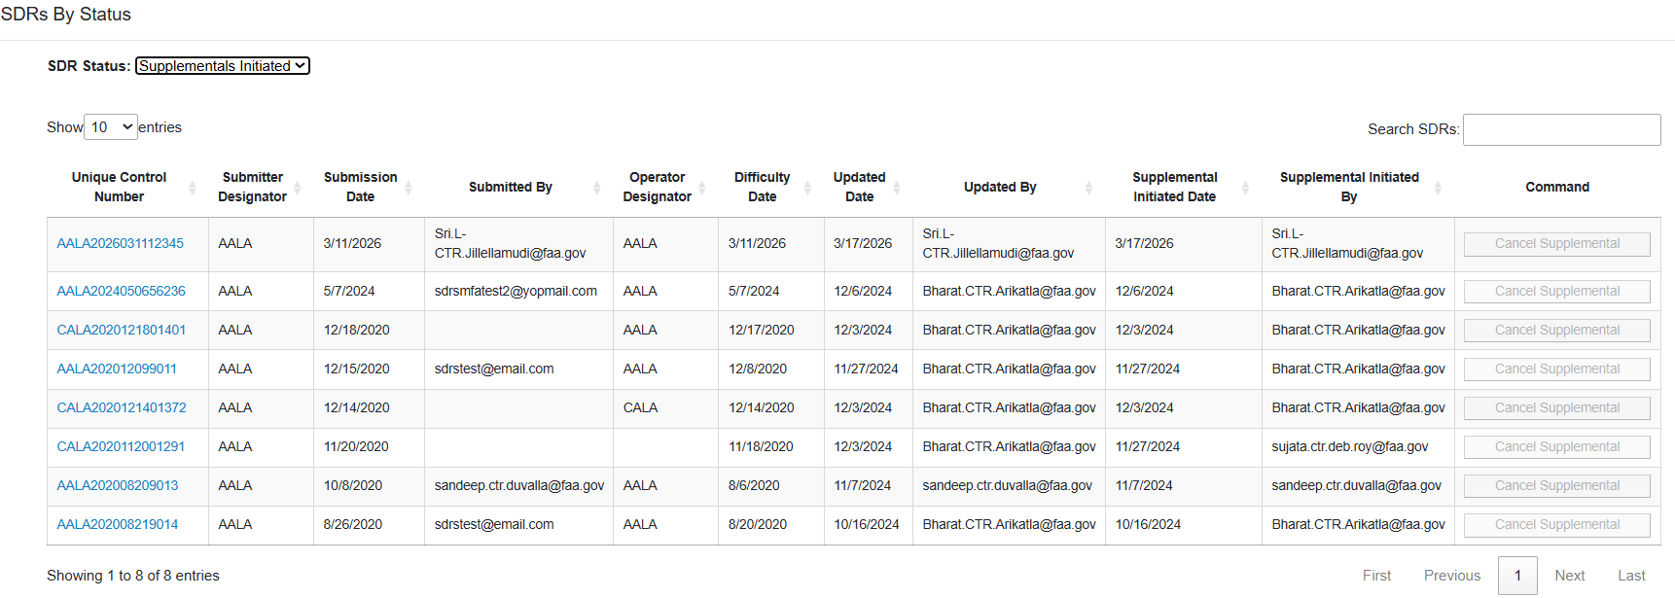
- SDR’s List is displayed based on the selection
Note: Oversight user role cannot cancel supplemental

- Select Unique Control Number to navigate to review SDR form. This page opens in read only mode.
- Review information and click ‘Return to SDR Status’ to navigate back to status page.

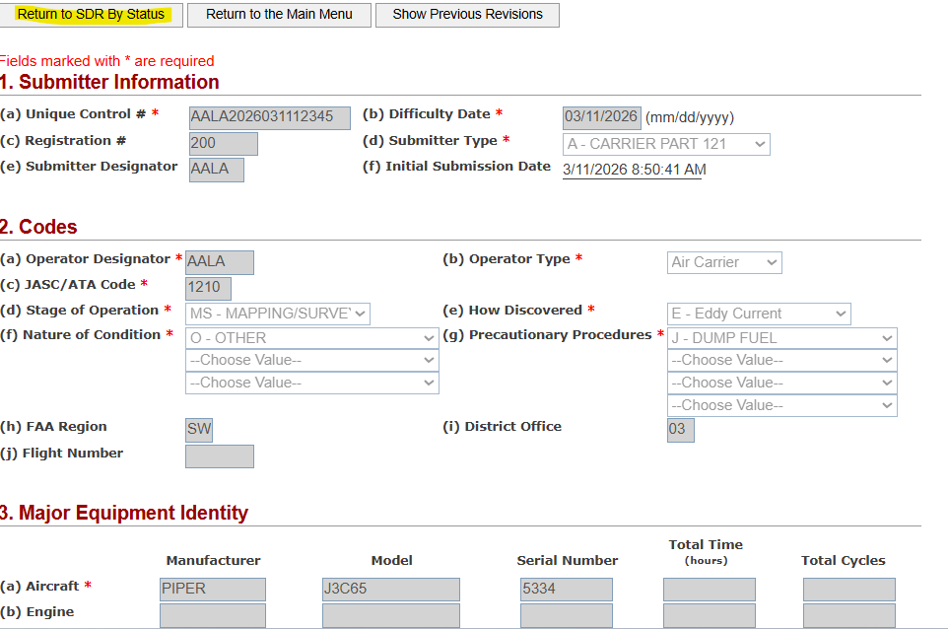

Processed
- Click SDR Status dropdown, select processed option.
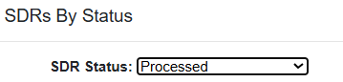
- All Processed SDR’s will be displayed
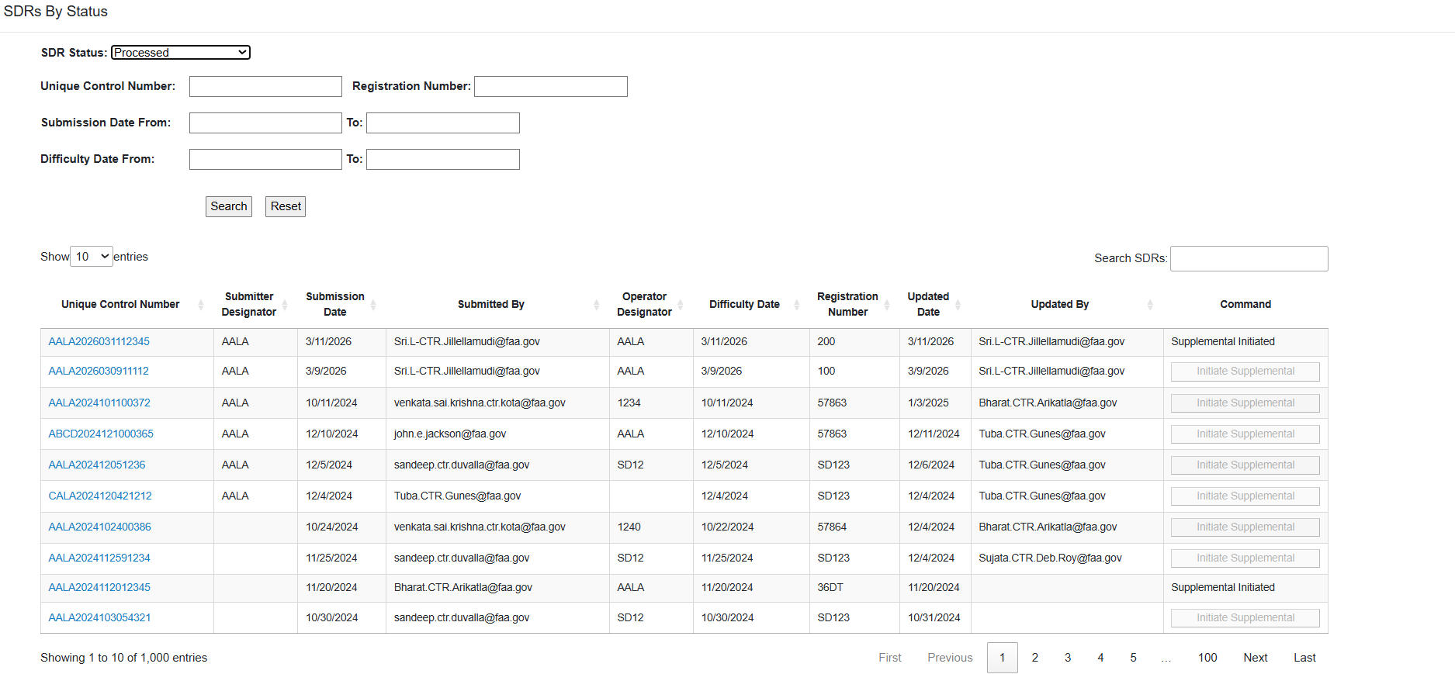

- Select Unique Control Number to navigate to review SDR form. This page opens in read only mode
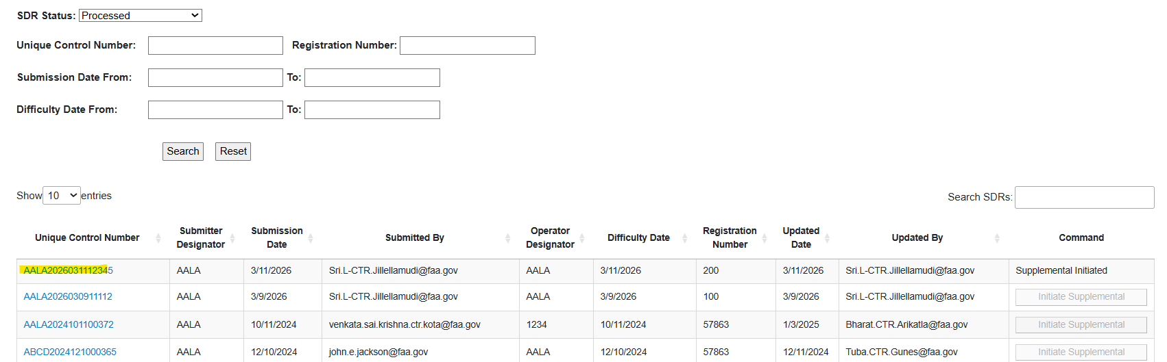
- Select ‘Return to SDR By Status’ to navigate back to main page.
- Note: User has the option to return to main page
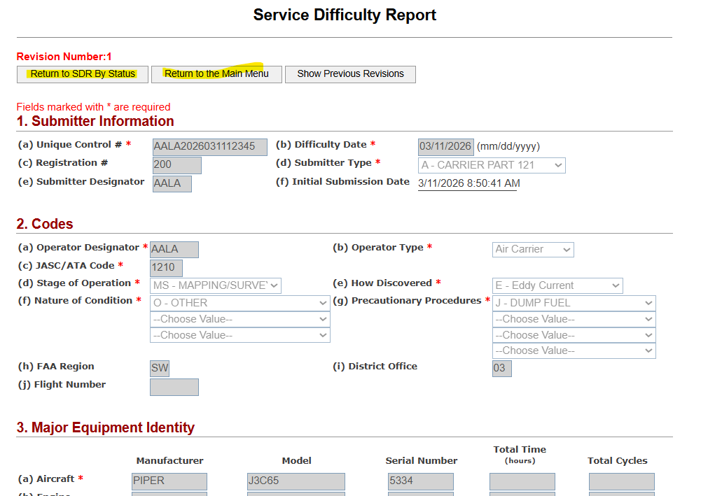

SDR Admin User Registration Application Features - Quality Control Tool, Maintenance Tool Functions And User Management
To access the SDR Administrator Application users will use the following link: https://sdradm.faa.gov
SDR Admin Screens are used for Admins to perform User Management, QC personnel to perform Technical and Non-Technical Quality Checks on SDR’s. When the QC for a submitted record is validated, the record is Saved to the SDR (production) Table. The following is a list of available functions:

- User Management
- QC Tool
- Maintenance Tool
- Other Tool

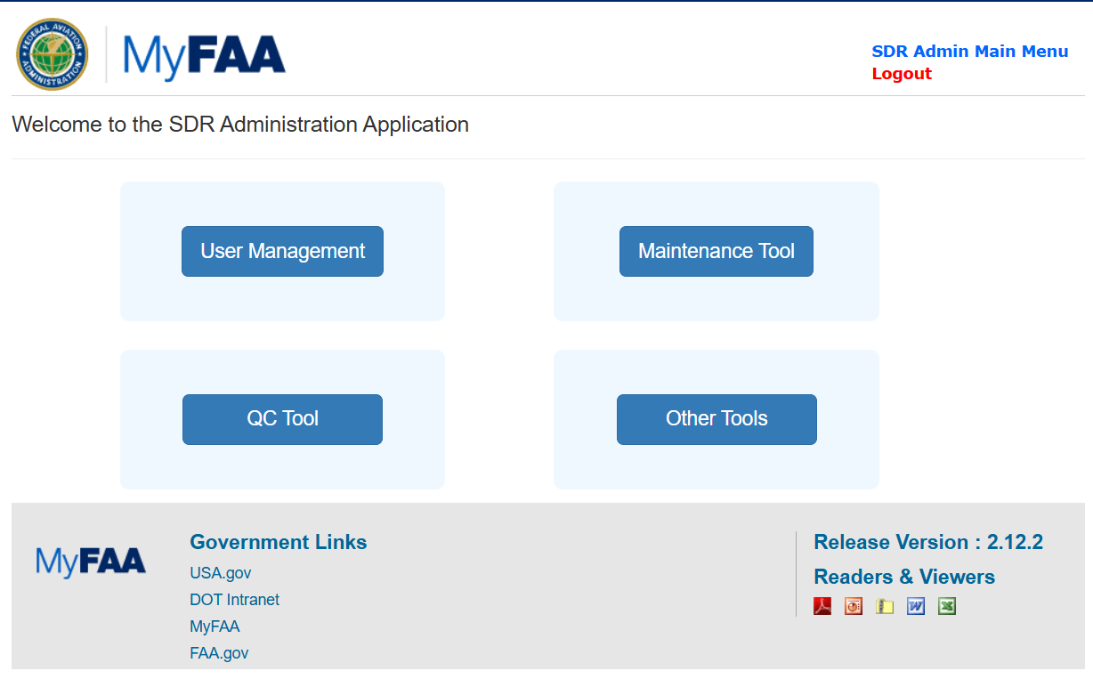

User Management
Click User Management tab, to perform User Account Management
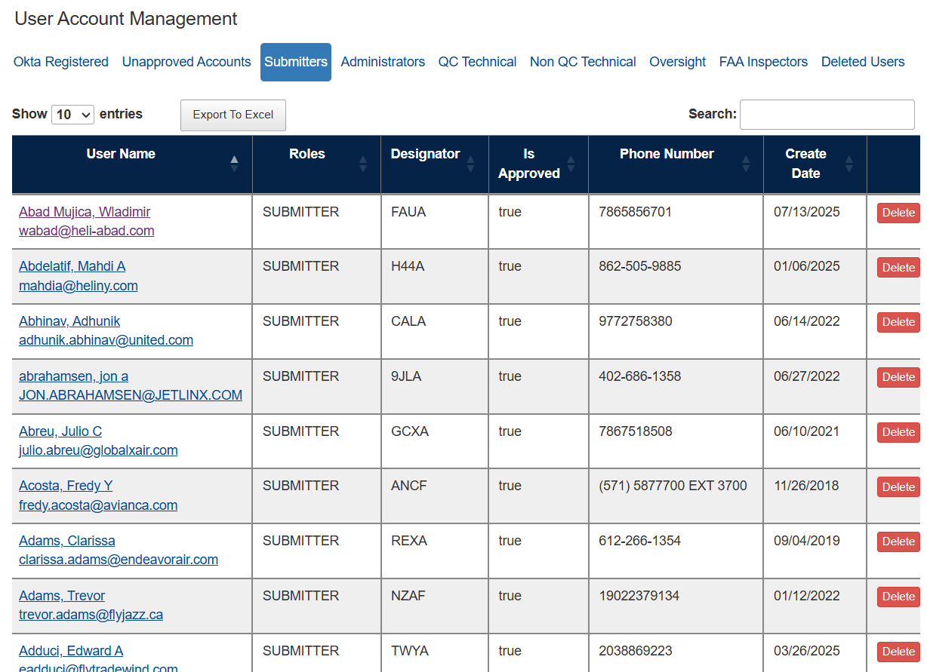
In search Text box, input a text to filter
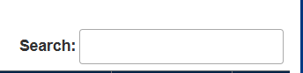

It will display the list of users based on the input text

Submitters
Click on UserName to drilldown to the user details. It navigates the ADMIN USER to the Edit user Account page to make necessary edits to the user profile.
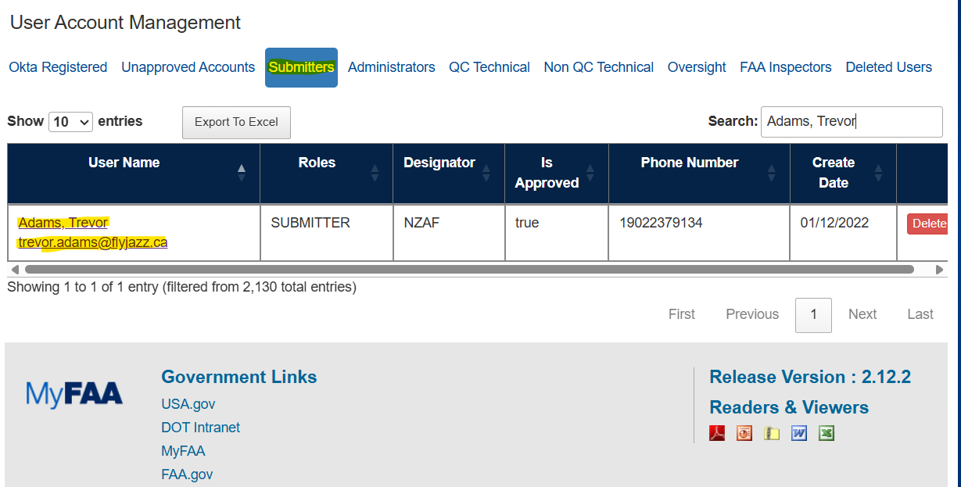
Make edits and click Save button to Save the changes.
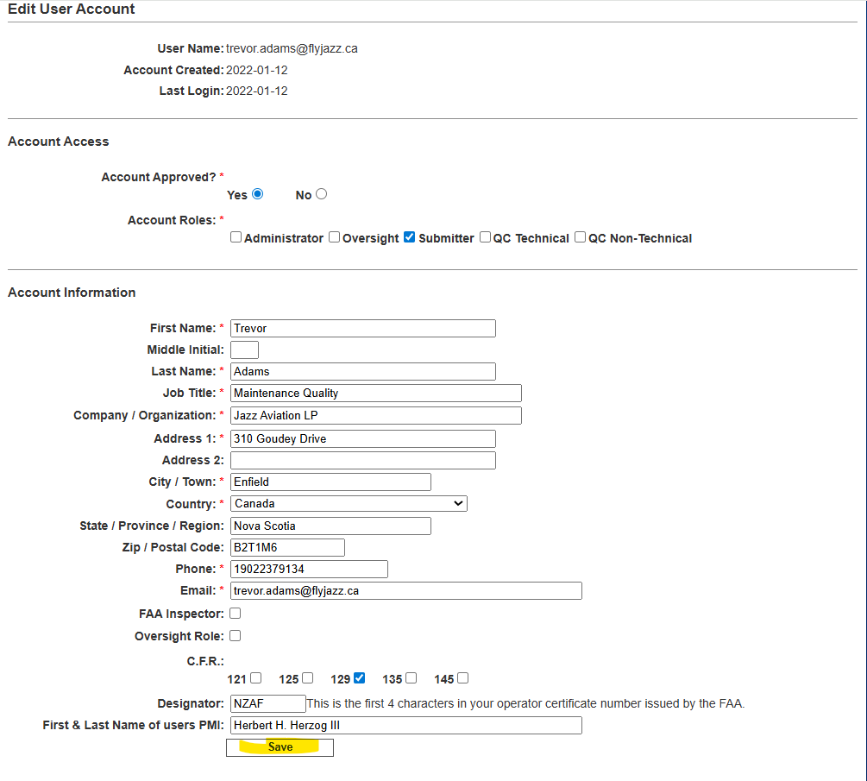
Go back to User Management and click on Okta Registered link

OKTA Registered Users
This tab lists all users that are Registered in OKTA for MFA.
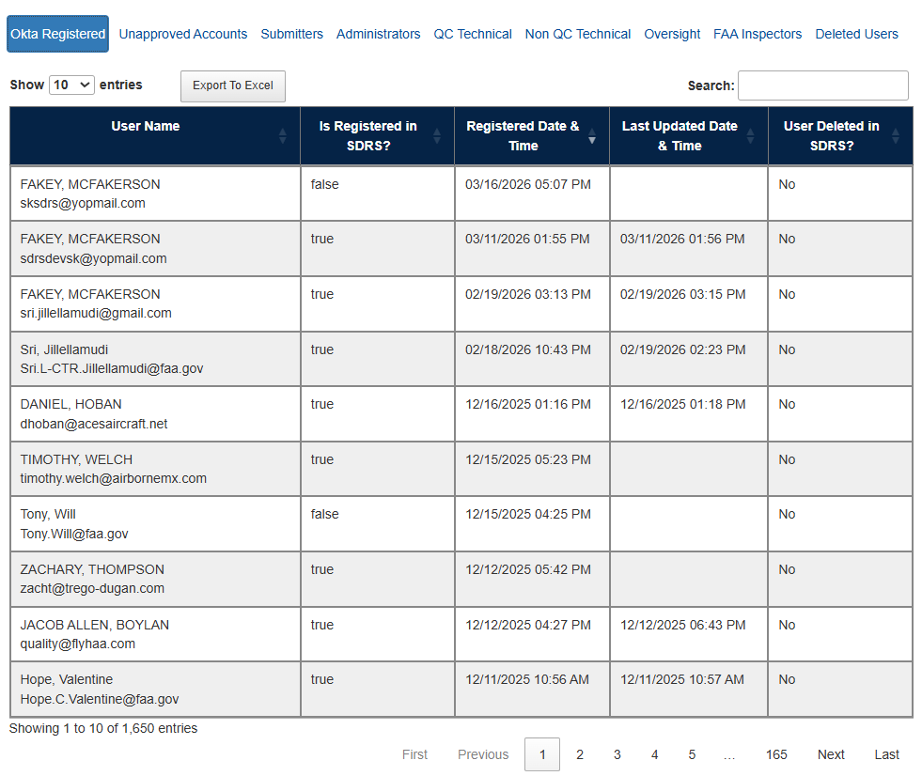
Note:
Registered in SDRS: This Column Lists all users that have completed their registration for the SDR application
- False means they are still not registered in SDRS
- True means they are registered in SDRS
User Deleted from SDRS: This column Lists all users that have been deleted from the SDRS system via the delete user profile.
- No means they are still not deleted from the SDRS application
- Yes, means they are deleted from the SDRS application

Unapproved Accounts
This tab lists all the Unapproved accounts. The ADMIN USER can decide to grant access or delete the user once they are in this queue.
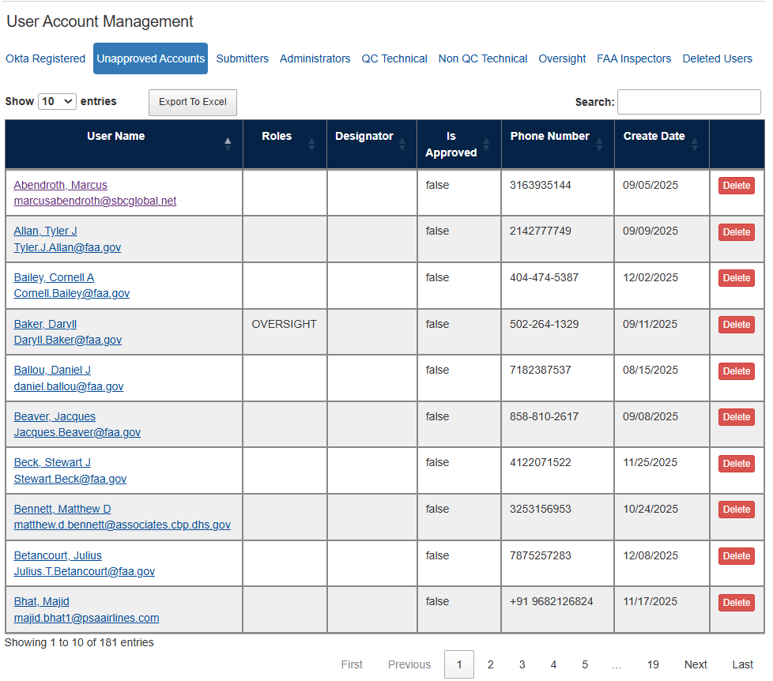
Click ‘Delete’ to delete a user account from the SDRS application. The user will no longer have access to the system.
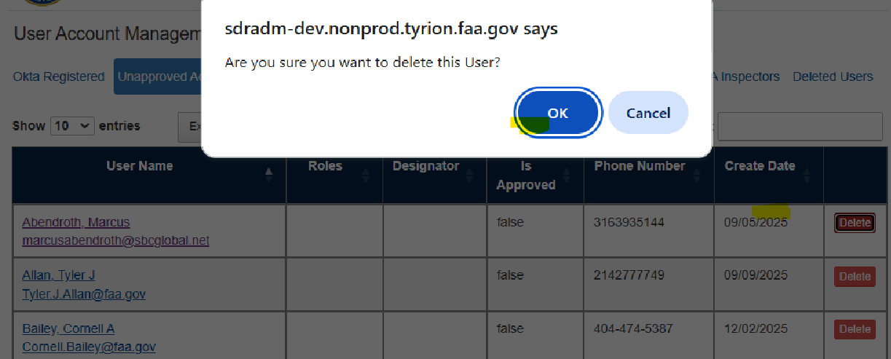

To Approve an account for SDRS access, click on the username

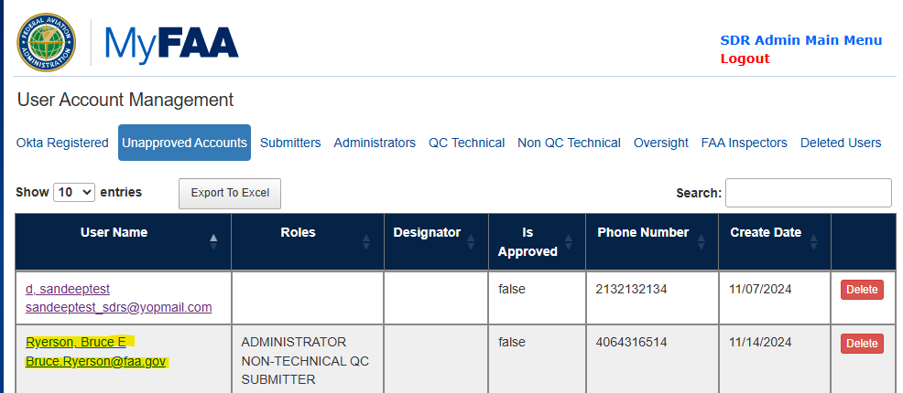

Select the Yes radio button on the “Account Approved” option and click on Save

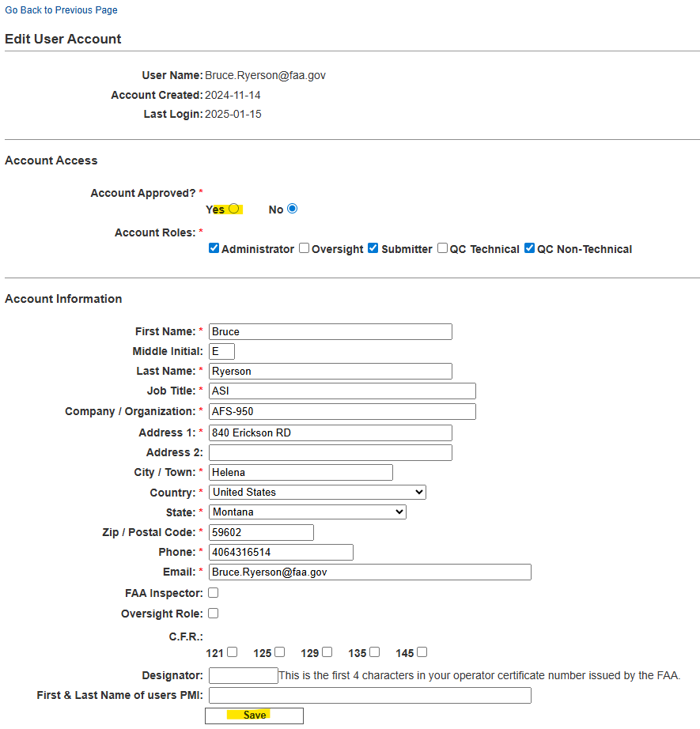

Administrators
This tab lists all users with Administrator accounts.
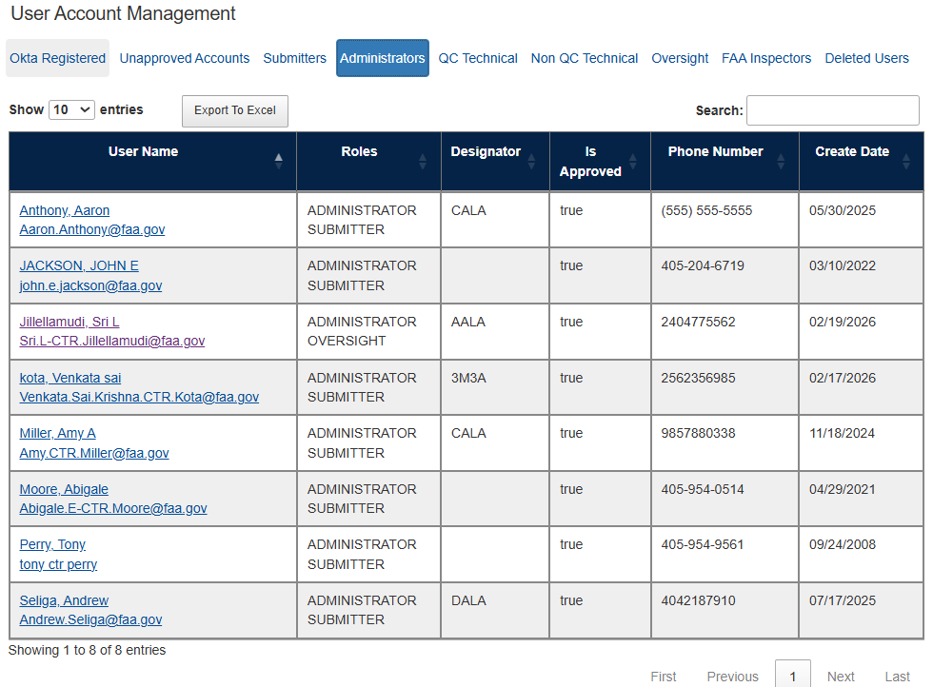

QC Technical
This tab lists all users accounts with access to the QC Technical role
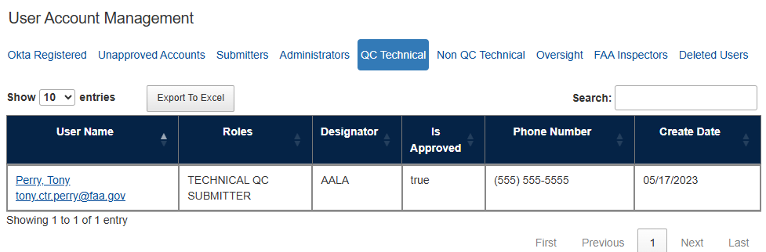

QC Non-Technical
This tab lists all users accounts with access to QC Non-Technical role
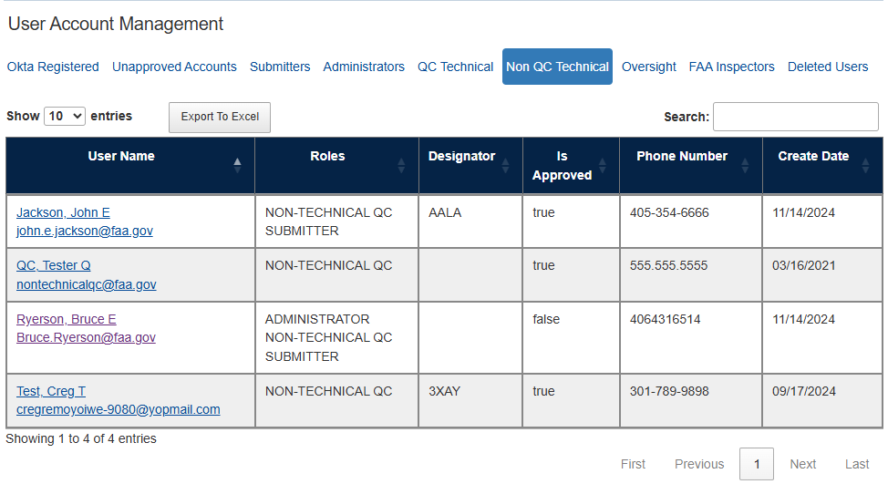

Oversight
This tab lists all users accounts who have Oversight role
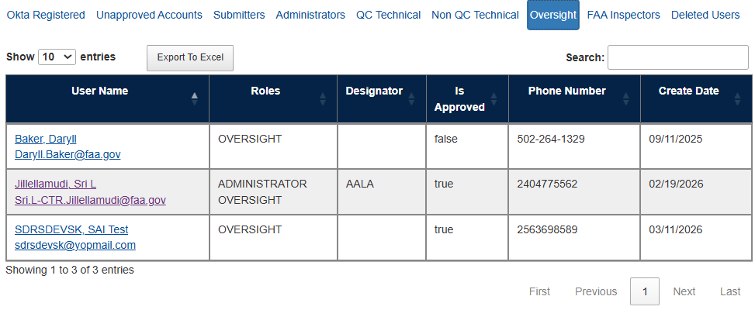

FAA Inspectors

This tab lists all the FAA Inspectors

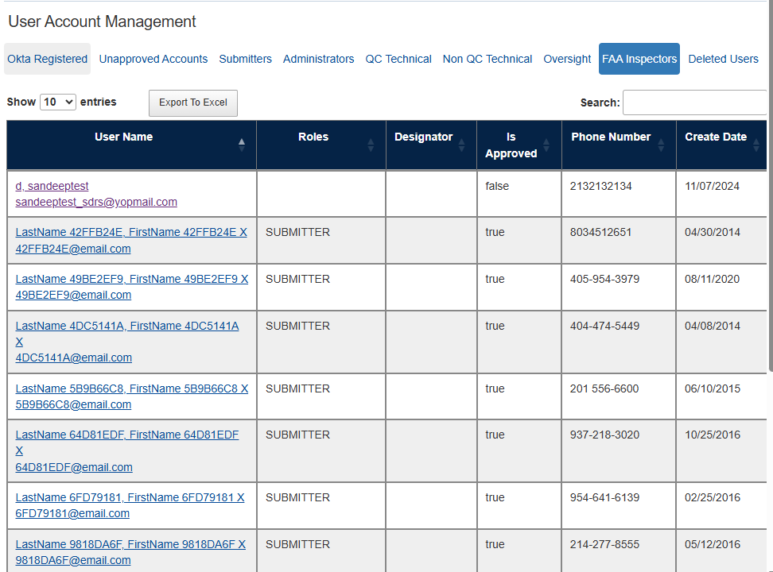

Deleted users
This tab lists all User that have been deleted from the SDRS application.

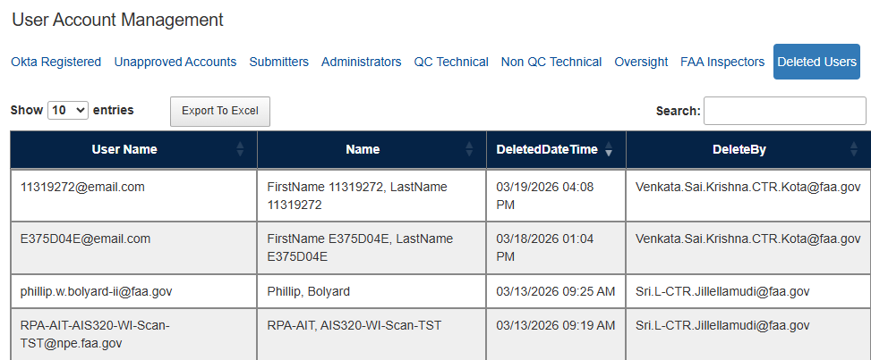

QC Tool
SDR QC Screens are used for Technical and Non-Technical Quality Checks on SDR’s.
Upon login, the QC Tool user will have the option to choose from the following workflows to work on:
- Awaiting QC: New SDRS or M or D records submitted to FAA
- Work In Progress: All items that are being worked on by the QC Team and not yet approved for the Production Table
- Returned for Correction: All items that have failed QC and returned to the Submitter for Correction
- Supplementals Received: If a Submitter initiates and submits a Supplemental, the record upon submission goes through the QC cycle. This queue contains records for which Supplementals have been initiated and submitted to FAA.
- Processed: List of all approved records in the production table
Note: If a person has access to only QC Tool then they will see QC Tool option only
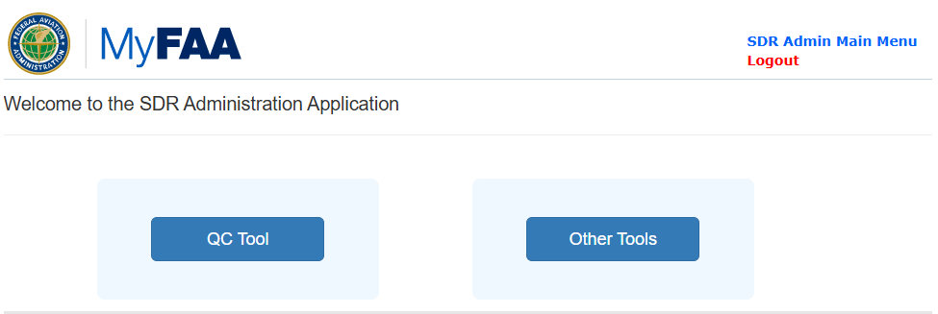

Awaiting QC
The following actions can be performed on items in the Awaiting QC Queue:

- The QC Tool user will click on the Unique Control Number
- They will see the SDRS Submission in the Edit Mode

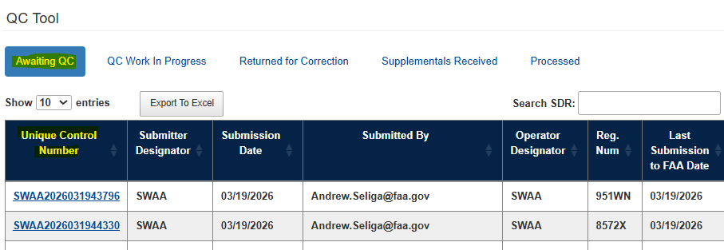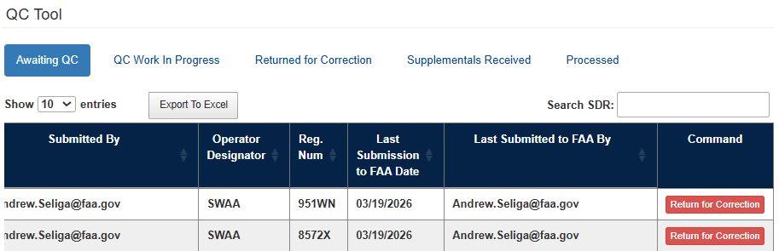

SDR Form is displayed for QC personnel to review and edit if required.
- The QC Tool User has the option to Save the record.
- Has the option to Save the changes and Submit the changes to the Production SDR
- Or, Return for Correction to the Submitter.
- Please Note: Only the QC Technical and ADMIN USER s will have the ability to Submit the record to the Production Tables. To Save a record to the Production Table they will click on the Save & Approve button.
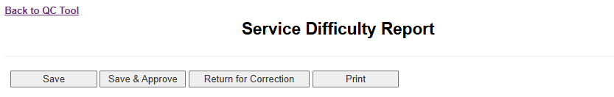
Return the record for the Submitter to update:
If the QC Tool user wants to return the record for the Submitter to Update, they will click on the Return for Correction Button

- In the Pop-Up screen provide a reason for requested changes before sending them back to the Submitter.

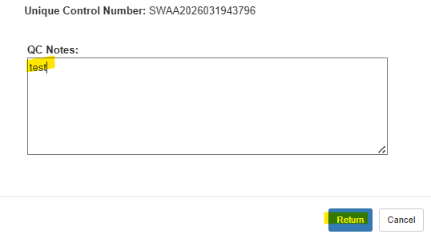
Click ‘Return’ button.
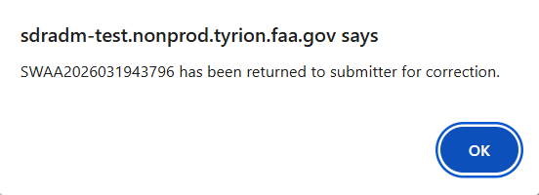
Click Ok on the confirmation popup message: Record will be moved from Awaiting QC to Returned for Correction status.

QC Work in Progress
The following actions can be performed on items in the QC Work in Progress Queue:
Note: Items in the Open queue include Non-Technical QC done and or some QC done.
- EDIT the record
- Return the record for the Submitter to update
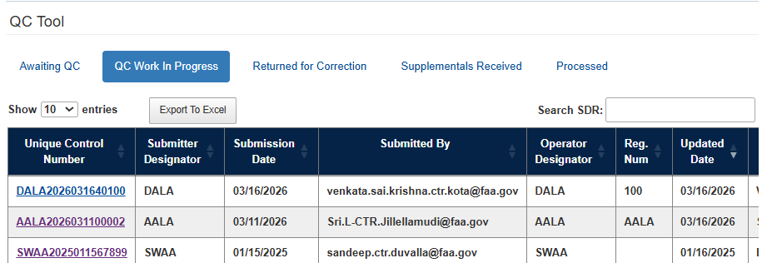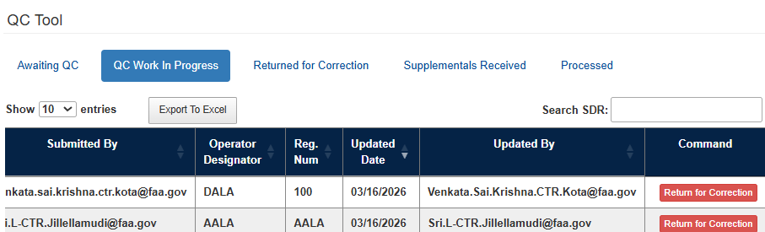
QC user will have ability to:
- Select ‘Save & Approve’
- Select ‘Return for Correction’
- Click Unique Control Number hyperlink to review and edit SDR form

Returned For Correction
Items in this queue are for View only. No action can be taken on these items. Items in this grid represent, SDRs that have been sent back to the Submitter for Correction. The View QC note button displays the notes that were added before sending back the record to the Submitter for Revision.
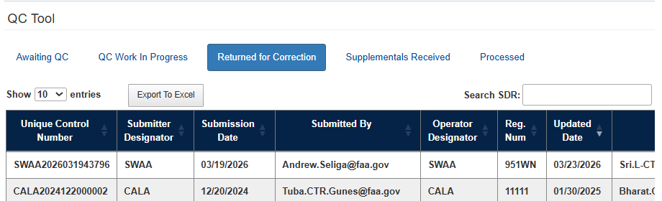
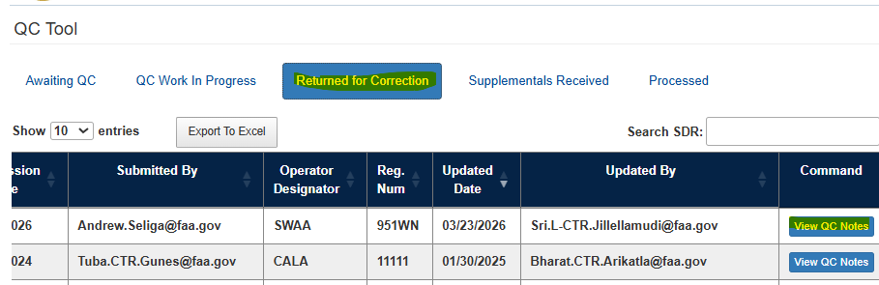
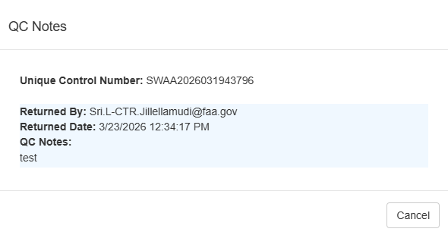

Supplementals Received
Select ‘Supplementals Received’ to view list of all Supplementals Received SDR’s
QC user will have ability to:
- Select ‘Return for Correction’
- Click Unique Control Number hyperlink to review and edit SDR form

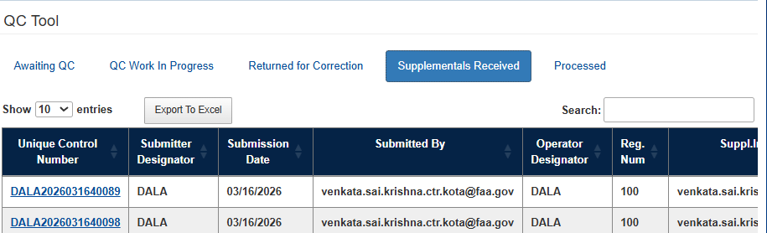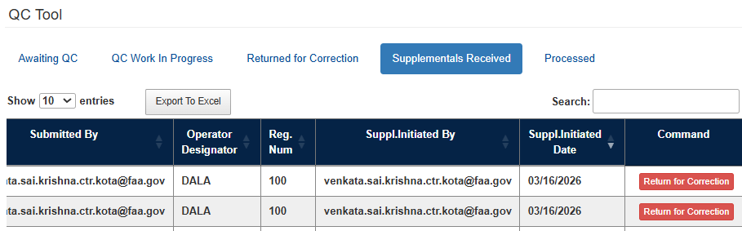

Processed
Select ‘Processed’ to view list of all Processed SDR’s that have been sent to production table
QC user will have ability to:
- Click Unique Control Number hyperlink to review and edit an SDR form
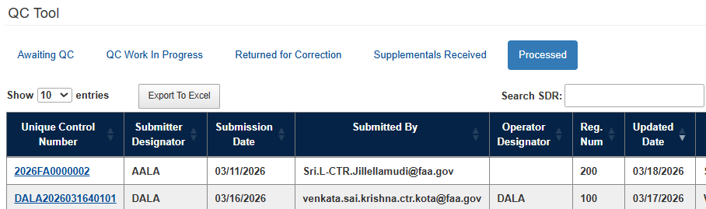

Maintenance Tool
Maintenance Tool Screens are used by Admins to use following components:
- Edit Production/Processed SDR
- Accessing EDIT SDRS within the SDRS Tool
- Field Descriptions and Rules
- Edit Part Condition—
- Used by ADMIN USER to update drop-down values for Part Condition
- Edit Part Name—
- Used by ADMIN USER to updates values for Part Name
- Submitters Designator
- Add or Edit Submitter Designator from FAMIS tables
- Delete SDRS Record
- Used by ADMIN USER to Delete SDRS or M or D records

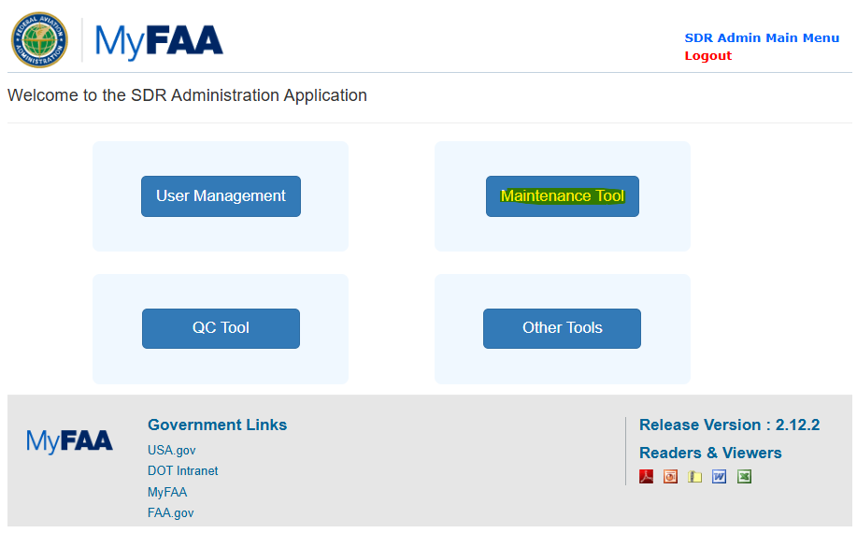

Edit SDR/ M or D
To access editing the SDRS/M or D, the ADMIN USER will click on the Maintenance Tool on the ADMIN landing page
- Upon Clicking the link, the ADMIN USER will navigate to “Search Production SDRS “

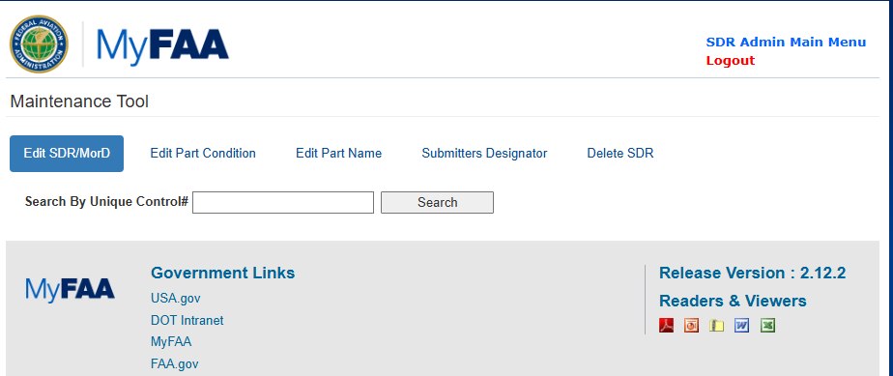
Search for SDRS based on Unique Control Number 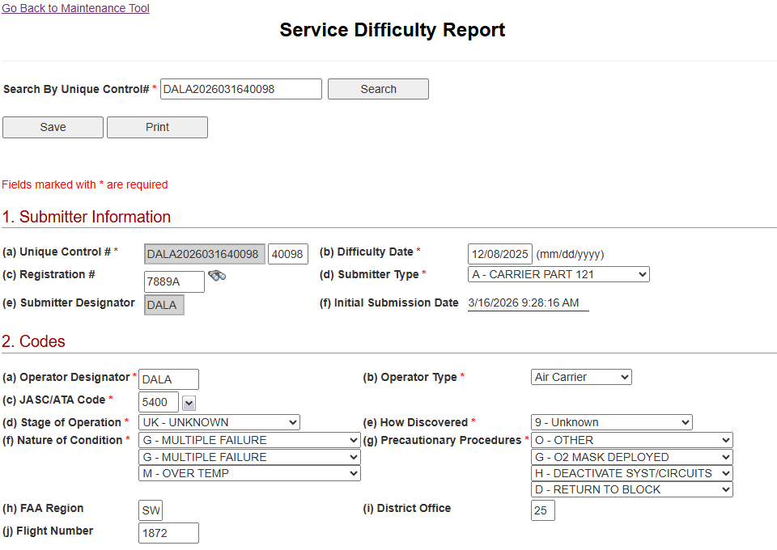
Updated SDR and Saved the changes.

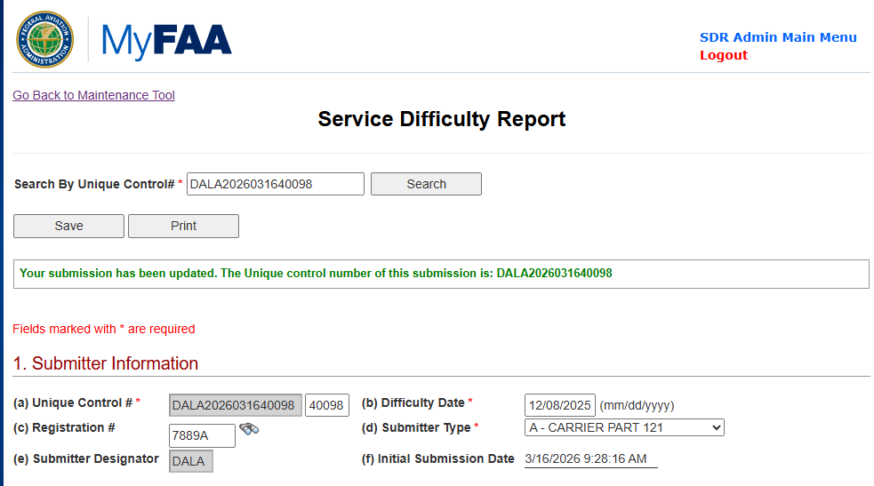

Edit Part Condition
Select ‘Edit Part Condition’ to update drop-down values for Part Condition
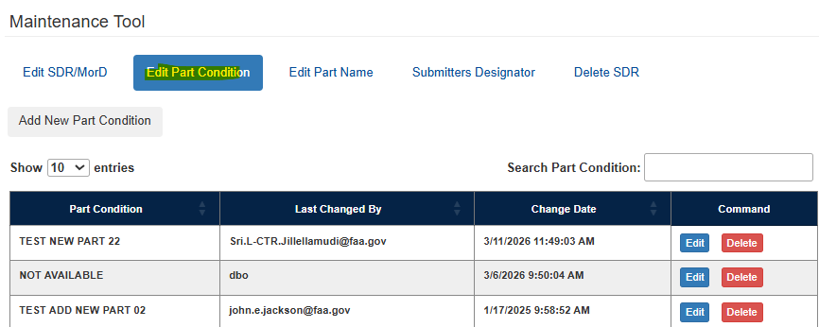
Edit Part Condition:
Click Edit button; Update the value in the text box and click Save
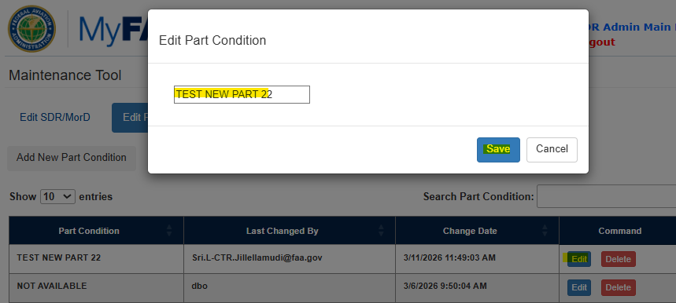
Add Part Condition:
Click ‘Add New Part Condition; add a new value in the part condition text box and click Save
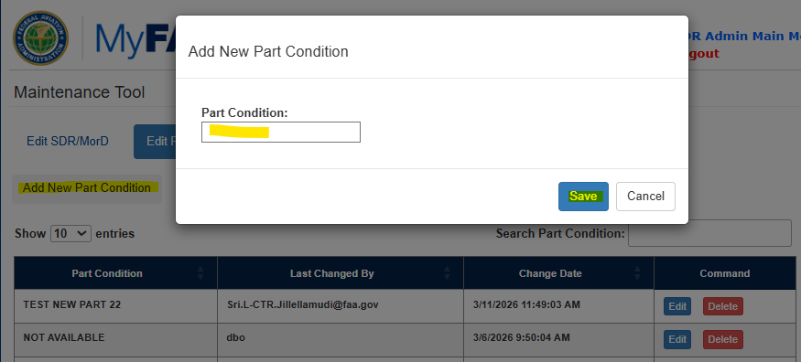
Delete Part Condition:
Click ‘Delete’ button, on the pop-up >> Click ‘Yes Delete’ button
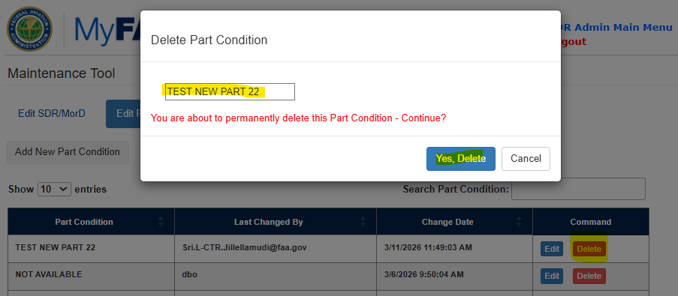

Edit Part Name
Select ‘Edit Part Name’ to update drop-down values for Part Name
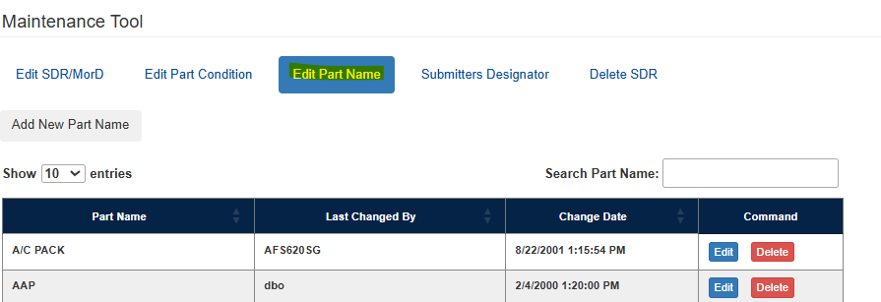
Edit Part Name:
Click Edit button; update the value in the text box and click Save
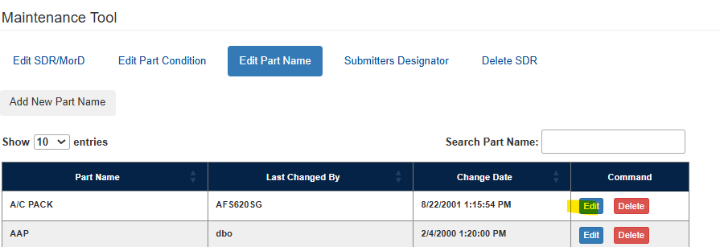
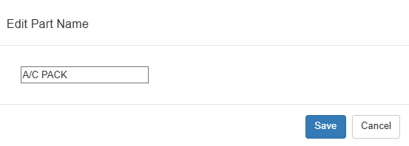

Add Part Name:
Click ‘Add New Part Button; add new value in the part condition text box and click Save
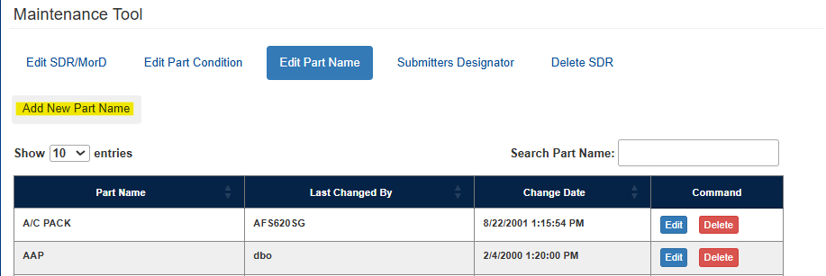
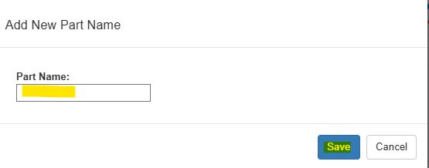
Delete Part Name:
Click ‘Delete’ button>> on the pop-up, Click ‘Yes, Delete’
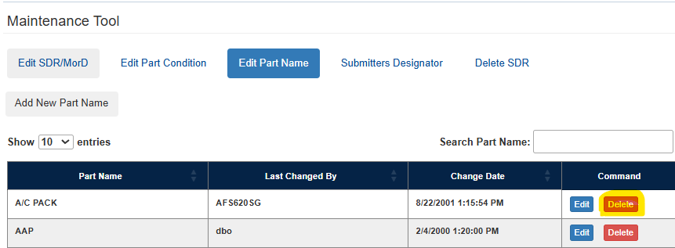
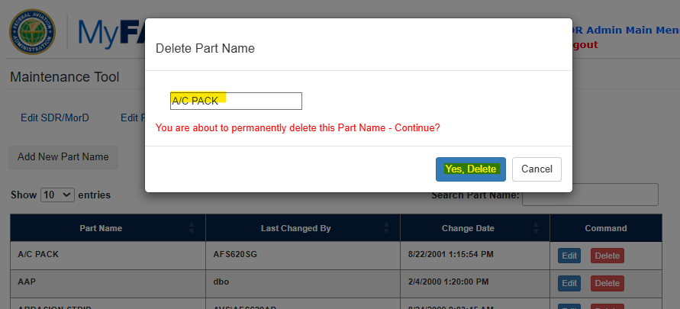

Delete an SDR or M or D Report
The ADMIN USER has the ability to delete an SDR or M or D record which is already processed. To Delete an SDR or M or D record follow the steps below:

Step 1: Navigate to the Delete SDR Tab and enter the unique control # to search for the record to Delete
Step 2: In the pop-up enter a reason for deletion
Step 3: In the additional pop-up Click ‘Ok” to delete the record
Delete SDR’ button
Step 4: a confirmation pop-up says that record is deleted
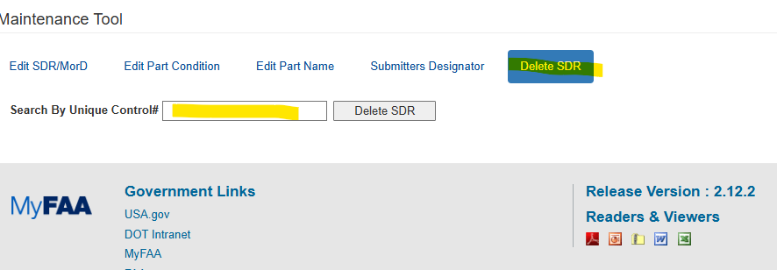
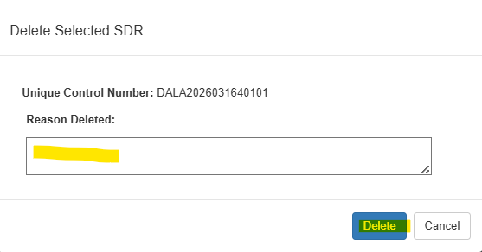
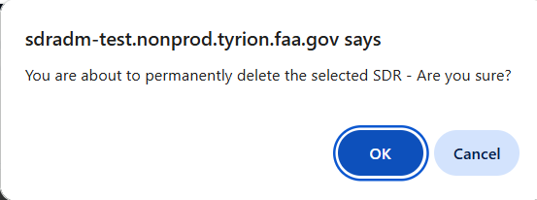

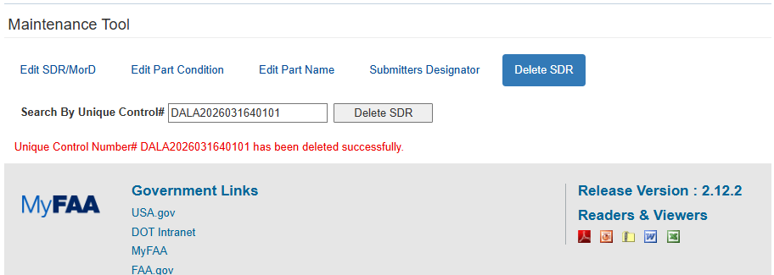

Submitters Designator
The ADMIN USER can add and update an existing submitters Designator from FAMIS
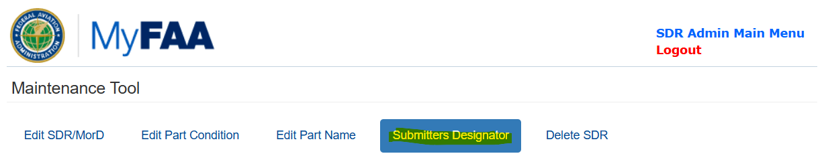
Navigate to Submitters Designator
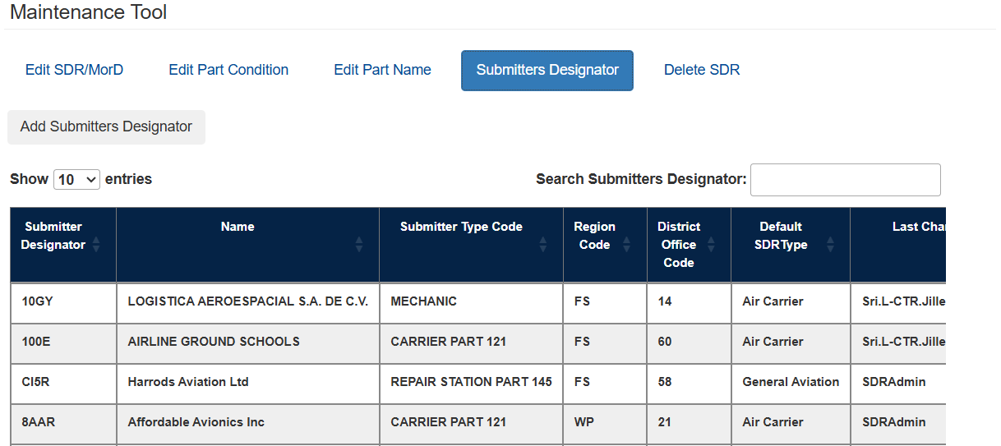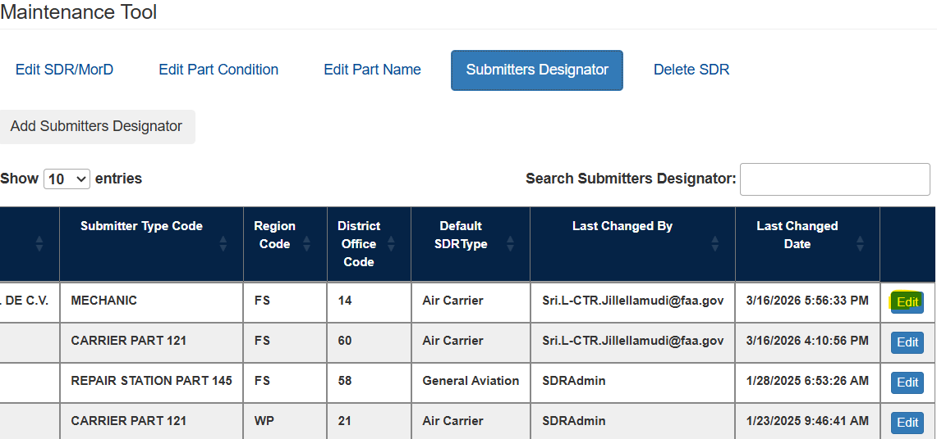
Click on Edit
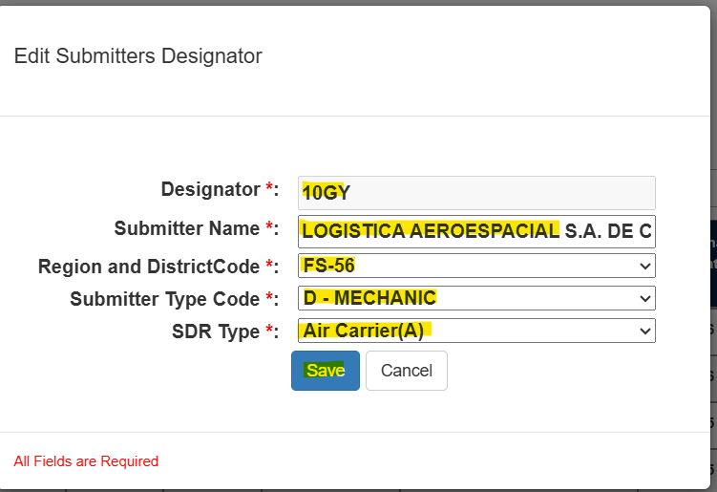
After updating click on Save
Add Submitters Designator:

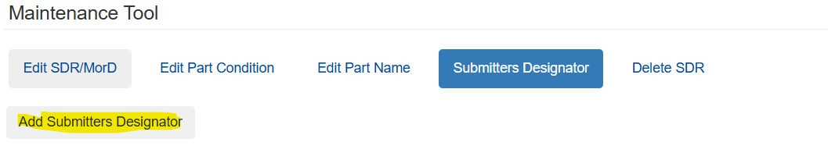
Click ‘Add Submitters Designator” Button
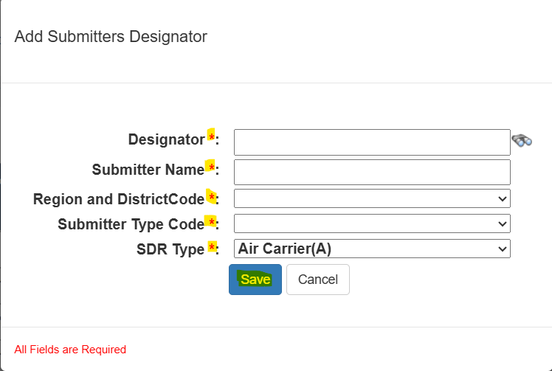

Enter the required input and click on Save
Note: Enter the Designator and click on the Look up icon, data gets auto populated from the FAMIS table in other fields

Other Tools
An Admin User can do the following on the Other Tool
- Submission by User Per Month across the Designators
- Access this report to see submissions per month, by each user and unique designator
- Reports
- Search SDR’s that are in different status
- Search by date range
- Submission Counts
- SDR Submission Statistics by Year and Month
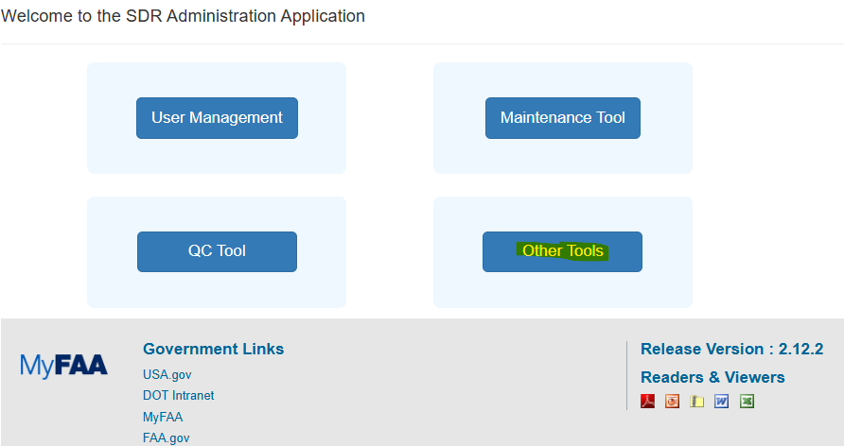
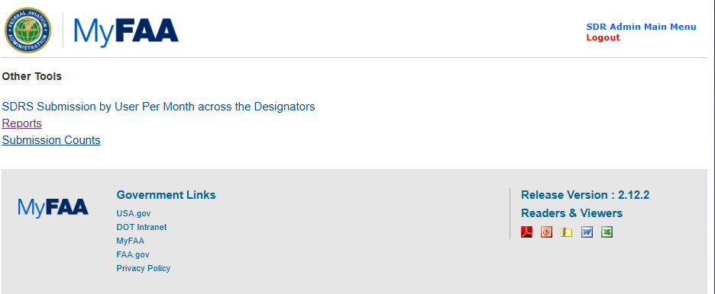

Submission by User Per Month across the Designators
  - Run report to see -- Submissions per month by each user and unique designator
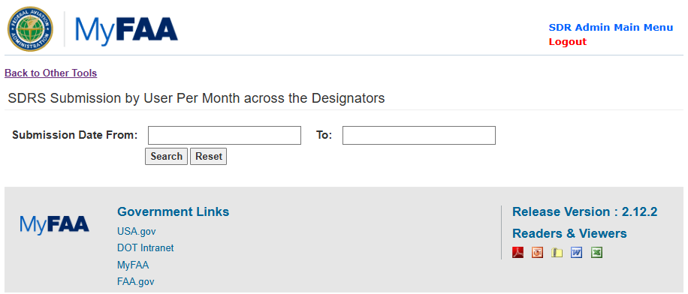
List of SDRs based on the search criteria are displayed
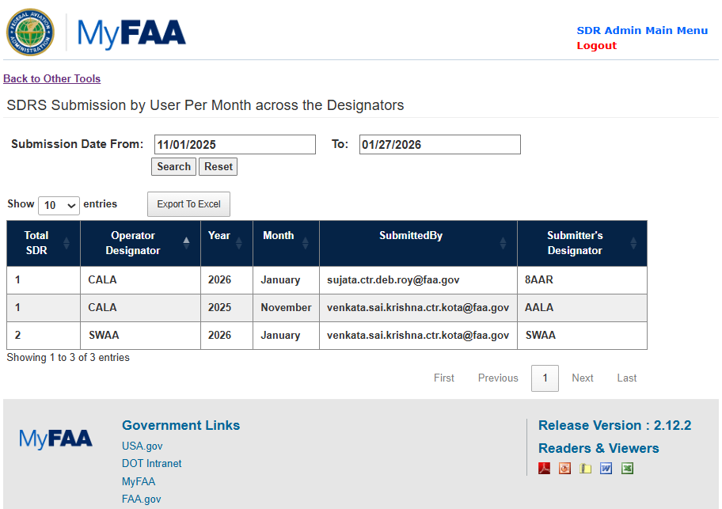

Reports
Users with access to Reports will see list of SDR’s that are in the following status:
- Awaiting QC: All new SDR and M or D reports that have been submitted by the Submitter will show up in this list
- QC Work In Progress: All SDR and M or D reports that are being worked on by the QC Tool User will show up in this list
- Supplementals Initiated: All SDR on which the Submitter user has initiated and submitted a Supplemental will show up in this list
- Returned for Correction: All items on this grid are for view only. This page provides an overview of all SDRS records that have been returned to the Submitter for updates/re-work.
- Processed: All SDRS and M or D reports that have been approved for production table will show up in this list
- Deleted SDRS’s: All SDR and M or D reports have been deleted by an Admin User will show up in this list
- All Submissions: All SDR and M or D reports that have been submitted will show up in this list

Awaiting QC
To display this report, select “Awaiting QC” from the drop-down

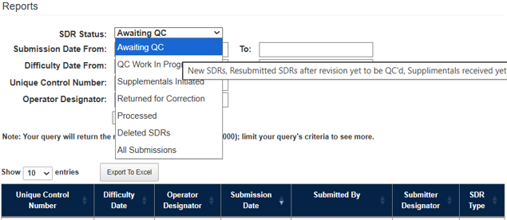

The following grid displays --

- Users can narrow down the list by searching by Date Range, Unique Control Number, Operator Designator
- User has the ability to export the list to an excel sheet
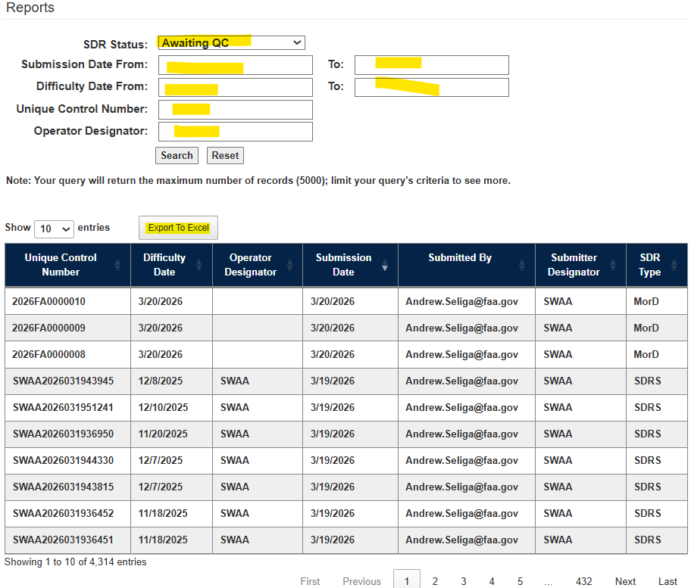

QC Work in Progress
The following grid is displayed upon selecting ‘QC Work In Progress’ from the SDR Status dropdown field.

- Users can narrow down the list by searching by Date Range, Unique Control Number, Operator Designator
- User has the ability to export the list to an excel sheet
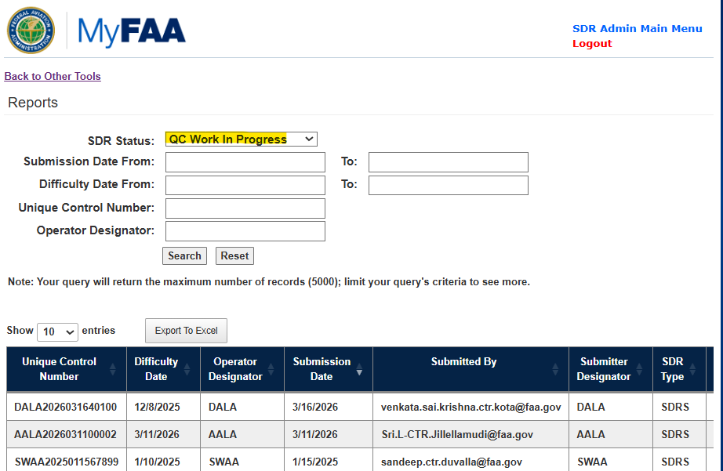

Supplementals Initiated
The following grid is displayed upon selecting ‘Supplemental Initiated’ from the SDR Status dropdown field.

- Users can narrow down the list by searching by Date Range, Unique Control Number, Operator Designator
- User can export the list to an excel sheet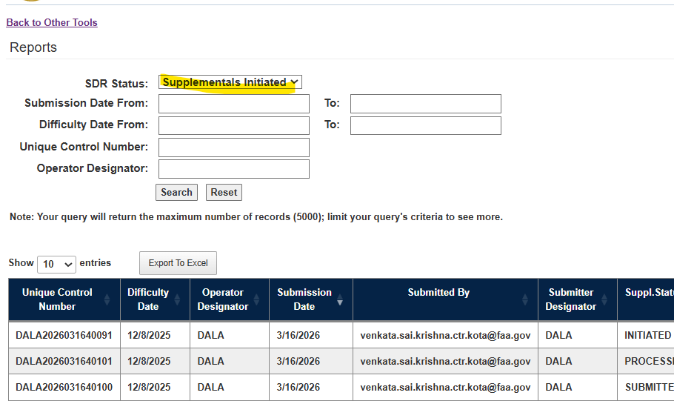

Returned For Correction
The following grid is displayed upon selecting ‘Returned for Correction’ from the SDR Status dropdown field.

- Users can narrow down the list by searching by Date Range, Unique Control Number, Operator Designator
- User has the ability to export the list to an excel sheet
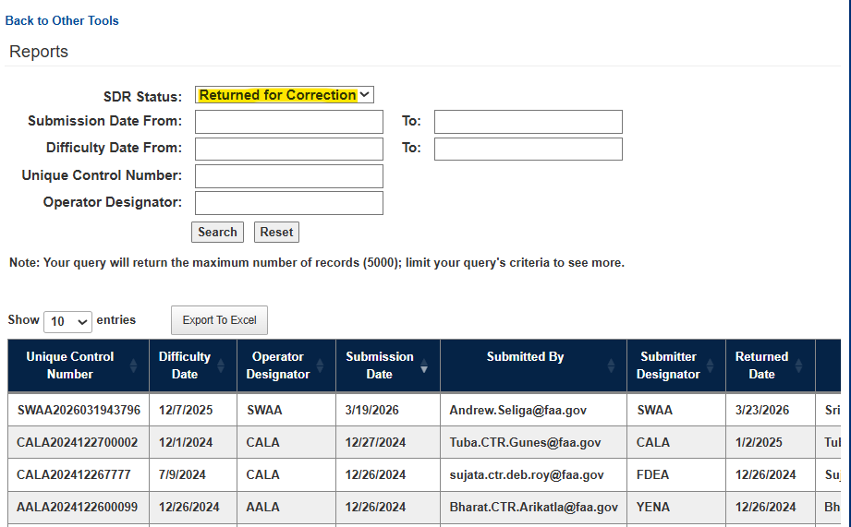

Processed
The following grid is displayed upon selecting ‘Processed’’ from the SDR Status dropdown field.

- Users can narrow down the list by searching by Date Range, Unique Control Number, Operator Designator
- User has ability to export the list to an excel sheet
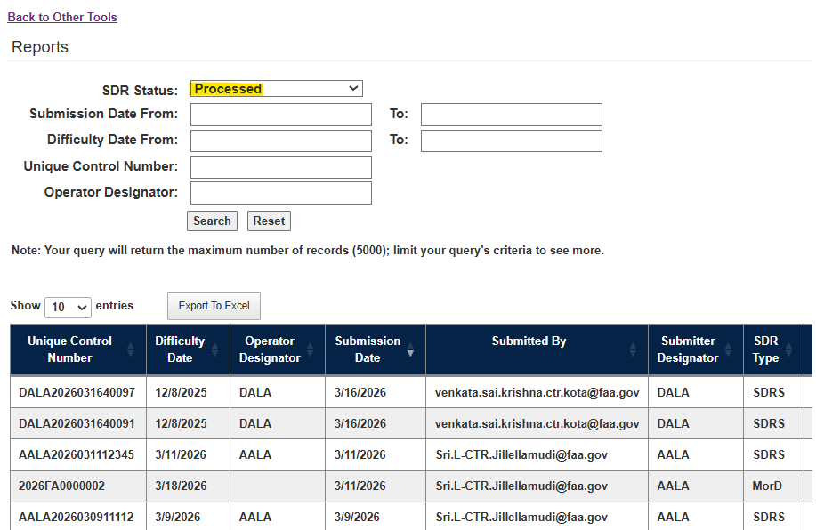

Deleted SDR’s
The following grid is displayed upon selecting ‘Deleted SDR’s’ from the SDR Status dropdown field.

- Users can narrow down the list by searching by Date Range, Unique Control Number, Operator Designator
- User has ability to export the list to an excel sheet
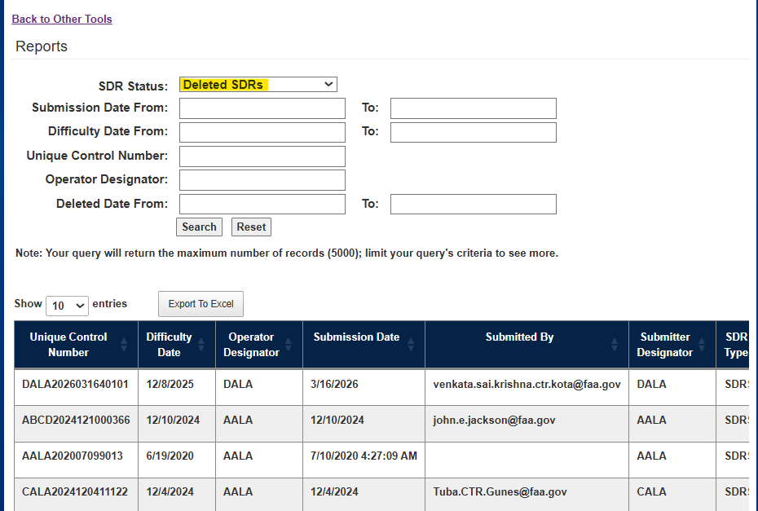

All Submissions
The following grid is displayed upon selecting ‘All Submissions’ from the SDR Status dropdown field.

- Users can narrow down the list by searching by Date Range, Unique Control Number, Operator Designator
- User has ability to export the list to an excel sheet
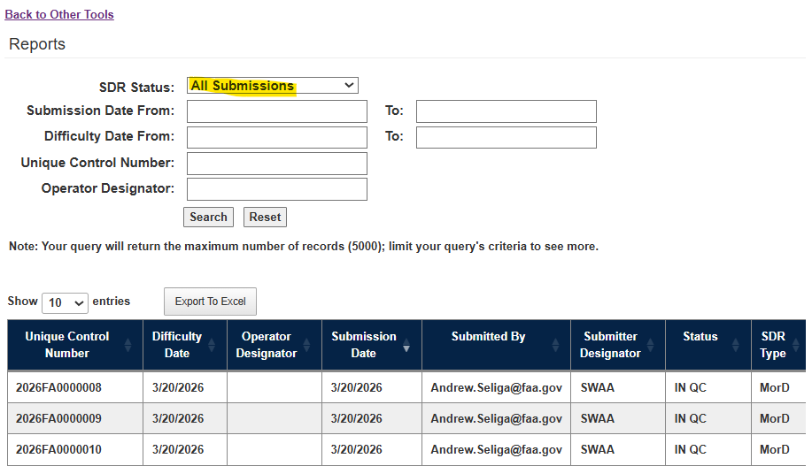

Click on Back to Other Tools then navigate to Submission Counts
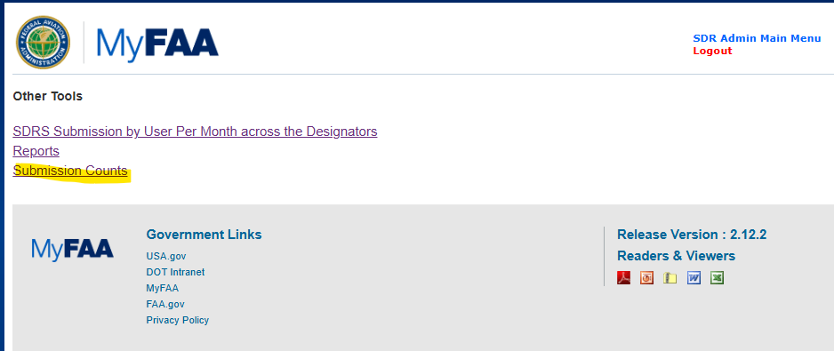

Submission Counts
This report allows ADMIN Users to see SDR submission statistics by year and month
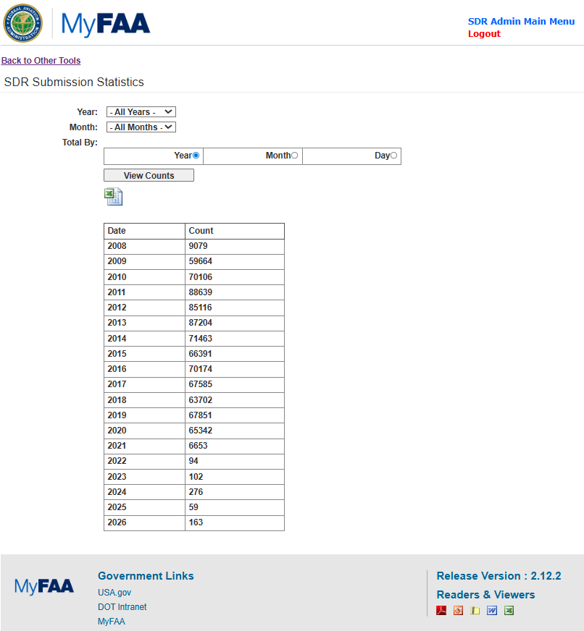

- User can narrow down the list by searching by Year, Month and day

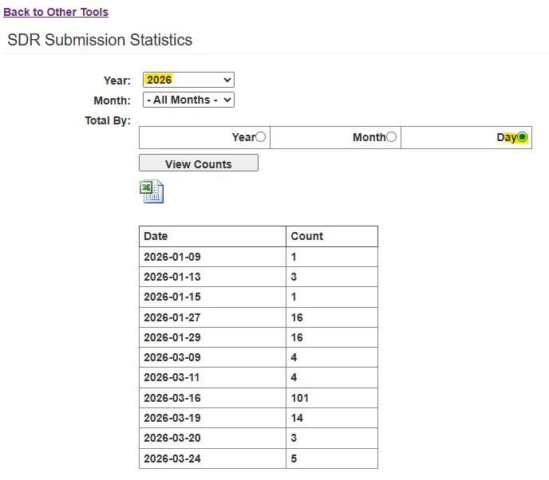

Override Functionality

QC Users will have the ability to override the following information under Major Equipment Identity section.

- Aircraft
- Engine
- Propeller
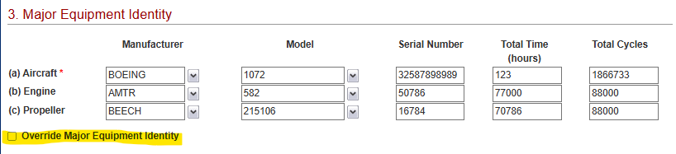

As a QC USER
Log in to SDR Administration Application and Click on the QC Tool
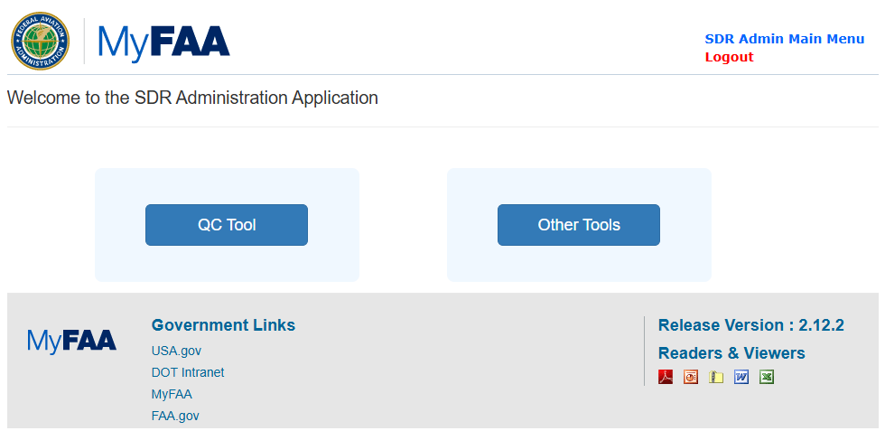
Click Unique Control Number under Awaiting QC list
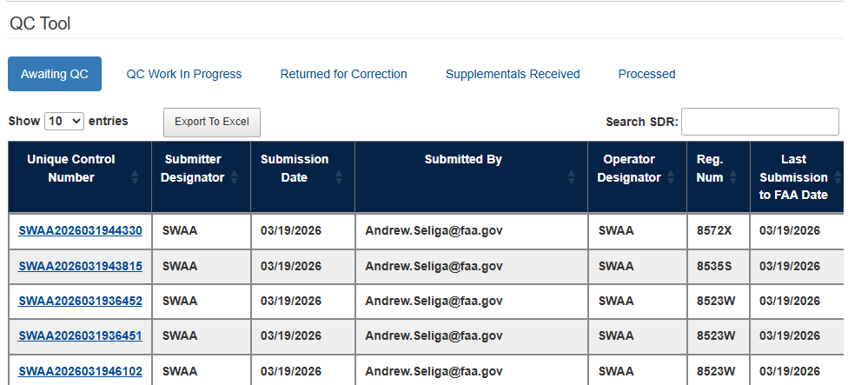
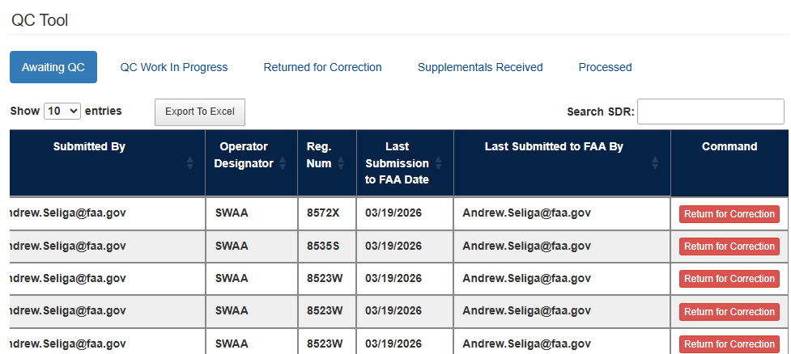
Select Override Major Equipment Identify radio button
Note: By selecting Override Major Equipment Identify radio button will disable validation rules on the fields under this section
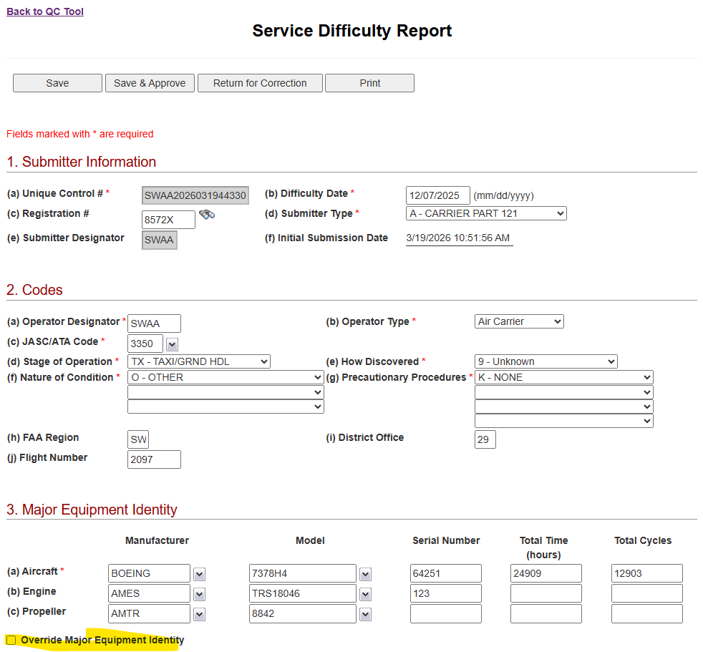
Click OK on the message pop up, make edits on the fields and Click ‘Save & Approve’
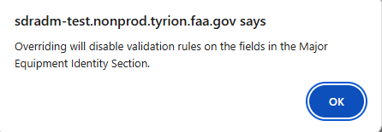
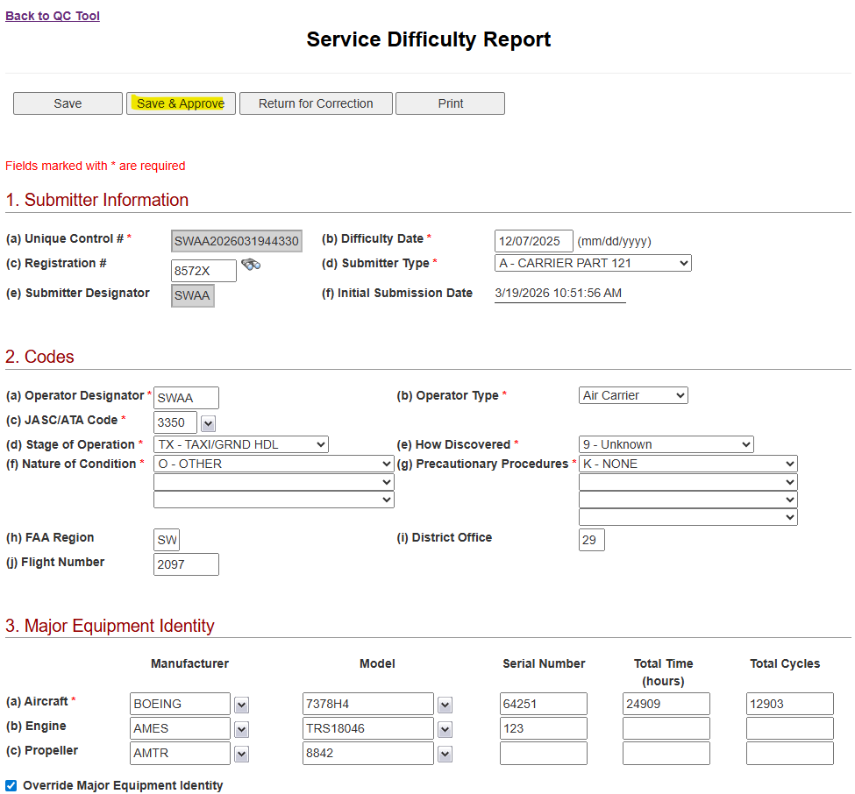

As a Submitter
Log in to SDRS External Application and Select SDRs By Status
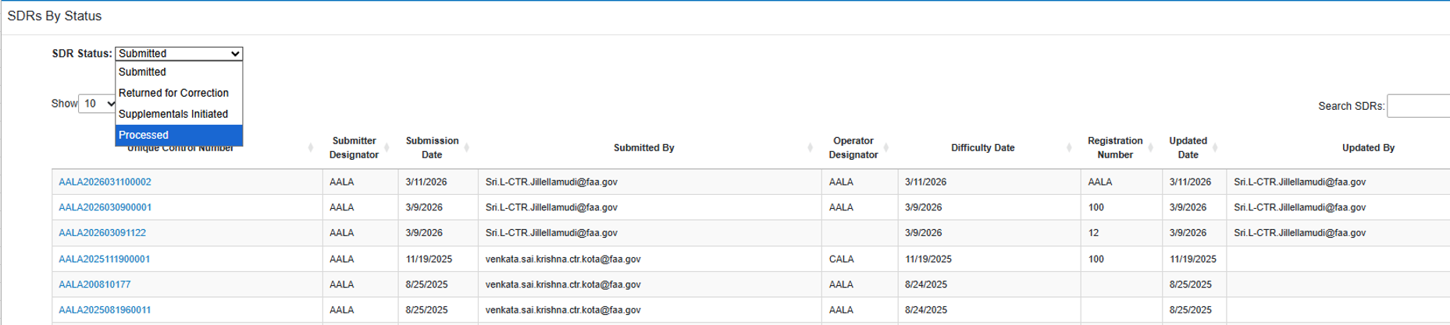
Select ‘Processed’ from the SDRS Status list
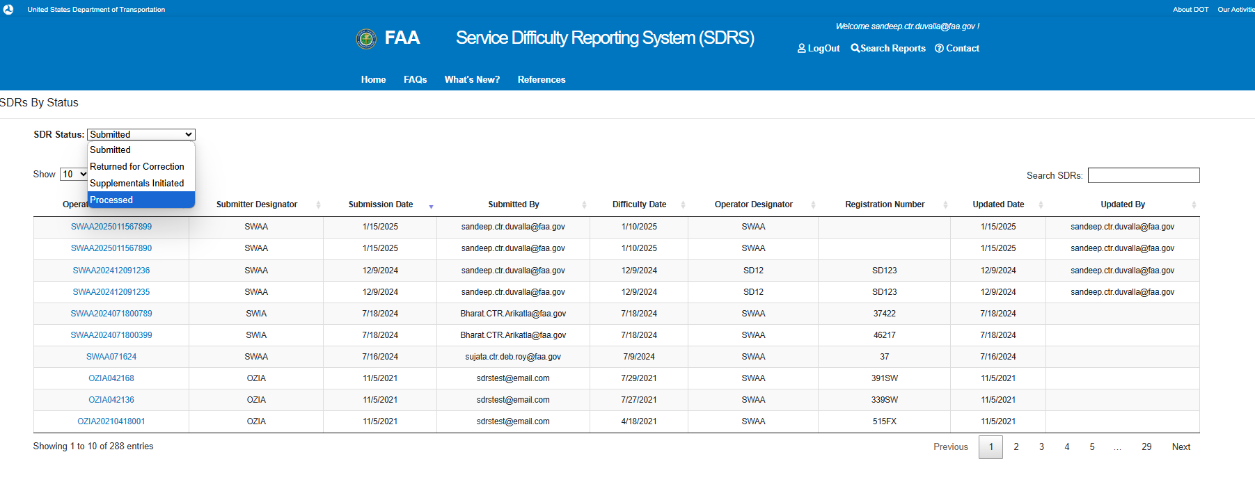

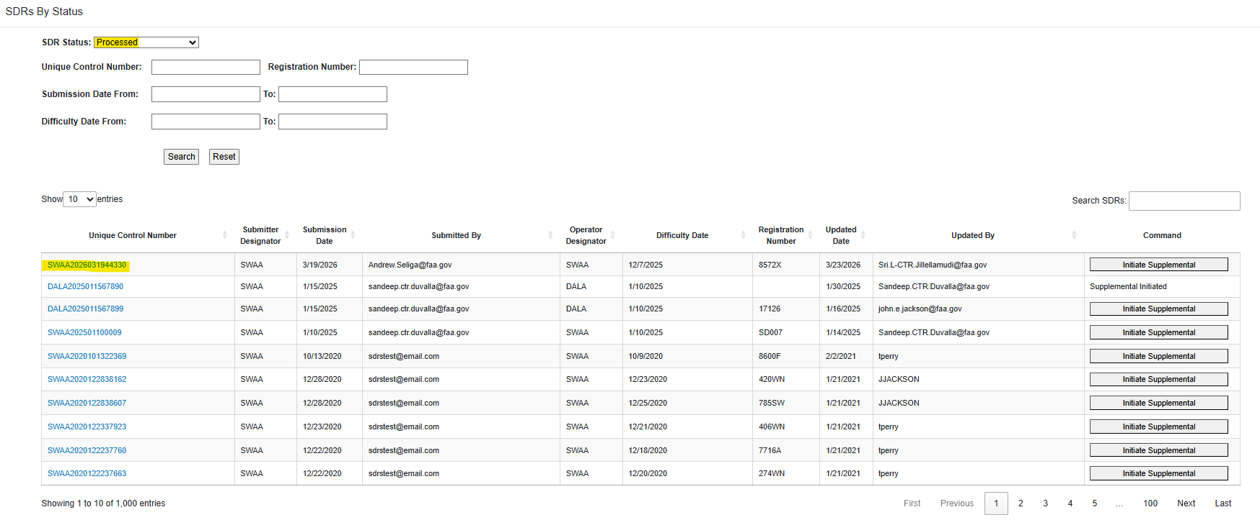
Submitter will be able to review and update the supplemental record
Note: Major Equipment Identity section will be grayed out for the submitter if the override major equipment Identity check box is checked.
Submitter User cannot uncheck the box and make any changes to Major Equipment Identity
